Embargoed Monday 20th January 00:01

Liverpool BID Company and Liverpool Biennial take over the city’s Commercial District with new project: Art in Motion

Artworks by Gordon Cheung to feature on Arriva buses and bus tickets, and coffee cups from Liverpool’s independent businesses

Art in Motion’s commissions respond to Liverpool’s distinctive Coat of Arms

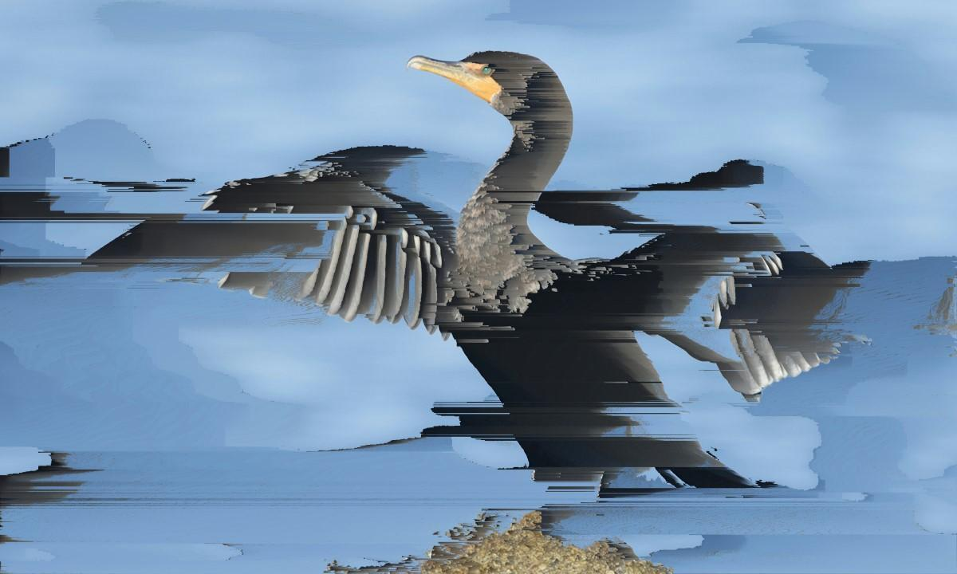
Gordon Cheung, Untitled, 2019. Image courtesy the artist and Cristea Roberts Gallery

Artworks will infiltrate daily life in Liverpool as the first stage of Art in Motion takes hold of the city’s Commercial District. An exciting partnership between Liverpool Biennial and Liverpool BID Company, Art in Motion sees artists create works which are distributed through city life in collaboration with Arriva, Merseytravel and local businesses. Initially featuring specially commissioned ‘glitch’ based artwork by contemporary artist Gordon Cheung, two further artists will be unveiled later in 2020.

From 20 January 2020, commuters and visitors across Liverpool’s Commercial District can encounter and collect Cheung’s artworks within the fabric of everyday life – on takeaway coffee cups, on internal graphics and tickets across the Arriva bus network, as well as on posters. The specially printed coffee cups are available at Baby E Coffee & Deli, Bloom & Bean, Bold Street Coffee, Cafe Lucaya, Espresso Café (at Bluecoat), Esquires Coffee, Hemingway’s Café, The Red Berry Club, Rococo Coffee House, Rope & Twines and Thoughtfully Café. A number of other exciting outlets and locations will gradually be unveiled across the city over the course of the project.

For 2020 the overarching theme of Art in Motion centres around the distinctive Liverpool Coat of Arms, which has existed in various formats since the 13th century. Each of the artists will play with ideas that interrogate the diverse history of Liverpool as a city of culture, commerce and exchange.

The first commissioned artist, Gordon Cheung, is a painter whose work explores themes of urban environments, history and speculation. He is known for working with pixel-sorted algorithms to produce ‘glitch’ prints of tulips. For his Art in Motion commission, Cheung is responding to Liverpool’s historic past and dynamic present by creating a series of ‘glitch’ based artworks inspired by the flowers and birds which appear in the city’s Coat of Arms.

With Art in Motion, Liverpool Biennial continues its commitment to producing ground-breaking art in the city’s Commercial District, having commissioned 2019 Turner Prize winner Lawrence Abu Hamdan’s permanent public artwork Hummingbird Clock in Derby Square for Biennial 2016 as part of Liverpool BID Company’s five-year Public Art Strategy for the Commercial District BID.
Follow Art in Motion’s progress at: Liverpoolartinmotion.com
Bill Addy, chief executive of the Liverpool BID Company, and chair of LVEN (Liverpool Visitor Economy Network), said:
“Commissioning and presenting quality and thought-provoking public art such as Art in Motion is vital in our commitment to enhance the areas we represent for our BID levy paying businesses and help create the catalyst for further activity and development in the future.
Our partnership with Liverpool Biennial goes back a long way, and was set up following a robust public consultation with our BID levy paying businesses located in the Commercial District BID, who made it clear that there is a real appetite for new public art in the area.
Art in Motion will raise the profile of the Commercial District, making it more attractive to work and dwell in, and in the vein of other works that the BID has brought to the area, such as The Liverpool Plinth in partnership with dot-art and Liverpool Parish Church, will bring a smile to the faces of those living and working in the neighbourhood, and hopefully instil a sense of local pride in this great city of ours."
Fatoş Üstek, Director of Liverpool Biennial, said:

“We are thrilled to be working with Liverpool BID Company to bring exciting artworks to the city’s Commercial District.

Art in Motion represents an opportunity for people to encounter contemporary art in their daily lives – our vision is to charge Liverpool with ambitious artworks that reach out and engage with people living and working in the city. For the first phase of the project, we are delighted to have commissioned Gordon Cheung to respond to Liverpool’s emblematic Coat of Arms with a series of invigorating, painterly images.
We are grateful to Liverpool BID Company for their openness, trust and commitment towards Liverpool Biennial and for working with us to make outstanding art happen, both in the city’s Commercial District and further afield.”

Editor’s Notes

Liverpool BID Company

Liverpool BID Company is a private, not-for-profit organisation, representing the interests of 1,500 levy paying businesses in Liverpool city centre, across two BIDs (Business Improvement Districts) - Retail & Leisure BID and Commercial District BID.

The aim of Liverpool BID Company is to:

- Bring added value to levy payers and build on the core services already provided by Liverpool City Council and Merseyside Police
- Ensure both BID areas are clean and secure for businesses and visitors, and have the right environment for the private sector to succeed - whether a retailer, restaurant owner, or legal and financial service
- Work with the city and charities to tackle street dwellers
- Drive footfall and develop activity where needed
- Champion the voice of the levy payers it represents, pushing forward their agendas and making things happen

The Liverpool BID areas cover some of the most iconic locations in Liverpool city centre:

- The eclectic and diverse independents of Bold Street
- The thriving restaurant and hotel scene of Castle Street
- Liverpool’s ever-evolving high street - from the iconic brands on Church Street and Williamson Square, to the high-end boutiques of Metquarter
- The professional and financial services around Old Hall Street
- Mathew Street and Cavern Quarter - the birthplace of The Beatles, a focal point in the city’s music heritage, and a colourful nightlife scene

For more information about Liverpool BID Company, please visit:

Website | Facebook | Twitter | Instagram | LinkedIn

Liverpool Biennial

Liverpool Biennial is the largest and the oldest biennial of contemporary art in the UK. Taking place every two years since 1998, the Biennial activates public institutions, historical sites and extraordinary locations, with every edition changing its theme and trail of encounters. Occupying a lead position amongst international biennials, Liverpool Biennial pioneers an innovative approach to commissioning artists in producing and presenting work in the context of Liverpool, with a longstanding commitment to introducing international artistic practices to national and international audiences, and the public at large. Underpinned by a year-round programme of research, education, residencies and commissions, Liverpool Biennial has commissioned over 340 new artworks and presented work by over 480 artists from around the world since its conception. The 11th edition of Liverpool Biennial, titled The Stomach and the Port will take place from 11 July – 25 October 2020.

For more information visit biennial.com
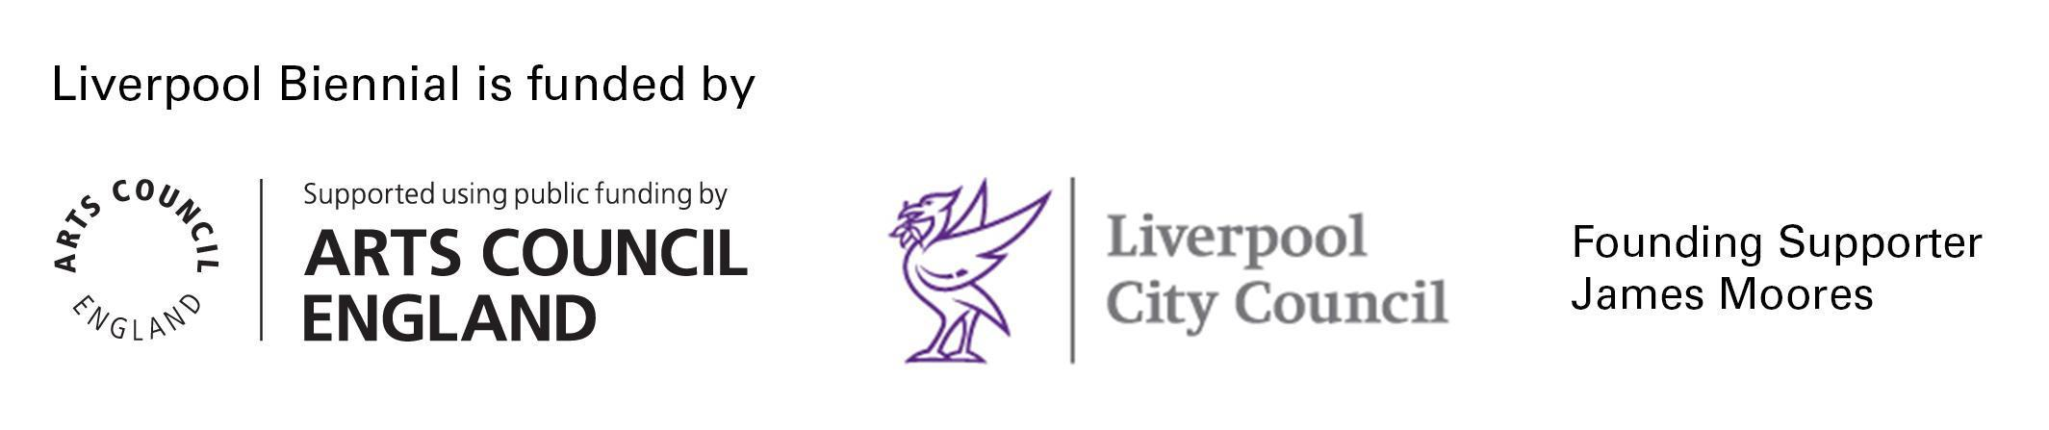

Art in Motion

Art in Motion is a new artistic initiative between Liverpool Biennial and Liverpool BID Company. In 2020, three artists will produce work which responds to the Liverpool Coat of Arms. The first artist to be commissioned is Gordon Cheung whose glitch-based artworks will feature across Liverpool’s Commercial District from 20 – 27 January 2020. In collaboration with Arriva and Merseytravel, the first set of works will feature on the backs of bus tickets, on internal graphics within selected Arriva buses, and on coffee cups across local businesses in and around Liverpool’s Commercial District. Art in Motion is curated by Sunny Cheung, Assistant Curator at Liverpool Biennial.
Follow the project at Liverpoolartinmotion.com.

Gordon Cheung

Gordon Cheung (b. 1975, London, UK) is of Hong Kong origin and lives and works in London. Cheung’s multi-media artworks capture the hallucinations between the virtual and actual realities of a globalised world oscillating between utopia and dystopia. Spray paint, oil, acrylic, pastels, stock listings and ink collide in his works to form epic techno-sublime vistas. Cheung graduated from the Royal College of Art in 2001 and his work has been exhibited internationally as well as featured in the largest and most ambitious survey of recent developments in art from the UK; The British Art Show 6 (2005) and The John Moores Painting 24 (2006). Solo shows include The Promised Land, Jack Shainman Gallery, New York, USA (2009) and The Four Horsemen of the Apocalypse, The New Art Gallery Walsall, UK (2009). Cheung's first solo US exhibition was at the Arizona State University Art Museum in 2010. Cheung's works are held in international collections including the Hirshhorn Museum, ASU Art Museum, and Knoxville Art Museum in the USA, and The New Art Gallery Walsall and Whitworth Museum, in the UK.
Press Enquiries

For further press information or images please contact:

Laura Brown
PR, Liverpool BID Company
laura@lauramariebrown.com
+44(0)7739321279

Bethany Garrett
Marketing & Communications Coordinator, Liverpool Biennial
bethany@biennial.com
+44(0)151 203 3579

