

**Curator and Dates Announced for Liverpool Biennial 2020**

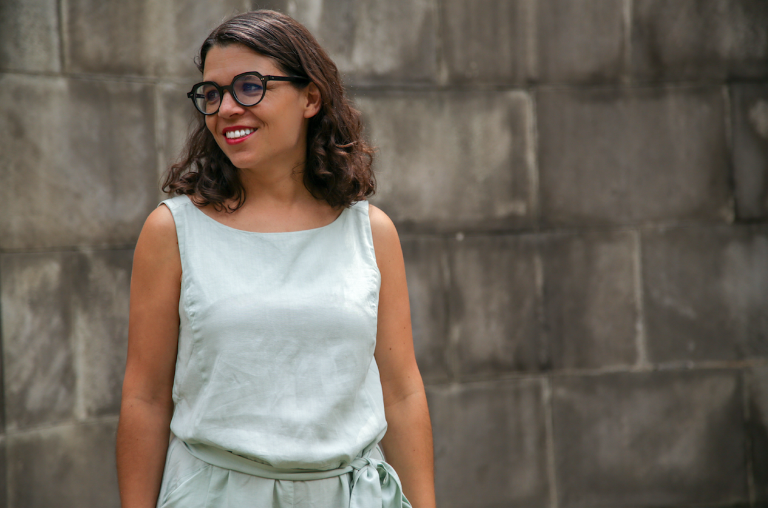

*Manuela Moscoso © Jacobo Braun*

Liverpool Biennial today announces the appointment of Manuela Moscoso as Curator for Liverpool Biennial 2020, which will take place 11 July – 25 October2020.

Moscoso, Senior Curator at Tamayo Museo, Mexico City, will co-curate the 11th edition with the Liverpool Biennial team.

Liverpool Biennial is the largest festival of contemporary visual art in the UK and has marked its 20th anniversary this year with the 10th edition under the title *Beautiful world, where are you?* (until 28 October 2018) curated by Kitty Scott and Sally Tallant with the Biennial team.

Manuela Moscoso, Curator, Liverpool Biennial 2020, said: "I am thrilled to be moving to Liverpool to start working with the talented team on the next edition of the Biennial. It is a challenge and a great new context in which to set my mind, and my heart, at play."

Sally Tallant, Director, Liverpool Biennial, said: “We are delighted that Manuela Moscoso will be joining us for 2020 and bringing her expertise to the team. I look forward to welcoming Manuela to the city and working with her together with our partners in Liverpool.”

Liverpool Biennial 2020

11 July – 25 October 2020

Venues and sites across Liverpool, free entry

[www.biennial.com](http://www.biennial.com)

High-res images available at:

<https://www.dropbox.com/sh/iuno2on49j27by1/AADcLjxkR7Fb4kXHg6vnQNCwa?dl=0>

Press enquiries:

Jane Quinn or Sim Eldem, Bolton & Quinn

+44 (0) 20 7221 5000

[jq@boltonquinn.com](mailto:jq@boltonquinn.com) or [sim@boltonquinn.com](mailto:sim@boltonquinn.com)

**Manuela Moscoso**, originally from Ecuador, is the Senior Curator at Tamayo Museo, Mexico City. Moscoso is part of Zarigüeya, a programme that activates relations between contemporary art and the pre-Columbian collection of the Museo de Arte Precolombino Casa del Alabado, Ecuador. She was the adjunct curator at the 12th Cuenca Biennial and the co-curator of the Queens International 2011 Biennial. In 2012 she was appointed co-director of Capacete, a residency programme based in Brazil where she also co-ran the curatorial programme, Typewriter. Moscoso has collaborated with CA2M, Di Tella, MAM Medellin, Museo de Rio, RedCat, Fundació Miró among other institutions. Her work and research focuses on artistic production that can articulate critical present endeavours, interrogating a linear history and univocal perspectives. Moscoso has a master’s degree from the Center for Curatorial Studies at Bard College and a Bachelor of Fine Arts from the Saint Martin’s School of Art and Design, London.

**Liverpool Biennial** is the UK biennial of contemporary art and commissions artists to make and present work in the context of Liverpool. It takes place every two years across the city in public spaces, galleries, museums and online. The Biennial is underpinned by a programme of research, education, residencies and commissions. Founded in 1998, Liverpool Biennial has commissioned over 340 new artworks and presented work by over 480 artists from around the world. Amongst artists presented in early editions are Doug Aitken, John Akomfrah, Mona Hatoum, Nicholas Hlobo, Yayoi Kusama, Takashi Murakami, Yoko Ono, Philippe Parreno, Ai Weiwei and Franz West.

