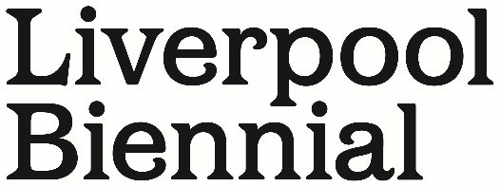

NEWS RELEASE

Landmark new commission by Nathan Coley revealed on Liverpool’s World Heritage Waterfront

A landmark new commission from Turner Prize shortlisted artist, Nathan Coley, has been revealed on Liverpool’s UNESCO World Heritage Waterfront.

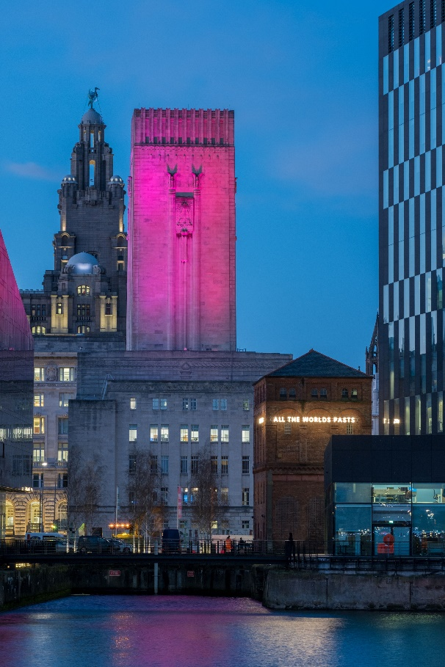
Installation view: From Here, 2020, by Nathan Coley,
St George’s Dock Pumping Station, Mann Island, Liverpool
© Photography by Mark McNulty

The installation From Here, 2020 is a co-commission between Liverpool Biennial and Culture Liverpool and is the latest in a series of high-profile outdoor artworks on the waterfront following 2018’s Liverpool Mountain by Ugo Rondinone.

The text-based light sculpture is made up of the words From Here, All the Worlds Futures, From Here, All the Worlds Pasts. Inspired by the writing of German philosopher, Walter Benjamin, and acknowledging the curator, Okwui Enwezor’s influential exhibition All The World’s Futures at Venice Biennale 2015, Nathan Coley’s expansion of the phrase presents a new meaning that reinforces the power of Liverpool as a place, its history and speaks to the hope for the future.

Measuring twenty metres in length, the work has been designed specifically to wrap around the four sides of the St. George’s Dock Pumping Station, an iconic Victorian red brick building located on Mann Island in the heart of the city, and still used on a daily basis by the building’s owners Network Rail.

Nathan Coley, said: “From Here in Liverpool is the largest text work I have made to date. Like the others in the series, it presents the public with a powerful poetic proclamation. I’m hoping in a small way it can be seen as an antidote to the darkness of 2020. The phrase speaks of place, history and times still to come. In the way I’ve given power to the words, I hope the sculpture creates a healthy discussion about public space, the making of place and the possible futures we all have.”

Dr. Sam Lackey, Interim Director of Liverpool Biennial, said: “Nathan is a brilliant artist, and we are delighted that we have been able to work with him on this project. The piece feels incredibly pertinent yet also expansive – a snapshot of the world in which we find ourselves in; a focus to give us a moment to both pause and reflect. Everyone worked so hard to get the piece built and installed before Christmas, as it felt important to us that the message of the work came at the end of this challenging year and to provide optimism for 2021.”

Claire McColgan MBE, Director of Culture Liverpool, said: “I couldn’t actually imagine this artwork being in any other city. Its message is a perfect fit for Liverpool. It is both reflective and thoughtful but also full of hope and ambition. Creativity is in this city’s DNA, and I am so very proud that even in the challenging moment we find ourselves in, we are still committed to creating brand new work and using our streets as a playground for artists to inspire and make people think about what we aspire to be.”

The installation will initially remain in situ for twelve months, alongside the 11th edition of the Liverpool Biennial, The Stomach and the Port, which runs from 20 March – 6 June 2021.

Further information, biographies, film and images are available here.

Notes to Editors:
About Nathan Coley
Nathan Coley lives and works in Glasgow. This will be the first time he has shown in Liverpool since his work was featured in the Turner Prize Exhibition at Tate Liverpool in 2007, for which he was shortlisted.

Recent solo exhibitions have included Parliament Hall, Edinburgh (2019), Parafin, London (2019, 2017); EAST Gallery, Norwich (2018); Scottish National Gallery of Modern Art, Edinburgh (2017); New Art Centre, Roche Court, Salisbury (2016), while notable group exhibitions comprise Utopias, Whitworth Art Gallery, Manchester (2020); Stories for an Uncertain World, Edinburgh Art Festival (2019); The Aerodrome, Ikon, Birmingham (2019); Sculpture In The City, London (2019); Possibilities For a Non-Alienated Life, Kochi Muziris Biennale (2018); Arhus2017 – European Capital of Culture (2017); Actions - The Image of the World can be Different, Kettle's Yard, Cambridge (2018); Age of Terror - Art since 9/11, Imperial War Museum, London (2018); Glow, Van Abbemuseum, Eindhoven (2016); and Daydreaming With Stanley Kubrick, Somerset House, London (2016). Coley's work is held in important international collections including Tate, London; Scottish National Galleries, Edinburgh; Government Art Collection, London; Whitworth Art Gallery, Manchester; Israel Museum, Tel Aviv; VanAbbemuseum, Eindhoven; and Auckland Art Gallery, New Zealand.

About Liverpool Biennial
Liverpool Biennial is the oldest and largest festival of contemporary visual art in the UK. Since its inception in 1998, the Biennial has become renowned in the international contemporary art world, bringing together a wide array of international voices and artistic practices. Taking place every two years, Liverpool Biennial activates public institutions, historical sites and extraordinary locations across Liverpool, ensuring major commissions in the public realm. Pioneering an innovative approach underpinned by a year-round programme of research, education, residencies, projects and commissions, each biennial edition introduces renewed thinking and scale of production. Having commissioned over 340 new artworks and presented work by over 480 celebrated artists from around the world, the Biennial is built on a longstanding commitment to connecting international artist with local practitioners, communities and the general public.
For more information visit: https://www.biennial.com/

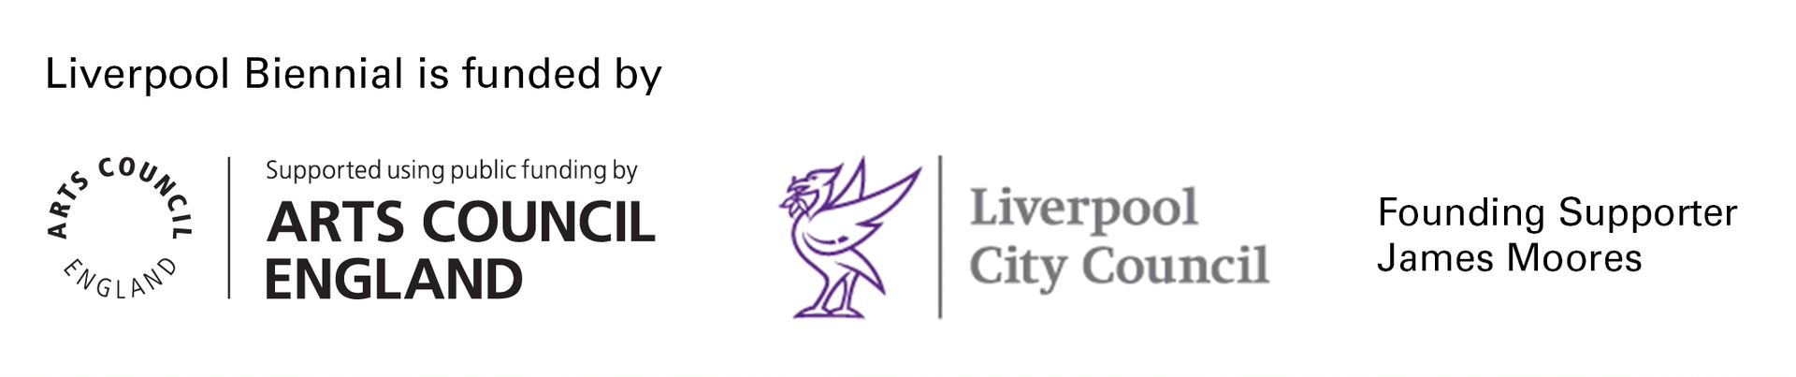

For further press information or images please contact:
Susie Gault, Press & PR Advisor, Liverpool Biennial: susie@biennial.com +44 (0) 777 584 1206

