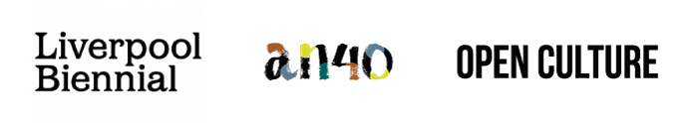
NEWS RELEASE

Liverpool Biennial 2021 and a-n The Artists Information Company join forces to announce five new support and research bursaries for artists across the UK

The 11th edition of the Liverpool Biennial in 2021 and a-n The Artists Information Company are working in partnership, in association with Open Culture, to offer five support and research bursaries of £1,500 each as part of a shared commitment to supporting artists across the UK.

For over two decades, the Biennial has been transforming the city of Liverpool through contemporary art, taking over unexpected venues and public spaces, historic sites and art galleries with exhibitions, installations and new commissions. The 2021 edition The Stomach and the Port, 20 March - 6 June, is curated by Manuela Moscoso and draws on non-Western ways of thinking to explore notions of the body as a fluid organism which is continuously and simultaneously shaped by and shaping its environment.

LB x a-n Artist Bursaries will support a range of activity which aids professional development of artistic careers and practices, particularly the growth of new skills, knowledge and networks. The bursaries are open to all a-n Artist and Joint (Artist and Arts Organiser) members who are living and working in the UK. Reflecting on the diversity of artist practices in The Stomach & The Port, applications are encouraged from artists working in all visual and sonic arts disciplines and at any stage in their career.

Delivered as part of the Biennial’s public programme, the bursaries will offer both financial and in-kind support to recipients in their self-determined professional development activity. Artists will benefit from dedicated time with the festival’s exhibition team, plus assistance from the marketing and wider Biennial staff to support their research and development, help make connections and to create opportunities for the sharing or showcasing work or practices within the framework of the public programme underpinning The Stomach and the Port.

Sam Lackey, Interim Director of Liverpool Biennial, said: “Artists are at the heart of the Liverpool Biennial; over the past twenty-two years we have championed established and emerging artists from all over the world. We are delighted to be partnering with a-n to produce the LB x a-n Artist Bursaries, enabling artists to build on their practices and create new relationships as well as connecting artists across the UK with the city of Liverpool, opening up the potential for future discourse and collaboration. As we enter 2021 with the ongoing challenges of COVID-19, there could not be a more vital time to support and nurture artists with professional development and the opportunity to share their ideas with the public at the 11th edition of the Liverpool Biennial.”

Julie Lomax, Chief Executive Officer of a-n, said: “This exciting partnership takes place during a-n’s 40th anniversary year and we are delighted to be teaming up with renowned Liverpool Biennial to announce the LB x a-n Artist Bursaries. As the largest artists’ membership organisation in the UK, a-n advocates for the value of visual artists and their work. In what is expected to be another challenging year as the UK leaves the EU and continues to battle Covid-19, we are committed to supporting and empowering artists to further their artistic practice and careers. We look forward to seeing the work this important new opportunity generates.”
To apply to LB x a-n Artist Bursaries visit www.bienni.al/apply. The deadline for applications is 12 noon, Friday 12 February 2021. The applications will be reviewed by a selection panel of experts including representatives from Liverpool Biennial, a-n The Artists Information Company, Open Culture and Independents Biennial. The successful applicants will be notified on 5 March 2021.
Notes to Editors:
About Liverpool Biennial
Liverpool Biennial is the oldest and largest festival of contemporary visual art in the UK. Since its inception in 1998, the Biennial has become renowned in the international contemporary art world, bringing together a wide array of international voices and artistic practices. Taking place every two years, Liverpool Biennial activates public institutions, historical sites and extraordinary locations across Liverpool, ensuring major commissions in the public realm. Pioneering an innovative approach underpinned by a year-round programme of research, education, residencies, projects and commissions, each biennial edition introduces renewed thinking and scale of production. Having commissioned over 340 new artworks and presented work by over 480 celebrated artists from around the world, the Biennial is built on a longstanding commitment to connecting international artist with local practitioners, communities and the general public. For more information visit: www.biennial.com.

About a-n The Artists Information Company
a-n is the largest artists’ membership organisation in the UK with over 25,000 members. a-n supports artists and those who work with them in many practical ways, acting on behalf of it’s membership and the visual arts sector to improve artists’ livelihoods and inform cultural policy. Through advocacy and information and from the perspective of artists, a-n’s mission is to stimulate and support contemporary visual arts practice and affirm the value of artists in society. For more information visit: www.a-n.co.uk.

About Open Culture
Open Culture wants you and everyone you know to take part in more arty stuff around Merseyside. Mainly because it’s proven to make your life a bit better.
Established as part of 2008 Liverpool European Capital of Culture, Open Culture is an independent social enterprise working collaboratively across the region to increase the profile of, and engagement with the arts. Known for projects like LightNight Liverpool, the free one-night arts festival, the Tickle the Ivories street pianos, www.uncoverliverpool.com and the Winter and Summer Arts Markets, the organisation develops projects across multiple art forms that nurture and connect artists and audiences to make people happier. For more information visit www.culture.org.uk.

About LB x a-n Artist Bursaries
LB x a-n Artist Bursaries is open to artists at any stage of their career. Applicants must be a-n Artist and Joint (Artist and Arts Organiser) members, living and working in the UK with a UK bank account. For more information about the terms and conditions visit: www.bienni.al/apply.
Supported Activity:
LB x a-n Artist Bursaries supports the professional development of the artist’s career and is open to considering ideas that constitute a self-determined professional development opportunity, including those that combine the creation of work with other activities.
- Each artist recipient will be invited to host a public sharing or showcasing of their work or work in progress within the final two weeks of Liverpool Biennial festival timeframe, March - June 2021. This activity can range from informal sharing or discussion to a pop-up exhibition, either taking place digitally or in person.
- Each artist’s activity will be self-directed and produced with guidance from the Liverpool Biennial team to create a showcasing opportunity that is responsive, appropriate and comfortable for each recipient and their practice. This support may include finding a temporary exhibition or activity space and in-kind digital advertising of your activity, as well as connecting with other Liverpool-based organisations and events such as Light Night if appropriate.
- There is no expectation to complete a finished body of work as part of this bursary.
Bursary activity may include, but is not limited to:
- Research and development costs for a new way of working or collaboration
- Learning new skills through professional training, courses, peer-to-peer learning with visual arts or non-arts experts
- Mentoring, coaching or curatorial feedback
- Networking with artists, galleries, organisations or other groups of interest
- Making and sharing work with audiences
In addition to the bursary, there is additional financial support available to cover:
- Reasonable travel costs, accommodation and subsistence to support a visit to Liverpool Biennial (subject to the government pandemic guidelines)
- Costs for access support related to the bursary activity up to £500.
Other requirements for Bursary recipients:
- Provide information including an artist’s biography and examples of past work
- Participate in PR activity where necessary.
- Produce a blog post on the a-n website about activity and for use on the Liverpool Biennial website. Blogs can be completed by text, video, audio and/or images and must be completed before 21 May 2021.
- Contribute to an evaluation of the programme, including the completion of a final activity report.
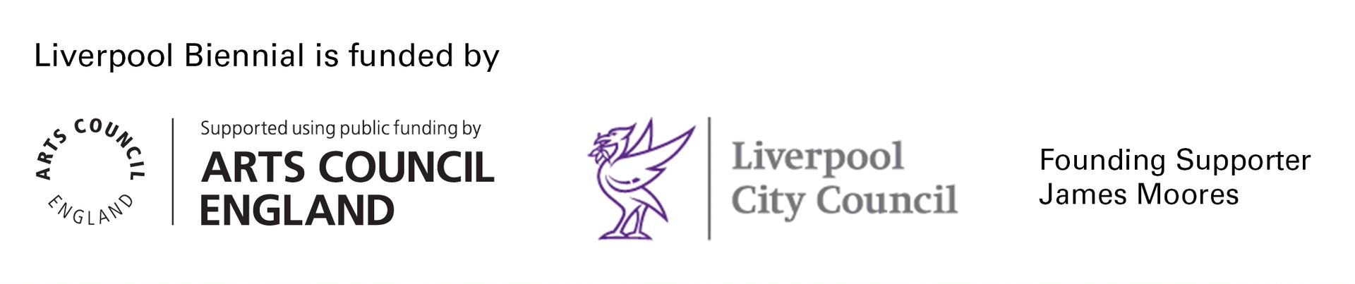
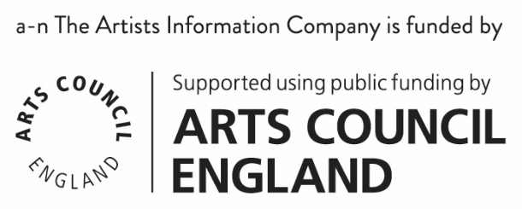

For further press information or images please contact:
Susie Gault, Press & PR Advisor, Liverpool Biennial: susie@biennial.com or 0777 584 1206
Catharine Braithwaite: cat@we-r-lethal.com or 07947644110
Carlotta Dennis-Lovaglio, Scott & Co: carlotta@scott-andco.com

