Press Release
12 February 2019
NEW DIRECTOR OF LIVERPOOL BIENNIAL APPOINTED

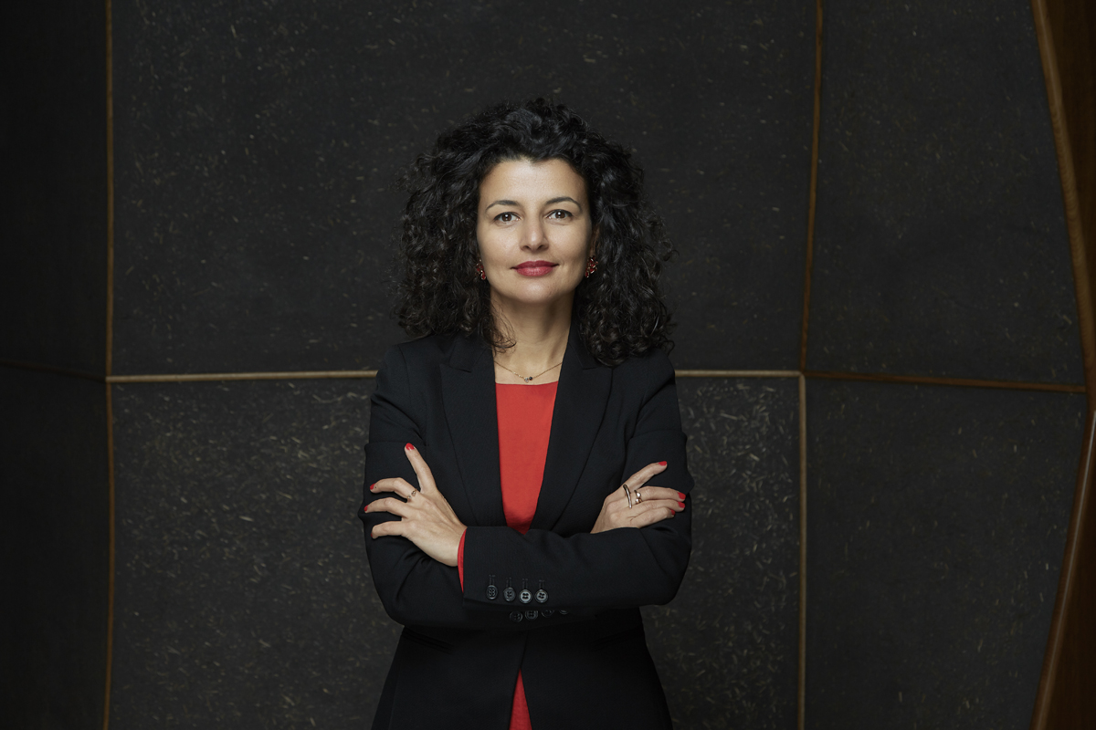

Fatoş Üstek. Photo credit: Christa Holka

The Trustees of Liverpool Biennial announced today that Fatoş Üstek has been appointed as the new Director of Liverpool Biennial. She will take up her position in May 2019.
Fatoş Üstek (b. 1980, Ankara, Turkey), curator and art writer, is regarded as one of the rising stars in the international art scene. Having been associate curator for the 10th Gwangju Biennale in South Korea in 2014, she went on to curate the internationally acclaimed fig-2, 50 projects in 50 weeks, in London the following year and then Art Night 2017 in East London. She is an external member of the Acquisitions Committee for the Arts Council Collection (2018-2020). Most recently she curated Do Ho Suh’s largest commission in the UK for Art Night and Sculpture in the City. She is currently Director and Chief Curator of the David Roberts Art Foundation.
Fatoş Üstek said: "I am thrilled to take up the role as Director of Liverpool Biennial. Through ten editions, Liverpool Biennial has gained a reputation for being one of the most important contemporary art events accessible to the large national and international public. I have been fortunate in my career to work with exceptional people and organisations including most recently the David Roberts Art Foundation, to whom I am immensely grateful. In my new role I will be taking Liverpool as my point of reference, while reflecting on current global discourses and developments in the international arena. I look forward to inviting everyone to join me and the Liverpool Biennial team in the city of Liverpool in 2020 for the 11th Biennial.”
Kathleen Soriano, Chair of the Board of Trustees of Liverpool Biennial, said: “Liverpool Biennial is delighted to be welcoming Fatoş Üstek as its new Director. Üstek’s rich experience across different art forms and her international connections will enable us to build confidently on the achievements of our two previous directors, Lewis Biggs and Sally Tallant. We are excited at the prospect of working with Üstek and are confident that she will lead with energy and artistic integrity on the delivery of future, ambitious biennials in Liverpool for our local, national and global audiences.”

-ENDS-
Press enquiries:
Joanne Karcheva, Liverpool Biennial, joanne@biennial.com +44 (0)151 203 3589
Jane Quinn, Bolton & Quinn, jq@boltonquinn.com +44 (0)20 7221 5000
High-resolution press image:
https://www.dropbox.com/s/o1mfvg12y7si9wz/Portrait%20of%20Fatos%20Ustek.%20Credit%20Christa%20Holka.jpg?dl=0
Fatoş Üstek (b. 1980, Ankara, Turkey) is currently Director and Chief Curator of the David Roberts Art Foundation. She is a recipient of a curatorial fellowship at Tornabuoni Art, London (2018). Amongst her notable projects is fig-2, 50 projects in 50 weeks (ICA Studio London), a revival of the legendary fig-1 that took place in 2000, which showcased 60 artists, 405 contributors, 50 openings and 148 collateral events throughout 2015. She was Curator of Art Night, East London (2017) in collaboration with Whitechapel Gallery which took over East London with 13 main venues and 60 collateral projects reaching out to 75,000 people. Most recently she was curator of Do Ho Suh’s largest commission in the UK co-commissioned by Art Night and Sculpture in the City (2018). She was associate curator for the 10th Gwangju Biennale in South Korea (2014).
Üstek is an external member of the Acquisitions Committee for the Arts Council Collection (2018-2020); contributing editor to Extra Extra; and chief juror for the Celeste Prize (2017). She is a founding member of the Association of Women in the Arts (AWITA); Art Night Trustee; member of Block Universe Advisory Board; member of AICA UK; and ICI Alumni. She is listed in the Apollo 40 under 40 Thinkers section in 2018; included in Evening Standard’s Progress 1000 London’s most influential people in 2018 and 2017; Artlyst Power 100 list 2018 and 2017; and nominated for ICI Gerrit Lansing Independent Curatorial Vision Award in 2016.
Amongst her international curatorial projects are Now Expanded, an exhibition trilogy that took place at Kunstfabrik, Berlin (2007); Tent, Rotterdam (2009); and DRAFT, London (2012). She is founding editor of Nowiswere Contemporary Art Magazine (with Veronika Hauer); editor of Unexpected Encounters Situations of Contemporary Art and Architecture published by Zorlu Centre, Istanbul (2012); and author of Book of Confusions published by Rossi & Rossi London (2012).
She received her MA at the Contemporary Art Theory Department at Goldsmiths College London, after completing her BA in Mathematics at Bogazici University in Istanbul, where she also gained a degree in Film Studies.
Liverpool Biennial
Founded in 1998, Liverpool Biennial is the UK biennial of contemporary art and commissions artists to make and present work in the context of Liverpool. It takes place every two years across the city in public spaces, galleries, museums and online. Amongst the partner organisations are Tate Liverpool, FACT, Bluecoat, National Museums Liverpool and Liverpool John Moores University. The Biennial is underpinned by a programme of research, education, residencies and commissions. Since 1998, Liverpool Biennial has commissioned over 340 new artworks and presented work by more than 480 artists. The 11th edition of Liverpool Biennial will take place from 11 July to 25 October 2020, with guest curator Manuela Moscoso. www.biennial.com

