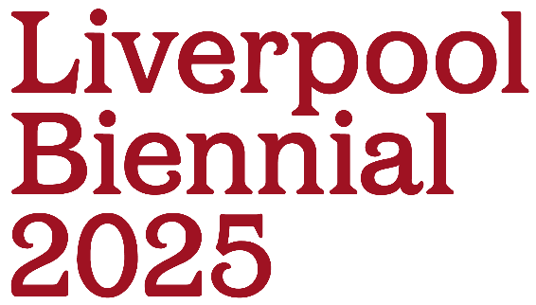

Wayfinding Guide:
How to find your way around Liverpool Biennial 2025

Liverpool Biennial 2025: ‘BEDROCK’
7 June – 14 September 2025
Contents
This wayfinding guide is a very long document so that we can provide you with information about each venue and what to expect during your visit.

You can jump to pages you need using the links in the following list of contents:

Finding Us |  | 3
Addresses and What3Words codes |  | 5
Opening Times |  | 7
Found Venues |  | 8
 | Pine Court | 9
 | Black-E | 15
 | SEVENSTORE | 19
 | 20 Jordan Street | 22
Outdoor Artworks |  | 28
 | Eurochemist: Anna Gonzalez Noguchi | 28
 | Berry Street: Kara Chin | 30
 | Liverpool ONE: Alice Rekab | 31
 | Mann Island: Anna Gonzalez Noguchi | 33
 | LJMU Art and Design Building: Isabel Nolan | 35
 | The Oratory: Petros Moris | 37
Galleries and Museums |  | 40
 | Bluecoat | 40
 | FACT Liverpool | 46
 | Open Eye Gallery | 50
 | Tate Liverpool + RIBA North | 52
 | Liverpool Cathedral | 56
 | Liverpool Central Library | 60
 | Walker Art Gallery | 62
 | Crosby Library | 67
Contact |  | 70

Finding Us

What3Words

A useful tool we’ve found is What3Words, this is an app that will help you find the location of the Liverpool Biennial venues and public spaces. On the app, you can find precise locations by typing in a 3-word address that corresponds to the exact location within an accuracy of 3 metres.

Download the app here: https://what3words.com/products/what3words-app

The What3Words addresses for each location are listed in the tables below and also as part of the venue information in this guide.

By Bus

There are many bus services serving Liverpool city centre stopping across the centre and at Liverpool One and Queens Square bus stations. Check the Merseytravel website for details of local bus services.

By Train

Liverpool Lime Street station, Liverpool's mainline railway station, is in the centre of Liverpool. You can find out more information about the station and services to and from Liverpool here: https://www.networkrail.co.uk/communities/passengers/our-stations/liverpool-lime-street/

Moorfields station is the local station nearest to Liverpool One and the Museum Quarter. James Street station is the station nearest to The Waterfront. Liverpool Central Station is nearest to China Town and the Ropewalks district. Check the Merseyrail website for details of local rail services.

Parking

If you are travelling by car there is more information about accessible parking in Liverpool on the Liverpool City Council Website:

https://liverpool.gov.uk/parking-roads-and-travel/find-parking/on-street-parking-bays/blue-badge-disabled-spaces/

The nearest accessible parking for each venue is listed alongside venue information throughout this guide.

Toilets

All of our venues have access to toilets and accessible toilets.

There are Changing Places facilities available at Liverpool One Shopping Centre, Liverpool Philharmonic Hall, Everyman Theatre, Museum of Liverpool, World Museum, St George's Hall and Merseyside Maritime Museum.

More information can be found here: https://www.changing-places.org/

Exhibition Venues

For Liverpool Biennial 2025, there are 12 venues and 6 public spaces where artworks will be shown around the city.

Within the 12 venues, we have 4 ‘found venues’ which are non-gallery spaces. The other venues will be galleries, museums and other notable buildings

Admission to ALL Liverpool Biennial exhibitions is free and you do not need a ticket to enter.

All of our venues have step-free access. Some have lifts to higher floors. The venue information in this guide provides you with details about accessing our found venues.

Assistance animals are welcome at all our venues. Our partner venues have access information on their websites with any additional information regarding assistance animals.

Addresses and What3Words codes

Liverpool Biennial venues:

These venues are existing galleries and museums in the city

Venues | Address | What3Words code
Bluecoat | School Lane, Liverpool, L1 3BX | ///point.clean.ruler
FACT Liverpool | 88 Wood St, Liverpool, L1 4DQ | ///prove.pirate.deeper
Open Eye Gallery | 19 Mann Island, Liverpool, L3 1BP | ///blaze.tile.twigs
Tate Liverpool + RIBA North | Mann Island, Liverpool L3 1BP | ///eggs.vows.fully
Liverpool Cathedral | St James’ Mount, Liverpool L1 7AZ | ///saints.catch.flies
Liverpool Central Library | William Brown Street, Liverpool L3 8EW | ///renew.finds.agrees
Walker Art Gallery | William Brown St, Liverpool L3 8EL | ///catch.body.starts
Crosby Library | Crosby Road North, Waterloo L22 0LQ | ///trail.splash.twins

Found Venues:

Our found venues are the unconventional spaces where we display artworks.

Found Venues | Address | What3Words code
Pine Court | 1 Nelson Street, Liverpool L1 5DW | ///ends.afford.solo
The Black-E | 1 Great George St, Liverpool L1 5EW | ///shared.punt.coins
20 Jordan Street | 20 Jordan Street, Liverpool L1 0BP | ///toward.admits.join
SEVENSTORE | 26 Norfolk Street, Liverpool L1 0BE | ///vibrate.pushy.maps

Outdoor Artworks:

Outdoor Artworks | Address | What3Words code
Eurochemist | 16-20 Berry St, Liverpool L1 4JF | ///cost.spice.thing
Liverpool ONE | Sugar House Steps, Thomas Steers Way, Liverpool L1 8LW | ///usual.filed.inspector
Mann Island | Mann Island, Liverpool, L3 1BP | ///admits.deals.drill
LJMU Art & Design Building | William Brown Street, L1 1JJ | ///branded.tones.horns
The Oratory | Upper Duke St, Cathedral Gate, Liverpool L1 7AZ | ///update.august.began

Opening Times

Venues | Days | Opening times
Bluecoat | Tuesday - Sunday | 11am – 5pm
FACT Liverpool | Wednesday - Sunday | 11am – 6pm
Open Eye Gallery | Tuesday - Sunday | 10am – 5pm
Tate Liverpool + RIBA North | Monday - Sunday | 10am – 5.50pm
Liverpool Cathedral | Monday - Sunday | 10am – 6pm
Liverpool Central Library | Monday - Saturday | Mon – Fri: 9am – 8pm  Saturday: 9am – 5pm
Walker Art Gallery | Tuesday - Sunday | 10am – 5pm
Crosby Library | Monday - Saturday | Mon – Fri: 10am – 5pm  Saturday: 10am – 2pm
Pine Court | Wednesday - Sunday | 11am – 6pm
The Black-E | Wednesday - Sunday | 11am – 6pm
20 Jordan Street | Wednesday - Sunday | 11am – 6pm
SEVENSTORE | Monday - Sunday | Mon - Sat: 10am – 6pm  Sunday: 11am – 5pm
Eurochemist | Monday - Friday | 9am – 6pm
Found Venues

These spaces are called our “found venues”. They are in parts of buildings that are not usually open to the public. Some of them are very old or have been empty for some time. These spaces can have uneven floors in places.

There will be Liverpool Biennial assistants (that we call “Festival Guides”) in these venues who will be able to help you navigate the spaces if you need assistance.

Anyone with this uniform or lanyard can assist you in the space:

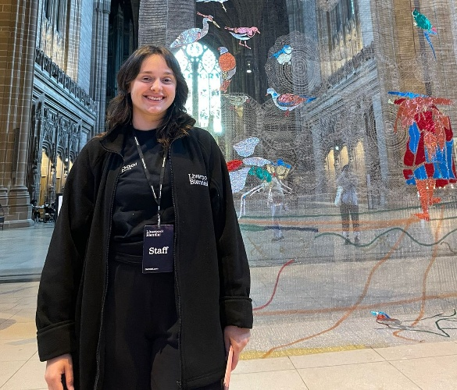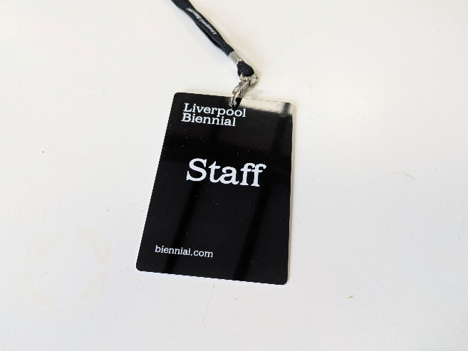

Pine Court

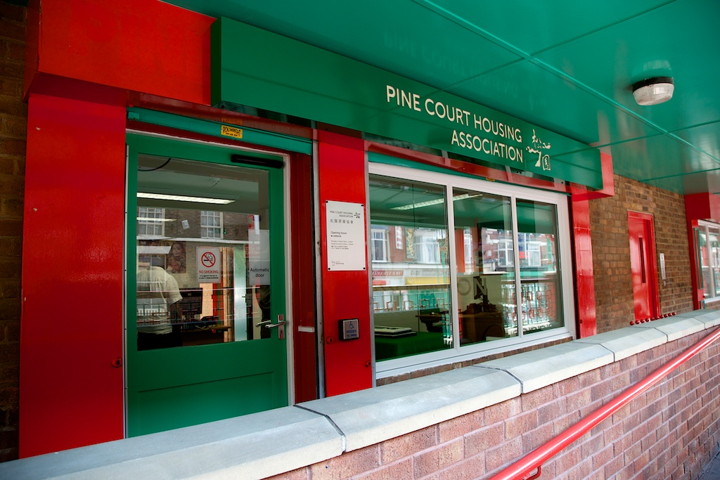

Liverpool Biennial 2025 marks the return of the festival to Chinatown, at a point when the area is celebrating the past and looking ahead to the future.

Both artists at Pine Court explore East and Southeast Asian identity within Western contexts.

What3words: ///ends.afford.solo

Parking

The nearest places to park are 33 on-street parking spaces on Nelson Street. These places are pay and display. Blue badge holders might be able to park in these spaces for free, but must register their blue badge with the parking management company APCOA.

More information is available here: https://www.apcoa.co.uk/parking-products/parking-products/blue-badge-parking/

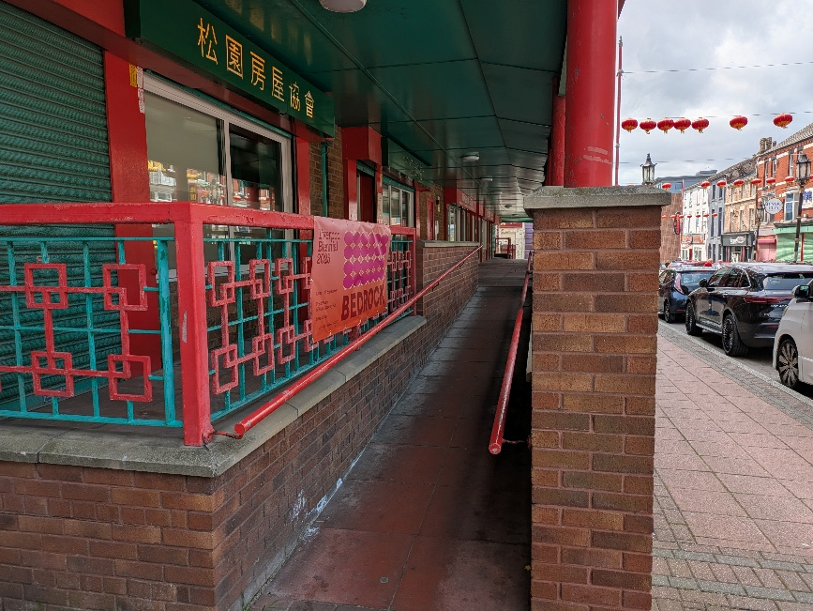 | There is a ramp to access the entrance to Pine Court.

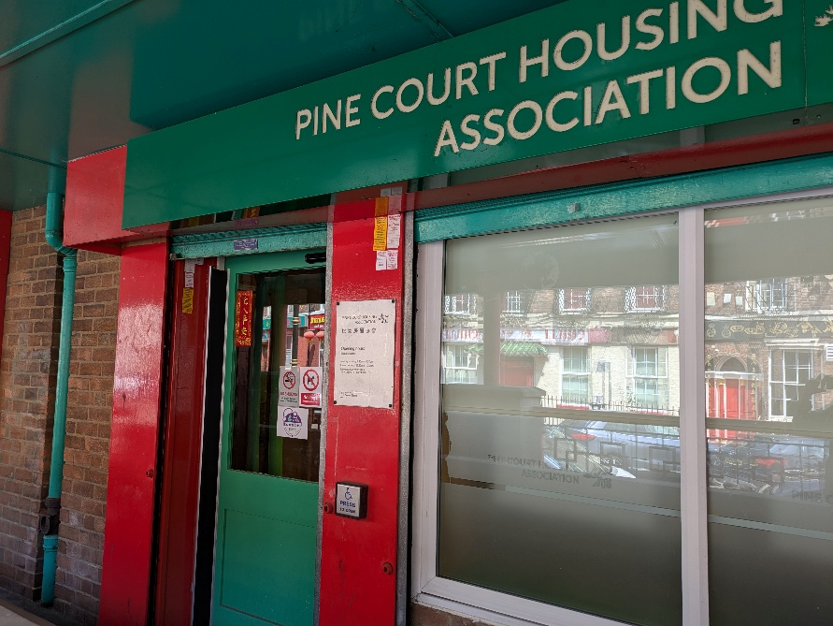
The entrance door opens inwards.

You can exit the building using the same door used to enter it.

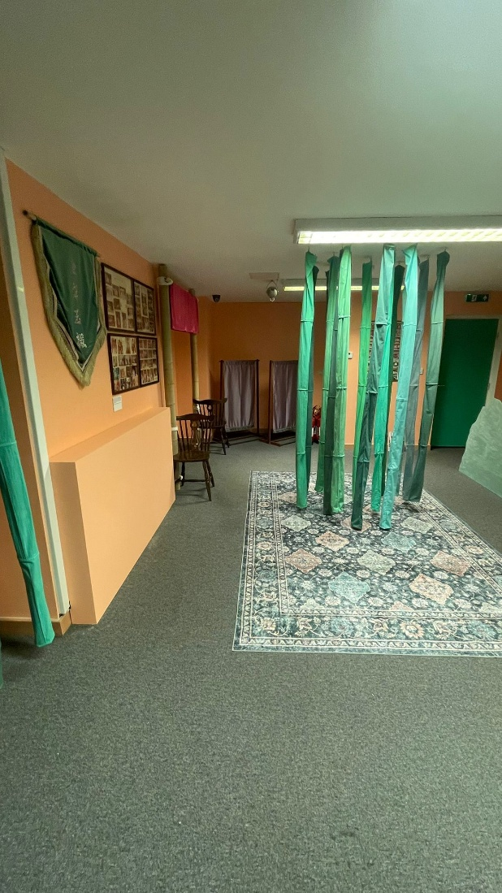
When you enter the space, you will see the beginning of Karen Tam’s installation hanging from the ceiling. The flooring is carpet.

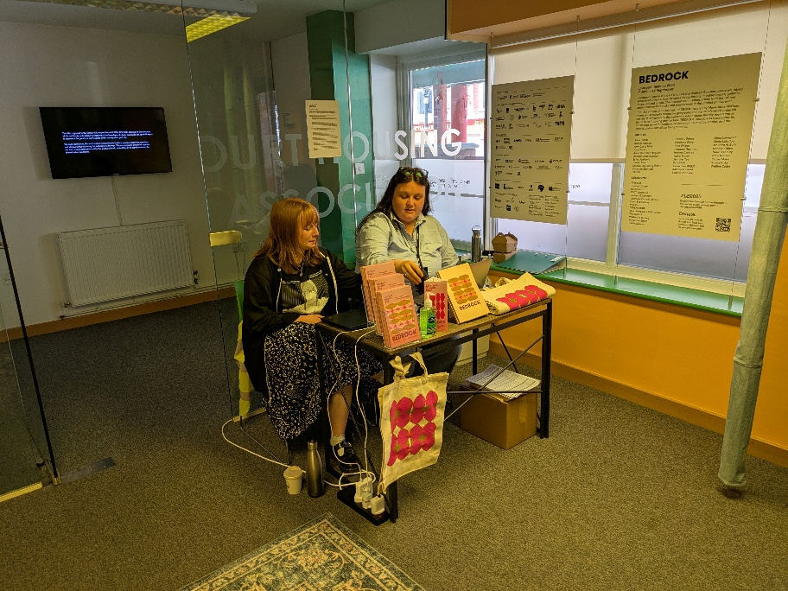
On your right will be a welcome desk, staffed by Festival Guides, who will be able to assist with information about the art works. Information about the venues and exhibitions will be displayed to the right of the welcome desk in the window space.

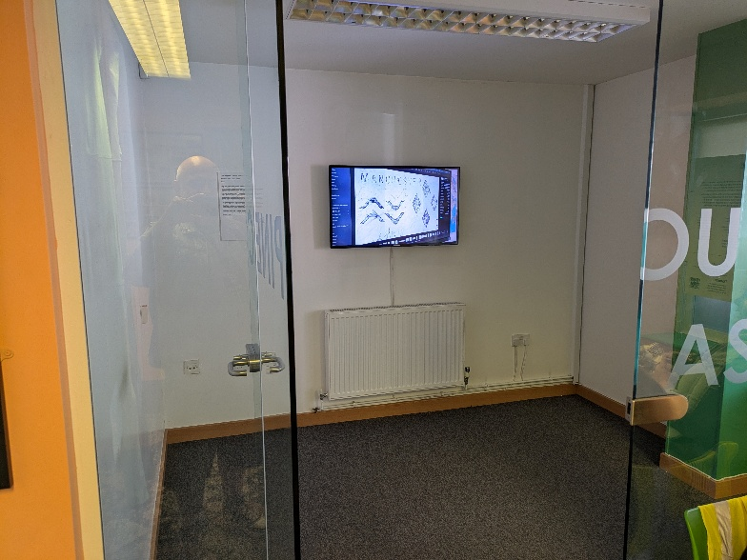
To the left of the welcome desk you will find the entrance to ChiChung Chang’s space showing a film about the creation of his outdoor artwork on Nelson Street.

To your left will be the main entry point to Karen Tam’s installation.

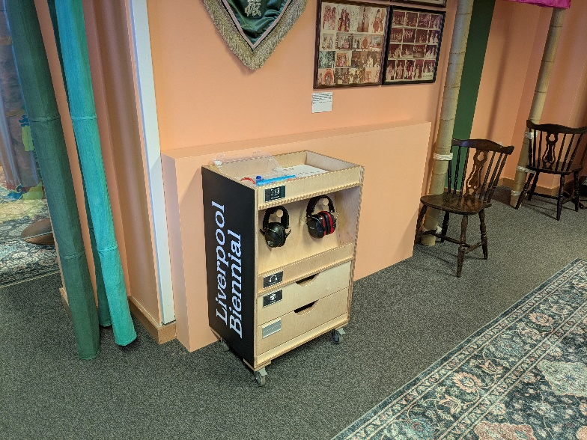
Against the wall to your left will be one of our access stations where you can pick up large print information about the exhibitions and borrow ear defenders, stim toys and examples of some of the materials in the installation for handling along with other information. Our Festival Guides will be able to help you with any questions.

Toilets

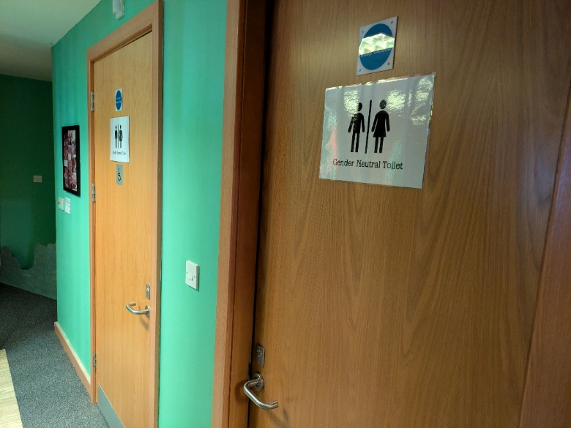
To the right of Karen Tam’s installation is the entrance to a narrow corridor where you will find the two toilets. They are gender neutral. One of the toilets is accessible. The doors open outwards. The accessible toilet may need power assist wheelchair users to remove front power assist attachments to access the toilet space comfortably.

Artists in Pine Court
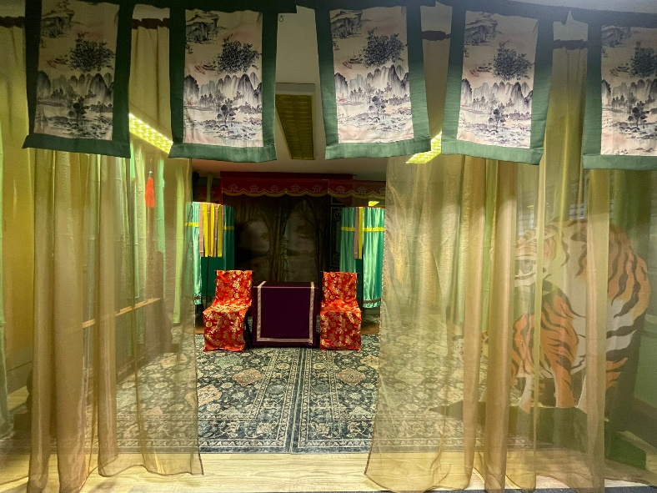

Karen Tam 譚嘉文

This artwork includes sound played aloud in the space

The artwork by Karen Tam is titled ‘Scent of Thunderbolts 雷霆之息’ (2024)

It is an installation incorporating many materials and props that recreates a Cantonese opera stage
Visitors are invited to walk across the stage and explore the space, finding their way between room dividers and a variety of printed backdrops.

You can sit on the benches and chairs and take photographs.

You can hear a description of the installation made by the artist by visiting the artist’s page here.

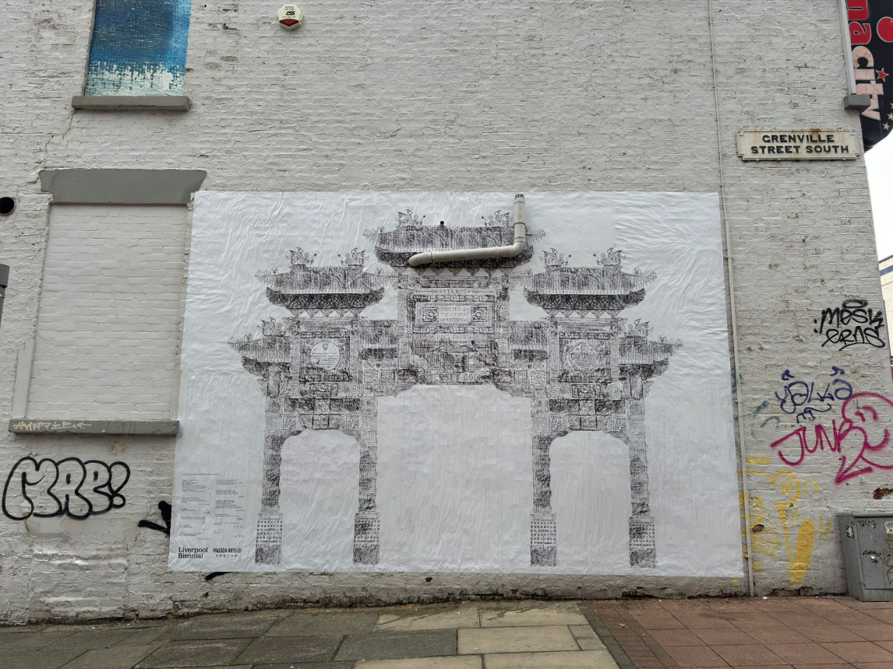

ChihChung Chang 張致中

The artwork in this space is a new film that documents the artist’s process of creating a temporary and collaborative public artwork for Liverpool, which can be seen on the wall of China City restaurant, a 2-minute walk from here along Nelson Street.

The final work is a mural which reflects the shape of Liverpool’s Imperial Arch – standing at 44 feet tall, it is the largest Chinese arch outside of China and features over 200 dragons. The arch was a gift from Shanghai to celebrate the twinning of cities 25 years ago in the year 2000. The mural composes images, text, signatures, and charcoal rubbings contributed from local people, combined with the artist’s own rubbings taken from across the city.

The Black-E

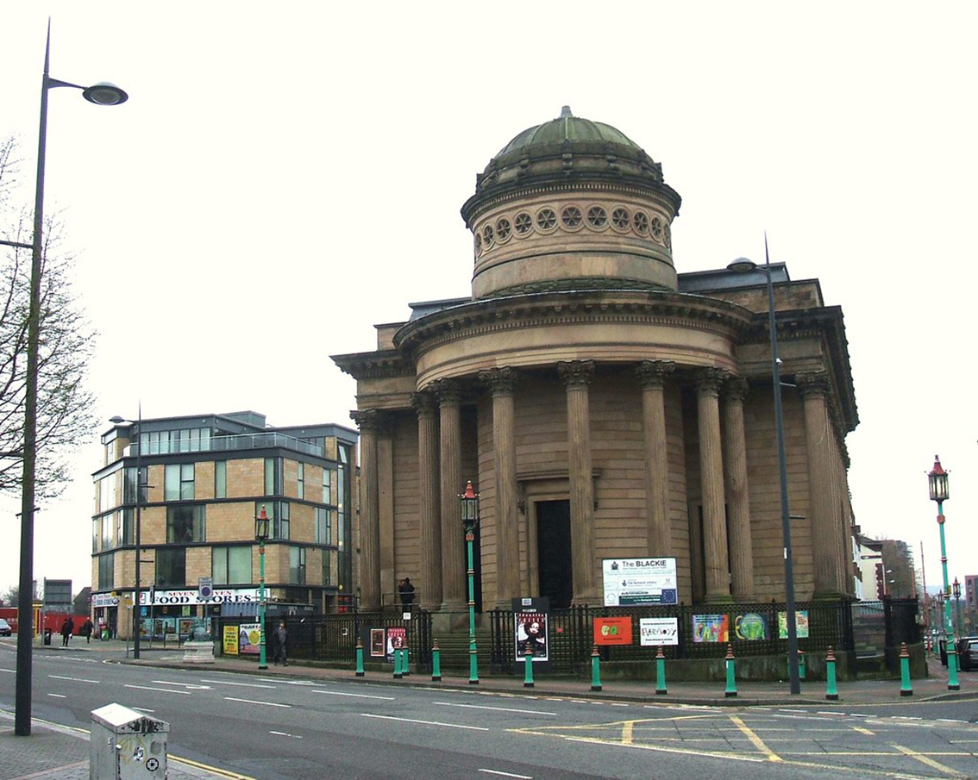

At The Black-E, Liverpool’s pioneering arts and community centre, the artist presents a major film, which centres on the architectural history of catholic modernist churches in post-war Britain.

What3words: ///shared.punt.coins

Parking

The nearest places to park are 33 on-street parking spaces on Nelson Street.

Theses paces are pay and display and run by APCOA. Blue badge holders might be able to park in these spaces for free but must register their blue badge with the parking management company APCOA. More information is available here: https://www.apcoa.co.uk/parking-products/parking-products/blue-badge-parking/

There is more information about access at The Black-E on the organisation’s website here: https://www.theblack-e.org/the-black-e-facilities/the-black-e-accessibility/

There is an accessible toilet at the venue. Our Festival Guides will be able to guide you on request.

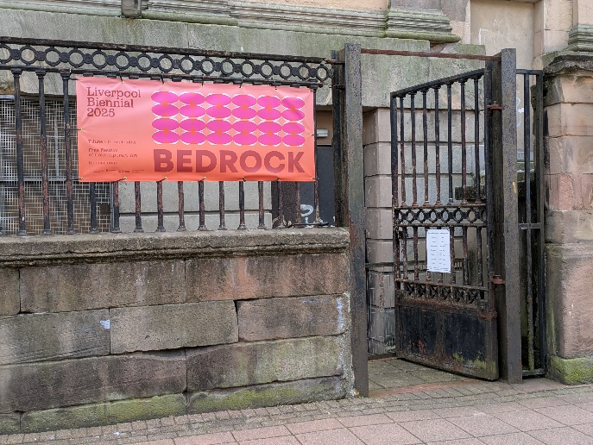
The Liverpool Biennial entrance to The Black-E is located on Nelson Street.

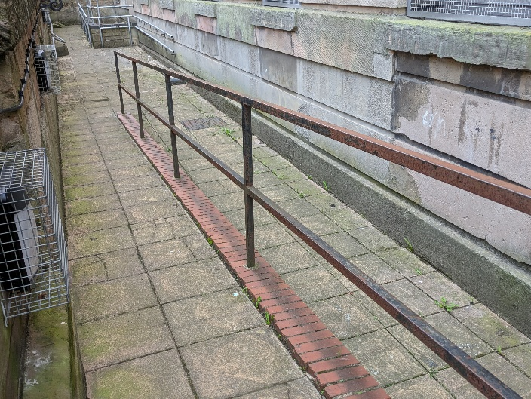
The route into the building is via a ramp leading down to the doorway.

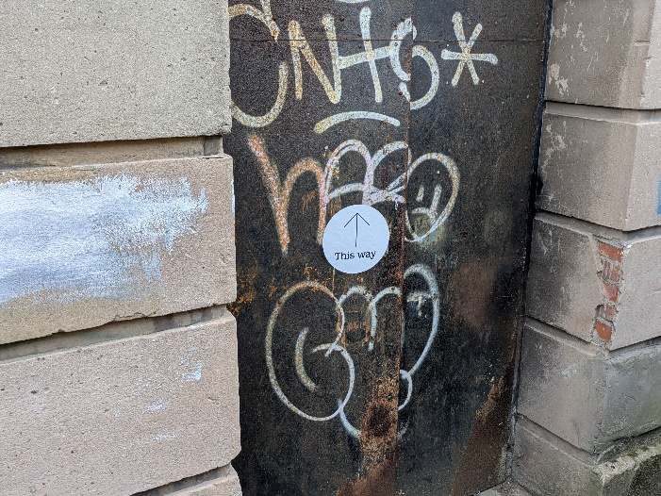

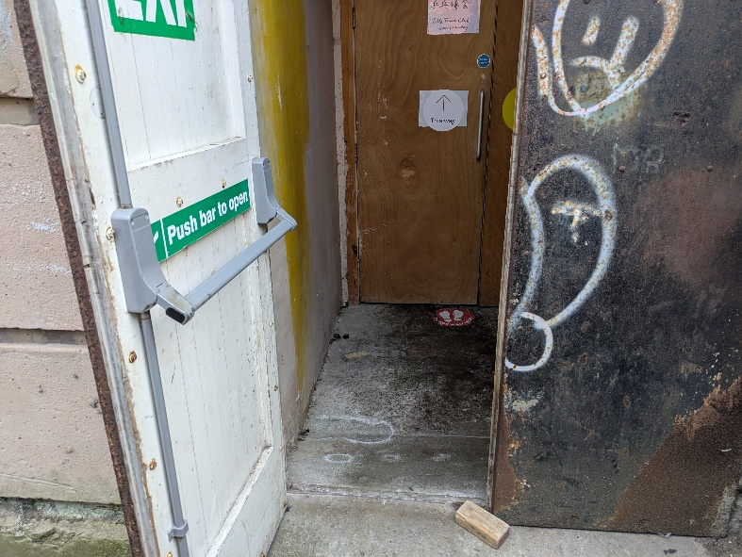
There is a slightly steep ramp inside the door to access the space.

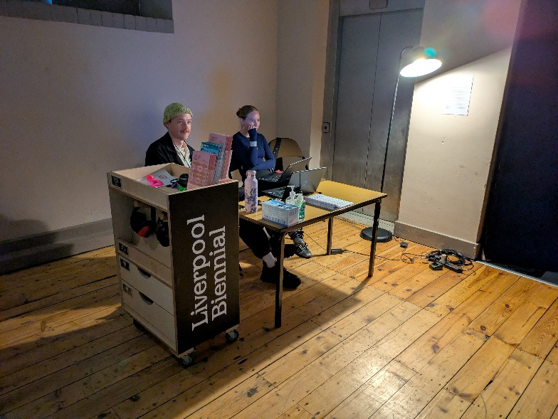
As you enter turn left into the welcome space where you will find our welcome desk and Festival Guides. They can provide you with more information about the film and assist you with any questions.

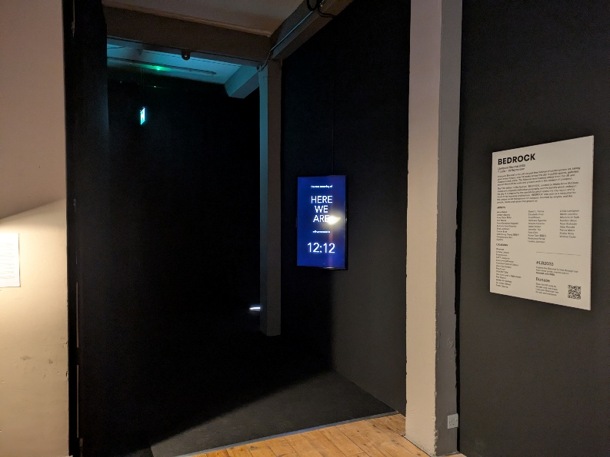
The space where the film is shown will be dark and is accessed by a corridor that is curtained off to shut off the outside light. There is low lighting to guide you to the main space. The flooring is carpet.

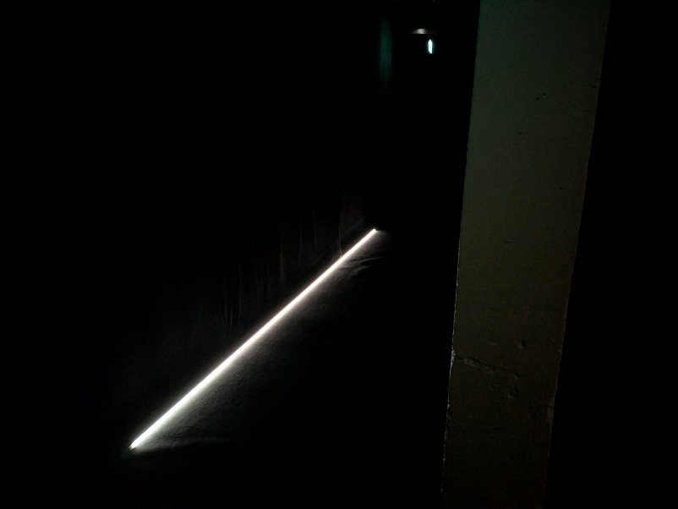

Artist in The Black-E
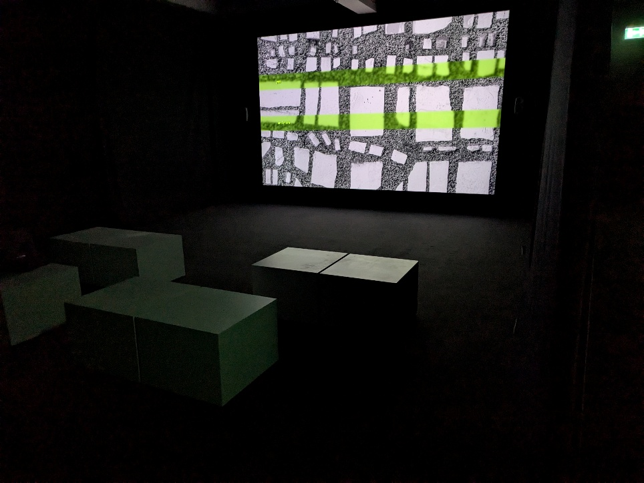

Elizabeth Price

‘HERE WE ARE’ (2024)
Digital film, single projection, monitor

Presented for the first time at Liverpool Biennial 2025, this major new single-channel film by Turner-Prize winning artist Elizabeth Price centres on the architectural history of Catholic Modernist churches in post-war Britain.

The space will be dark with very low lighting.

The film includes text over the images and loud sound.
SEVENSTORE

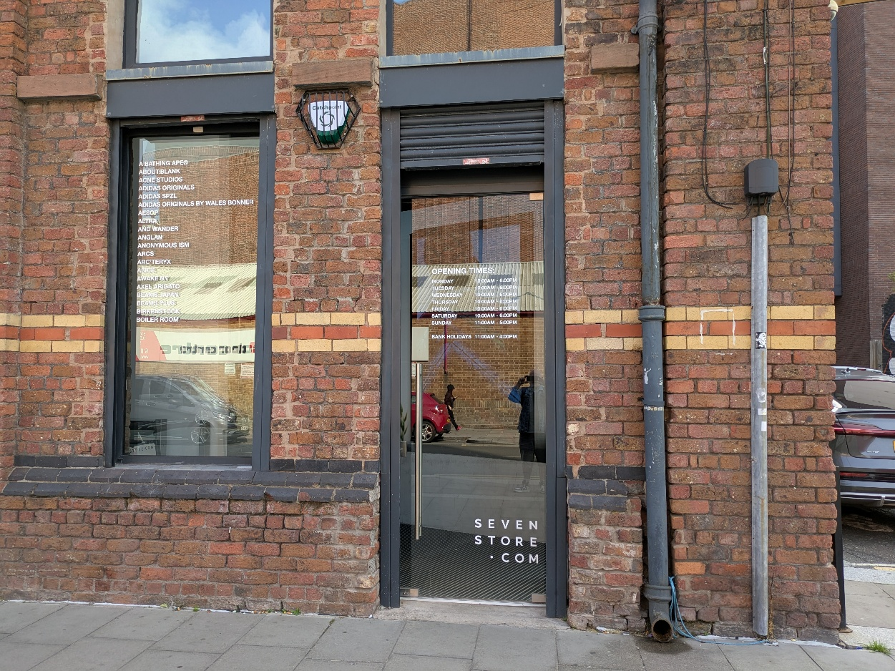

SEVENSTORE is a fashion retailer placing globally recognised fashion houses next to emerging talents – telling stories from Paris, Tokyo and London to the streets of Liverpool, unified by a need for expression and our connected, global culture.

You can view the artwork located here on Monday to Saturday from 10am-6pm and on Sunday from 11am-5pm.

SEVENSTORE is located on Jamaica Street.

What3words: ///vibrate.pushy.maps

Parking

The nearest car park is Jamaica Street Car Park L1 0AN.
The nearest on-street Blue Badge spaces are on Greenland Street and St James Street.

This venue has no Liverpool Biennial Festival Guides in the space but staff from the store will be able to assist you to locate the artwork.

There are two entrances. Inside the entrance to the left of the store there is a set of five steps leading to the area where the artwork is displayed. The artwork is located within the display of footwear to the left.

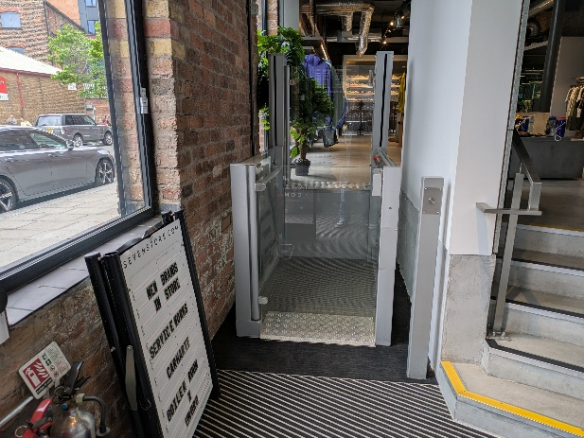
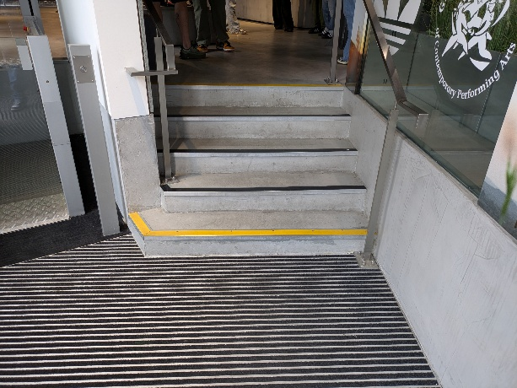
Inside the entrance on the right there is access to a set of 5 steps and a platform lift to the floor where the artwork is displayed. You will need to move across the store to the far wall where there is a display of footwear.

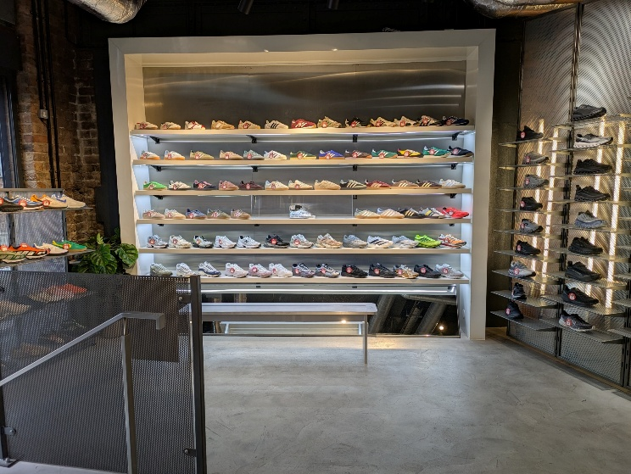
The work is displayed in the centre of the third shelf up from the bottom.

Artist in SEVENSTORE

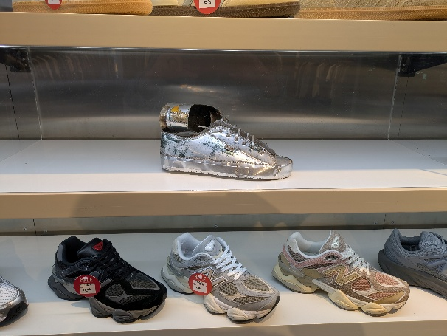

Odur Ronald

‘No Hurry’ (2020)

Odur Ronald uses aluminium printing plates to explore ideas of free movement, migration, access, belonging and identity. The material has always been important to Ronald, ever since he was child when he would collect scrap metal to sell for extra pocket money to buy toys.

'No Hurry' was made during an art residency at Silhouette Projects in Kampala, Uganda, during which Ronald reimagined and recreated objects which he interacted with and which he felt were important to him in his daily life. The work is based on a memory the artist has of his friend turning up to meet him at the airport in battered old trainers. The artist presents the work as a playful anecdote, claiming that his friends and, more generally, other Ugandans, would usually rather arrive late than sacrifice looking good.

20 Jordan Street

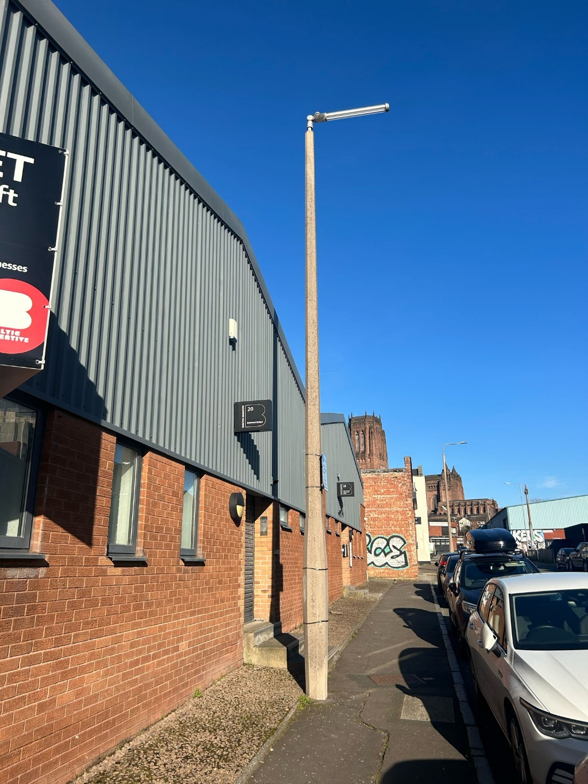

20 Jordan Street is managed by Baltic Creative CIC who provide bespoke property lettings, management and development for the creative and digital sector.
The artists at 20 Jordan Street explore foundational references from the city including football stadia and naturally occurring materials such as plants and clay.

What3 words:
Jordan Street Entrance (three steps): ///toward.admits.join
Brick Street Entrance (accessible): ///unable.agent.island

Parking

The nearest car park is Jamaica Street Car Park L1 0AN.
The nearest on-street Blue Badge spaces are on Greenland Street and St James Street.
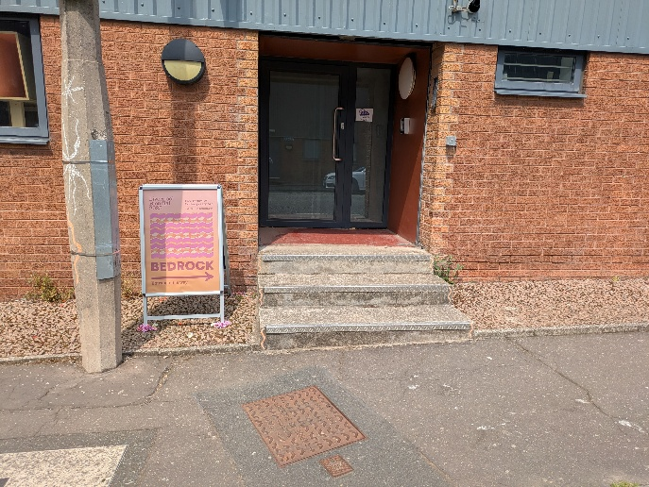
The entrance on Jordan Street has three steps leading to the door.

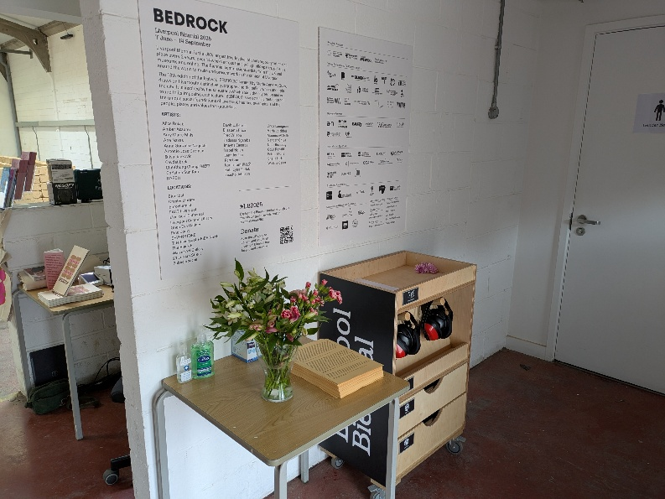
Inside this entrance there is information about the artworks in this venue on the wall in front of you and slightly to the right.

Here, you will find an access station where you can pick up large print information about the exhibitions and borrow ear defenders and stim toys. Our Festival Guides will be able to help you with any questions.

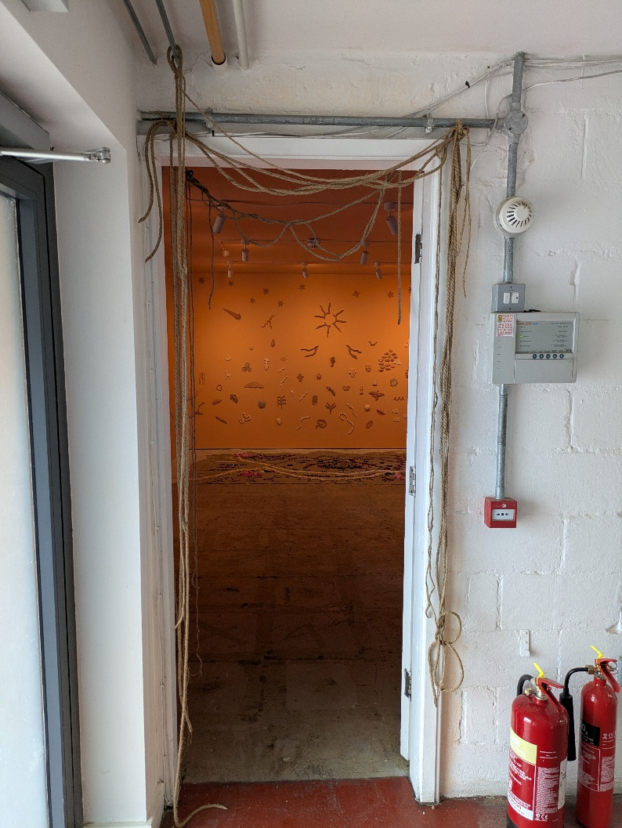
On your left you will find the entrance to the installation by Imayna Cacares.

Brick Street Entrance (Step Free Access)
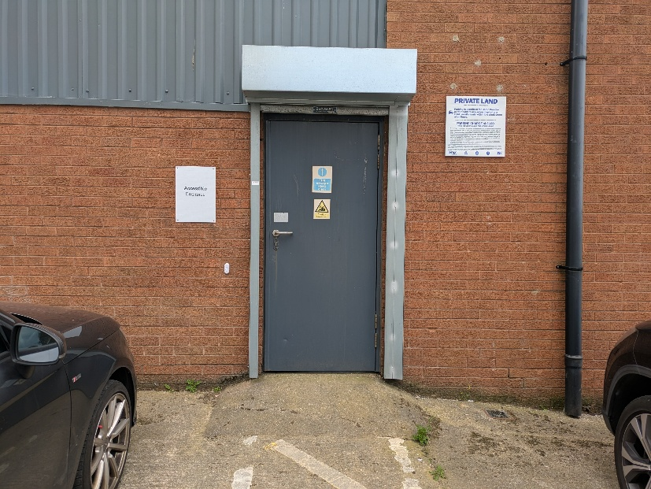
The entrance on Brick Street is the only step free access into the building.

This is through a door on the right-hand side at the back of the building. It is marked with a sign “Accessible Entrance”.

There is a doorbell on the left of the door to alert our festival guides for assistance.

This entrance has a steep ramp and wheelchair users may need assistance to navigate this.

Inside this entrance is the main room housing the installation by Cevdet Erek.

There is loud sound played as part of this artwork.

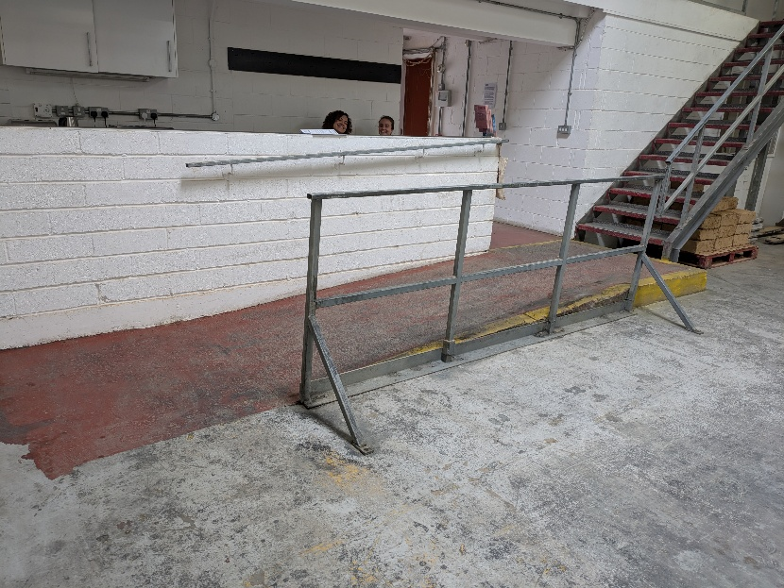
At the back of this room there is access to the upper level via a step or a ramp.

The upper level leads to the installation by Imayna Caceres, a welcome desk the access station and the toilets.

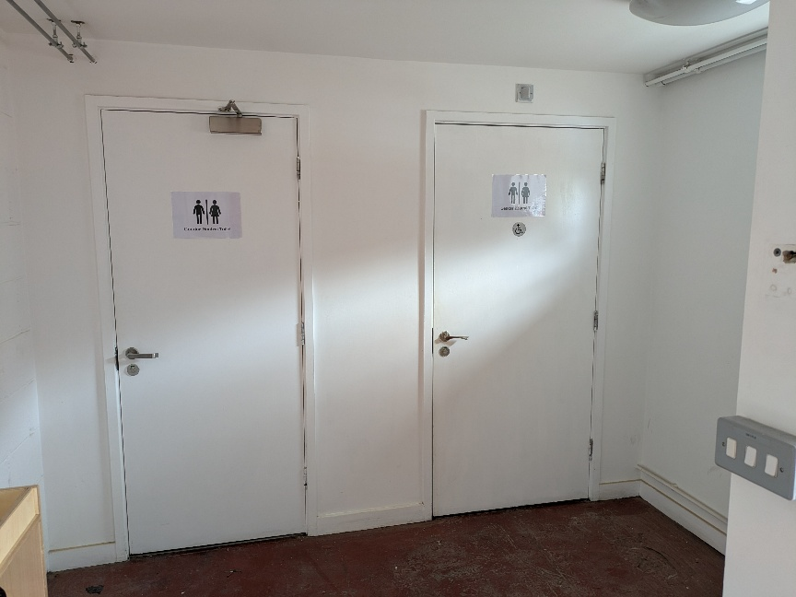
There are two toilets located on the upper level. They are gender neutral. One of the toilets is accessible.

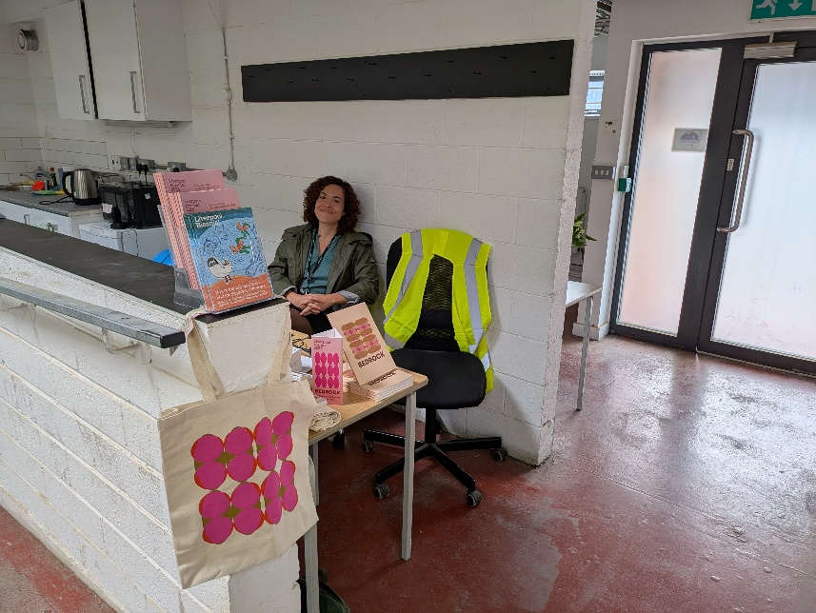
At our welcome desk our Festival Guides will be able to assist with information about the art works, access and other venues as part of Liverpool Biennial.

Artists in 20 Jordan Street

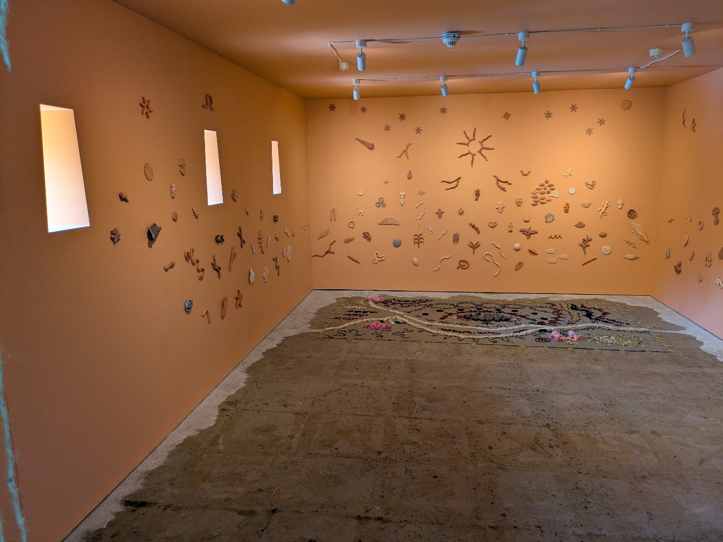

Imayna Caceres

‘Underground Flourishings’

Imayna Caceres is interested in how plant, animal and natural worlds are formed and shape one another.

In this new installation, Caceres adopts motifs from pre-Columbian cultures – such as Inca trapezoid windows and an ancestral ritual offering - that reference knowledge systems that are still practiced in Latin America today.

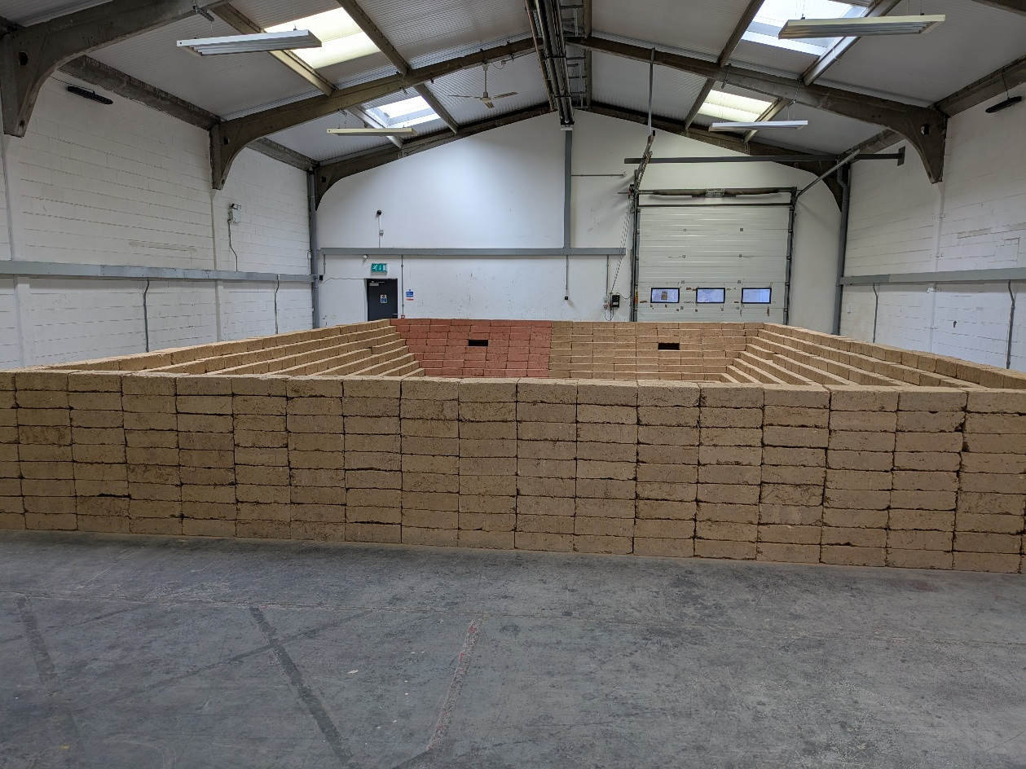

Cevdet Erek

‘Away Terrace (Us and Them)’

There is loud sound played as part of this artwork.

This new sculptural and audio installation is inspired by the atmosphere and layouts of football stadia. The structure is made from Earth Blocks, an organic and sustainable building material manufactured in the UK which uses only clay soil, barley straw and water.

This site-specific piece questions how football supporters’ culture and the spatial design of stadia can simultaneously connect us and divide us.

Outdoor Artworks

There are five artworks that are located in public spaces, most artworks can be accessed at any time throughout the Biennial.

Eurochemist – Anna Gonzalez Noguchi

Located on Berry Street near Chinatown, The Eurochemist is a local pharmacy with a strong reputation for its charitable work and close-knit patient community.

Serving the area for over 40 years, it is regarded by many as more of a community-focused health hub than a traditional pharmacy. The team, who are fluent in Cantonese and Mandarin, create a variety of vital health resources and support materials in multiple languages for the community.

What3words: ///cost.spice.thing

The artwork can be viewed through the window on the right-hand side of the shop front when the pharmacy is open between 9am & 6pm Monday to Friday.

Parking

There is pay and display parking located on Bold Place L1 9DN.
Blue badge holders can park in these bays free of charge, but you should check signs for restrictions.

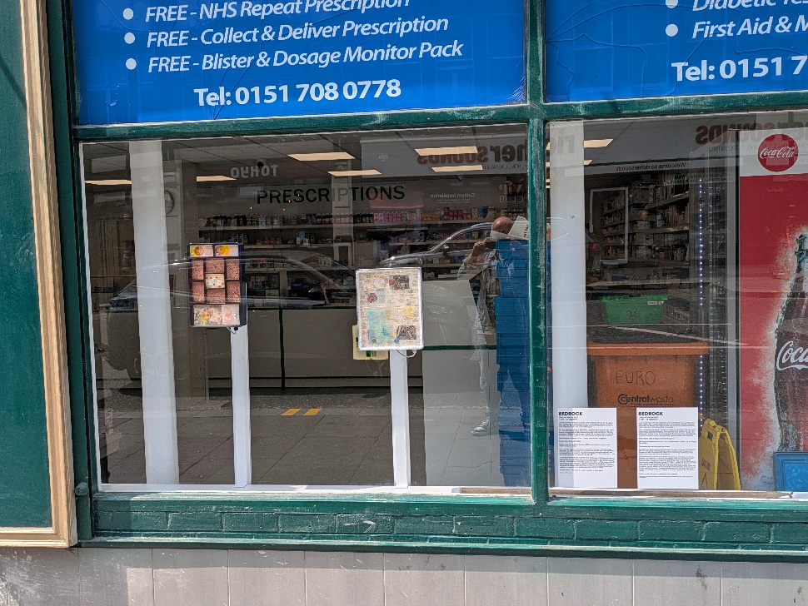

About the Artwork

Anna Gonzalez Noguchi

‘Comfort Cavity I’ (2023) & ‘Comfort Cavity II’ (2023)

Noguchi’s art practice is informed by her cross-cultural heritage, particularly her relationship with her Japanese grandparents, who often inspire the materials used. She attempts to preserve fragmented memories and experiences from her childhood as a way of identifying with her biography and heritage.

The artist combines machine and hand-made objects, some of which are found and some created new. She layers them on top of one another to give them new life and purpose, referencing how our memories can often change or take on new meaning over time. The works have a nostalgic quality, reminding us of both treasured family mementos and kitsch souvenirs.

Berry Street – Kara Chin

Located on Berry Street you will find four intricate ceramic tiles embedded into the pavement. These link to the installation by Kara Chin whose installation “Mapping the Wasteland” is located at FACT Liverpool on Wood Street.

What3words: ///remote.coats.young

Parking

There is pay and display parking located on Bold Place L1 9DN.
Blue badge holders can park in these bays free of charge but you should check signs for restrictions.

About the Artwork

Kara Chin

Mapping the Wasteland (trail) (2025)

Along Berry Street, the artist has installed a ‘breadcrumb trail’ of tiles set into the pavement for passers-by to discover. She refers to these intricate works as ‘litter fossils’ as they reference common sights and objects found in cities such as takeaway cartons, seagulls and other city detritus.

The trail of works links Liverpool Biennial 2025 venues, ultimately leading us to FACT Liverpool where Chin presents a new, interactive multimedia installation. Part of the same body of work, her installation at FACT explores rage, grief and nuisance through repeated motifs such as seagulls, parking meters, and the seemingly invasive Buddleia plant often found in cities including Liverpool.

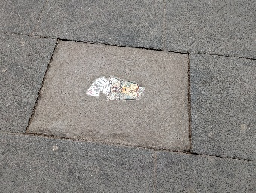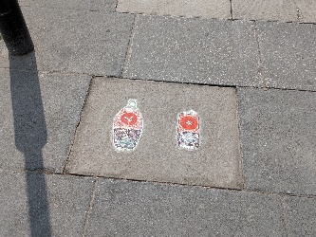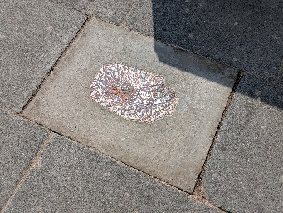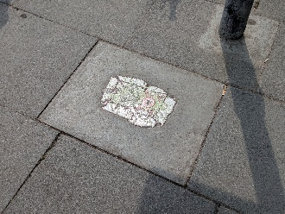

Liverpool ONE – Alice Rekab

Liverpool One is the shopping area in the centre of Liverpool. The artwork is located at the Sugar House Steps near to the John Lewis store and can be accessed at any time throughout the Biennial.

What3words: ///usual.filed.inspector

Parking

There are 3 car parks at Liverpool ONE with many accessible parking bays. Blue Badge holders still need to pay for car parking in the main car-parks

You can find more information about access at Liverpool ONE here: https://www.liverpool-one.com/accessibility/

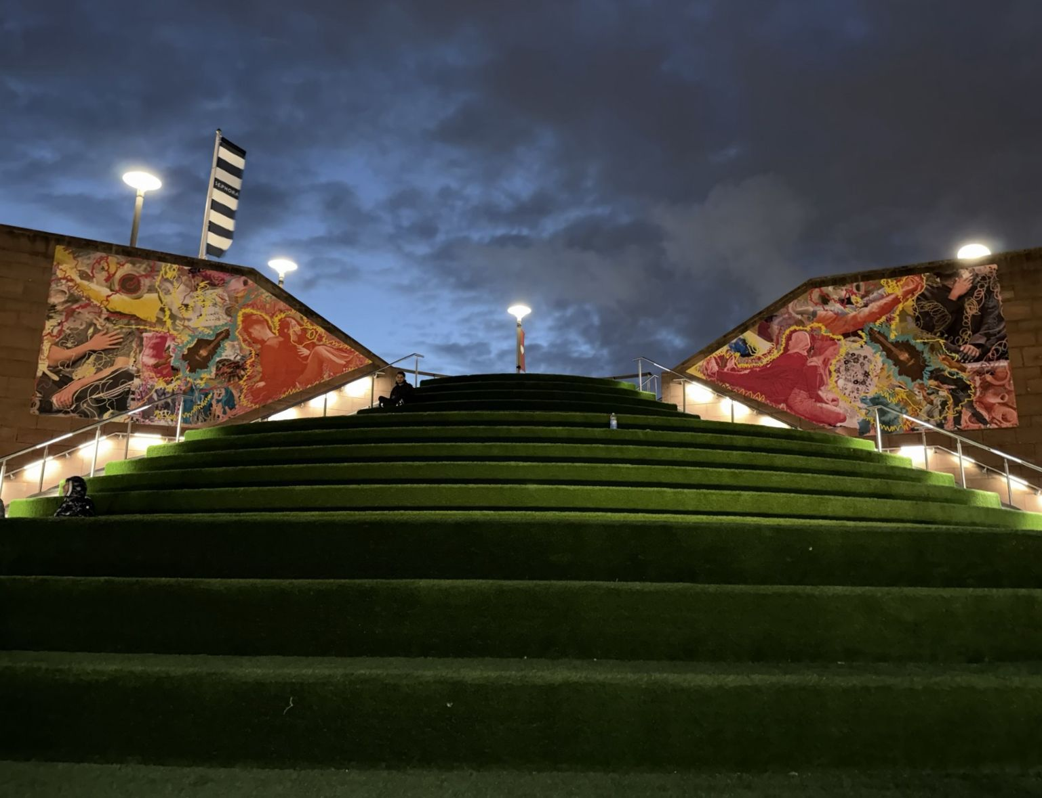

About the Artwork

Alice Rekab

Bunchlann/Buncharriag (2025)

The work is by Alice Rekab who presents a multi-city billboard project in Liverpool and Edinburgh.

To create this work, Alice Rekab collaborated with students from the City of
Liverpool College through a series of workshops which investigated and celebrated
notions of identity. Led by artists Tobi Balogun, Maïa Nunes and Aisling-Ór Ní
Aodha, the group – all of whom had personal or familial connections to migration –
shared stories about their heritage and culture through personal belongings, and
explored self-expression through the mediums of hip-hop dance, language and
voice.

The work is designed to be viewed from a distance and can be seen from the base of Sugar House Steps or from the first landing of the steps that can be accessed via a lift next to Starbucks Coffee Shop or via the Chavasse Park pathways.

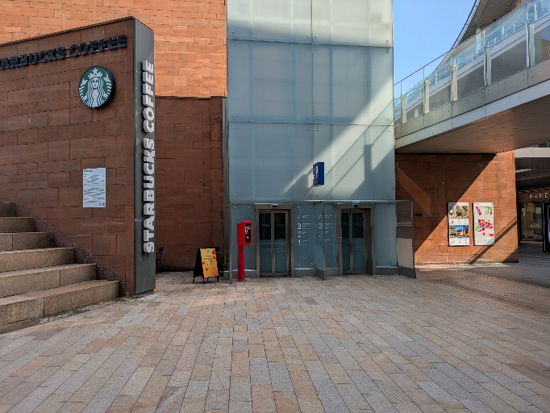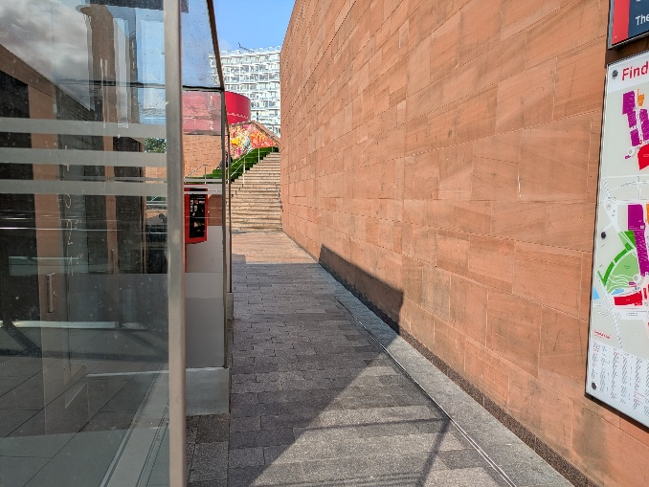

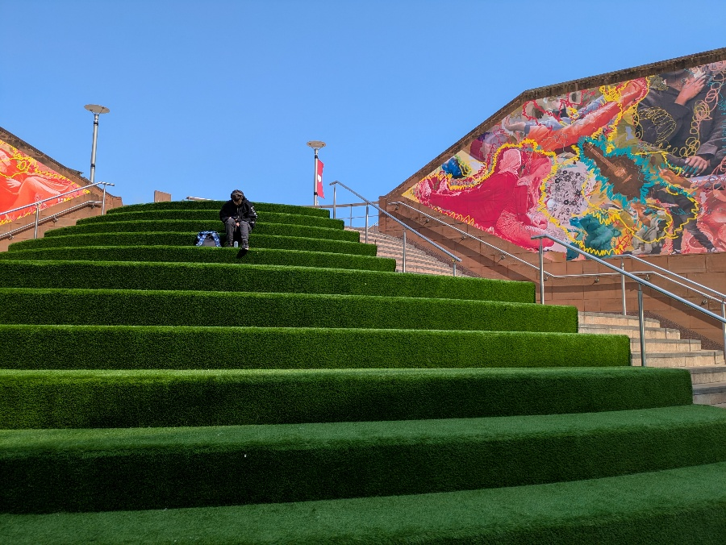
Mann Island - Anna Gonzalez Noguchi

The Mann Island development is a complex of three black buildings that sit between the Strand, the Canning Dock and the new Museum of Liverpool. The artwork located here is by Anna Gozalez Noguchi, and it is in the outdoor space near Tate + RIBA North and can be accessed at any time throughout the Biennial.

What3words: ///admits.deals.drill

Parking

On Mann Island, accessed from The Strand via Brunswick Street, there are a small number of on street parking spaces, paid for by a meter – there are also 4 designated parking spaces for Blue Badge Holders.

About the Artwork

Anna Gonzalez Noguchi, ‘Ecstatic Dispersal’ (2025)

Created specifically for this waterfront location, ‘Ecstatic Dispersal’ (2025) is a modular sculpture referencing Liverpool’s wind and water routes, which facilitated the historical import of ‘foreign’ plants into the UK. Plants from the city’s botanical archives, such as the Himalayan Balsam, are engraved onto the work. They were originally collected for ornamental or medicinal use, or for their ‘splendid invasiveness’ – the rapid and widespread growth of certain non-native plants.
From a distance, the work’s metallic surfaces can act like mirrors, causing the structure to flicker in natural light or camouflage into its surroundings
Incorporated into the work are benches on which visitors are invited to sit. The top of each seat features a cutout of the day of the week written in Japanese kanji characters. Through these cutouts, the work becomes a physical calendar, tracking days across different moments in time. By sitting alongside other visitors, we mimic the behaviour of plants, cross-pollinating with the work and each other.

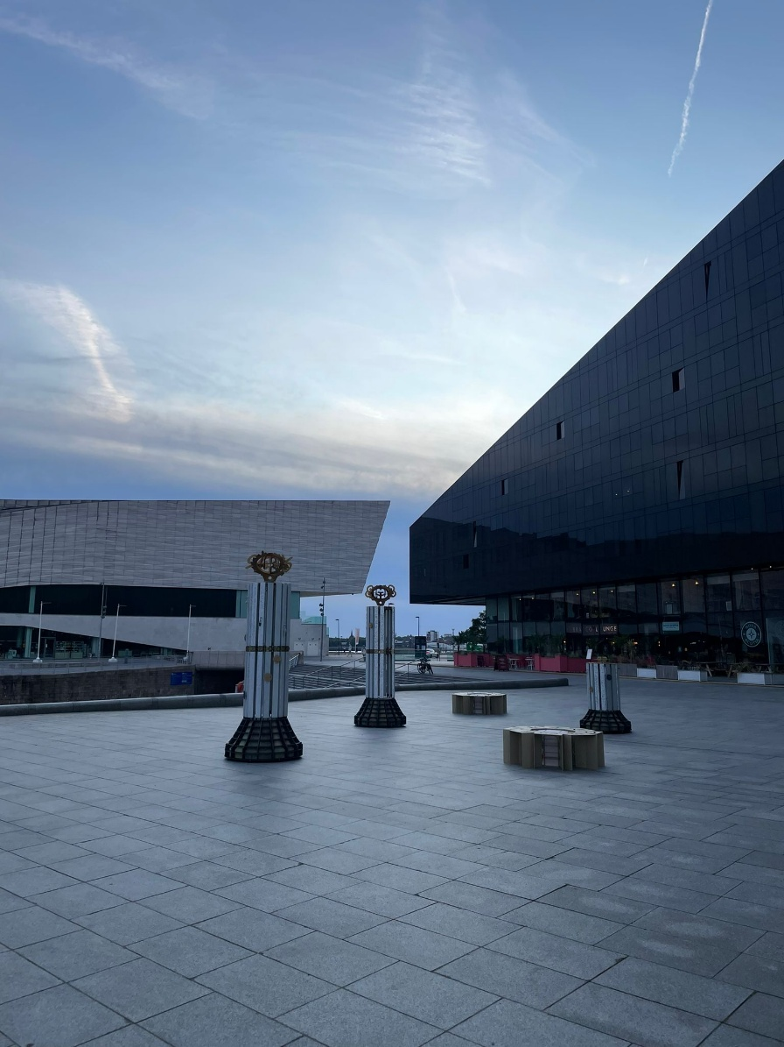

LJMU Art and Design Building – Isabel Nolan

The Liverpool John Moores University Art and Design Building is located behind Liverpool Metropolitan Catherdal and can be accessed via Great Orford Street from Mount Pleasant or via Duckinfield Street from Browlow Hill.

What3words: ///branded.tones.horns

Parking

The nearest pay and display parking is on Hope Street (parking meters) or at the NCP car park at the bottom of Mount Pleasant.

There are a limited number of disabled parking spaces on site via Great Orford Street.

The artwork is located on the lawn opposite the main entrance to the art and design building.

About the Artwork

Isabel Nolan, ‘Where you are, what we are, with others’ (2025)

Isabel Nolan draws inspiration from a diverse range of different sources to create her artwork, including religious relics, architectural plans, literary and historical figures, and human and animal behaviour.

This new public sculpture is based on plans for stained-glass windows found in local archives. The designs are inspired by two historic Liverpool Cathedrals – St Nicholas’ Pro-Cathedral and Lutyen’s Crypt at Liverpool Metropolitan Cathedral.
Built in 1813, St Nicholas’ stood on Copperas Hill and served as Liverpool’s Catholic Pro-Cathedral until 1967 – the upright section of Nolan’s work is loyal to the original tracery of the east window. The other half is geometric – reminiscent of the windows in Lutyen’s Crypt, which sits beneath the Metropolitan Cathedral.

Lying here on its side, the piece might evoke ideas of architectural ruins, yet the bright colours – a nod to stained glass and industrial steelwork palettes – suggest possibility and ambition.

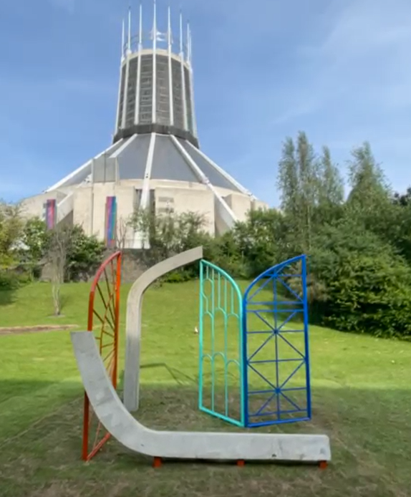

The Oratory – Petros Moris

The Oratory is located near to the front entrance of Liverpool Cathedral it was originbally the mortuary chapel for St James’ Cemetary. It was built in 1829 and used for funeral services before burials in the adjacent cemetery.

What3words: ///update.august.began

You can access The Oratory via Cathedral Gate or from Upper Duke Street.

Parking

There is limited onsite parking available on a first-come, first-served basis at Liverpool Cathedral. The first 30 minutes are free, after that, you pay for the time your car is in the car park. It is a pay-on-exit system car park.

The car park has eight designated bays for disabled parking.

Before you leave the Liverpool Cathedral car park, please pay at the payment machines. You’ll need to remember your vehicle registration number (number plate).
Enter your vehicle registration number into the payment machine. You can use coins, cards or contactless to pay for your parking.

We use an automatic number plate recognition (ANPR) system to calculate how long you have parked your car at Liverpool Cathedral.

The artworks stand in the grounds of The Oratory and can be viewed through the front gate. You will find the gate via the paved plaza in front of the Cathedral. This gate will not be open, but the artworks can be viewed through the railings.

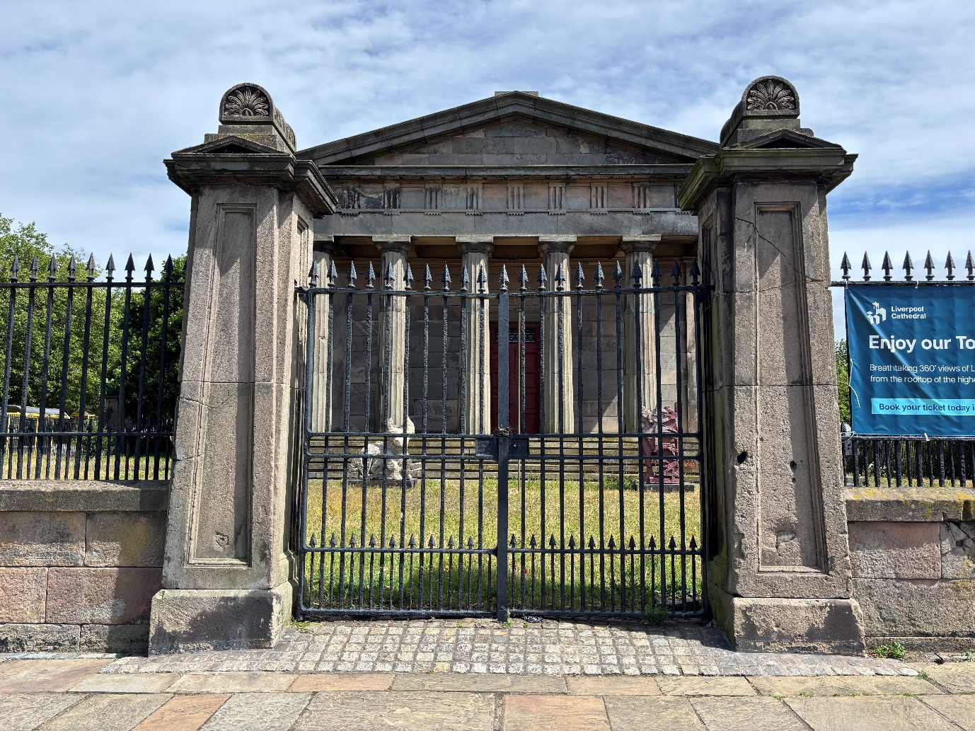
About the Artwork

Petros Moris ‘Ghost (ALONE) I, II, III, IV & V’ (2024)

Petros Moris explores how fragments of history can help us think differently about the future, transforming remnants of the past into symbols of renewal. The works exhibited here in at The Oratory are part of the artist’s ‘ALONE’ series of mosaic sculptures and reliefs.
The ‘ALONE’ project is inspired by a personal encounter which the artist had in an abandoned urban playground in his home city of Lamia, Greece – a site that was left unbuilt due to archaeological discoveries. Here he found a marble tile mosaic crafted by his parents in 1985 which had been painted over by a local graffiti artist with the word ‘ALONE’.
Created using a mixture of digital fabrication and traditional techniques, the hybrid shape and animalistic forms of these five sculptures combine and layer different attributes, including references to ancient artefacts which are exhibited in an archaeological museum in his hometown.

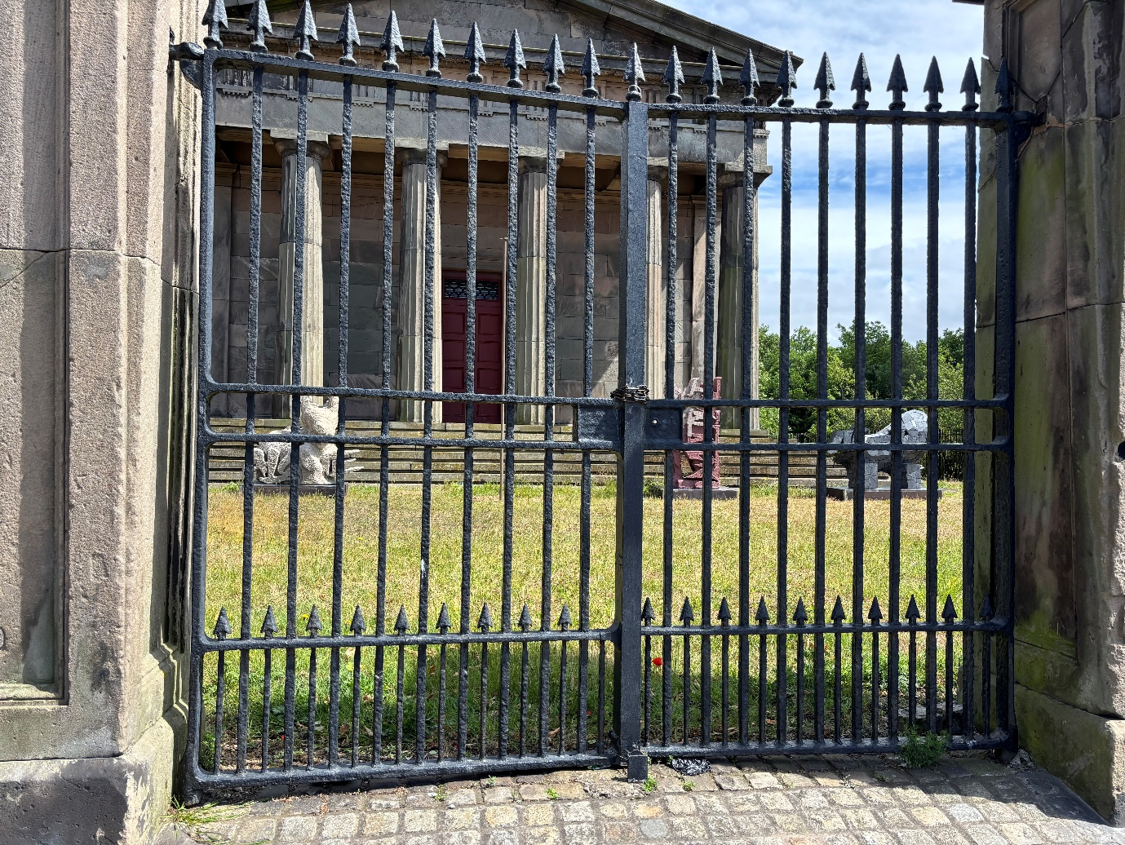
You can hear a description of the artworks made by the artist here.

Galleries and Museums

There are seven venues that are showing exhibitions as part of Liverpool Biennial.

The Bluecoat

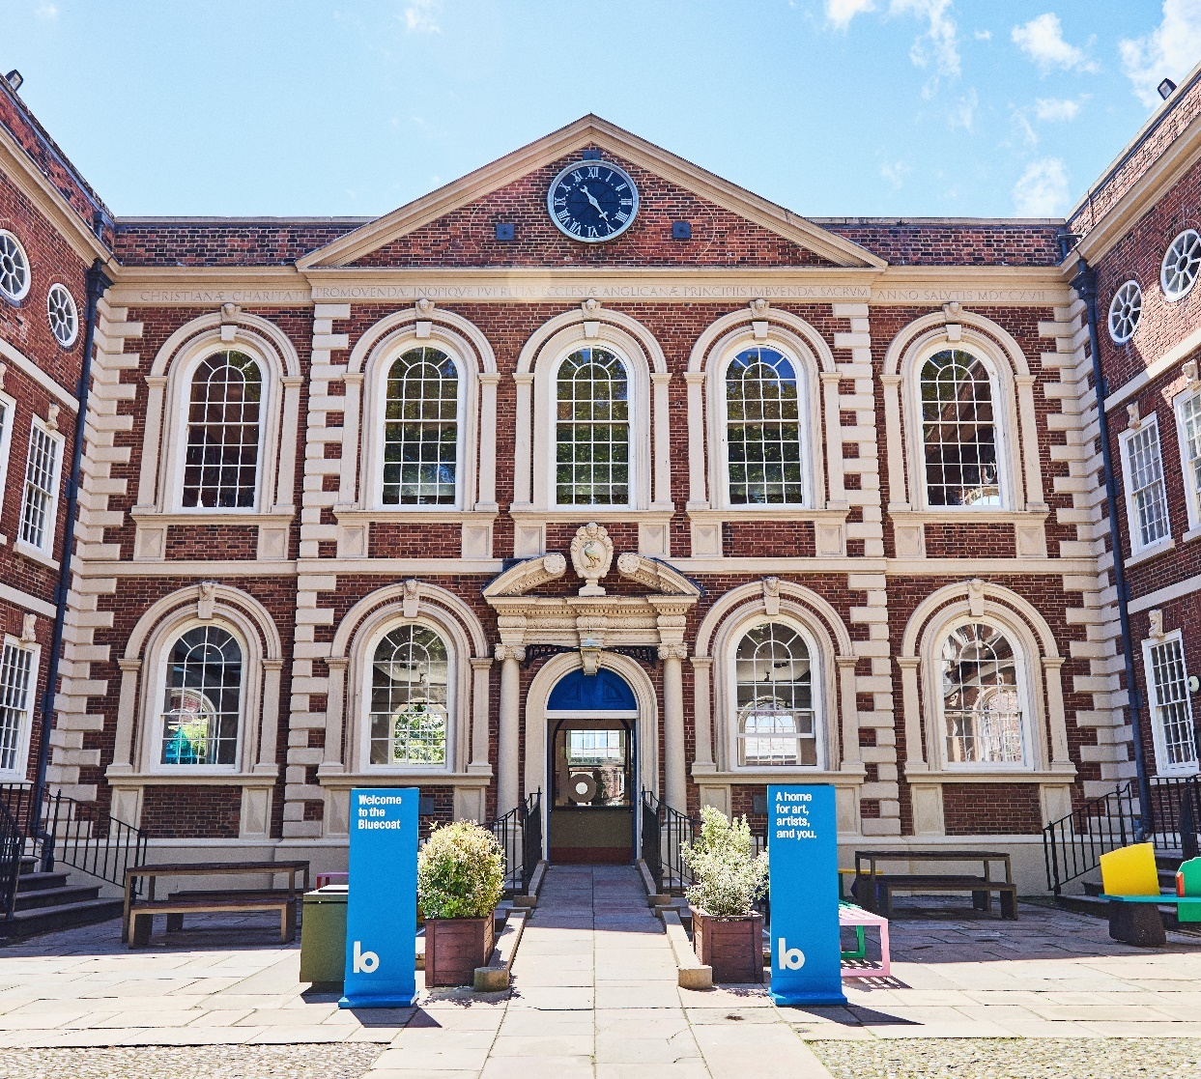

There are 6 artists showing work here.

The artists at Bluecoat all bring insights into the family, chosen family and cultural heritage that they carry with them, and which grounds them.

What3words:
School Lane entrance - ///point.clean.ruler
College lane entrance - ///sorry.baking.crab

The building is open from Tuesday to Sunday from 11am until 5pm.

Parking

The two nearest car parks to Bluecoat are Q-Park on hanover Street (2 minute walk) or Q-park John Lewis (6 minute walk). Both car parks have designated disabled parking bays.

Entrances to Bluecoat

There are two entrances.
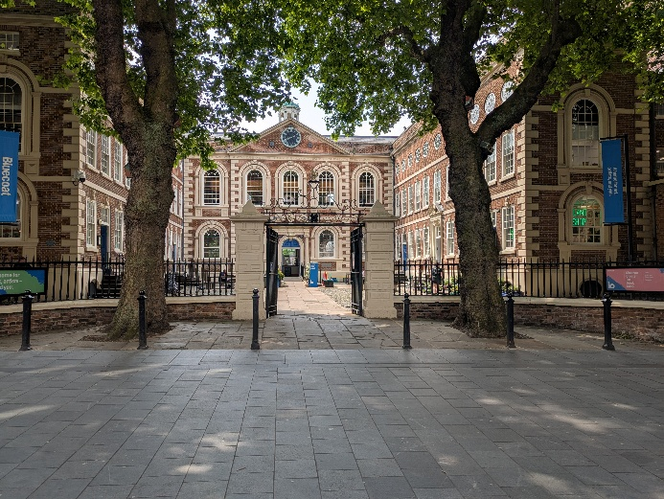
One is from School Lane (behind the Primark store) via the front courtyard. A ramp leads to this main entrance.

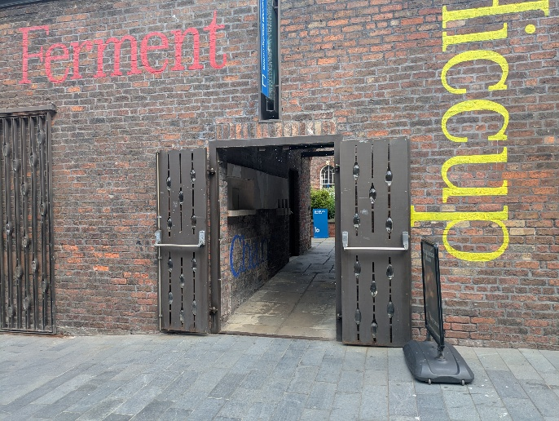
The other is at the back of the venue on College Lane via a passageway and entering through the garden space. There is a level access route through the garden if you turn right at the end of the passage.

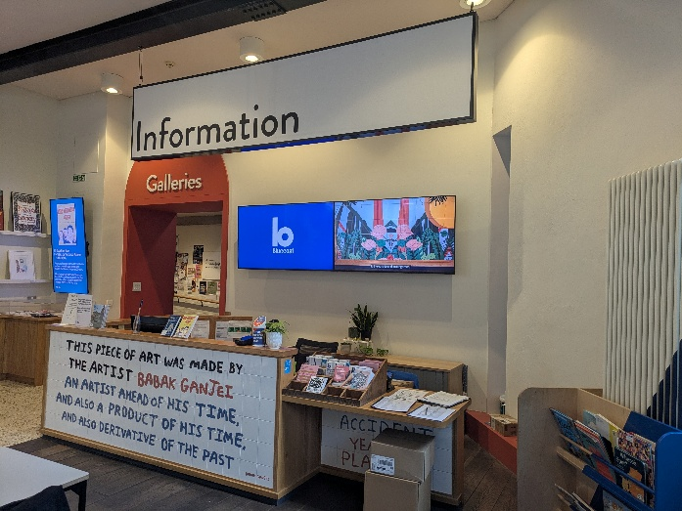
Turn left at the front entrance, or turn right at the garden entrance, and you will see the Bluecoat information desk, where you can find information about exhibitions and events. The entrance to the galleries is to the left of the information desk.

There are Bluecoat information assistants in the galleries to help you if you need assistance.

Bluecoat Facilities

Café

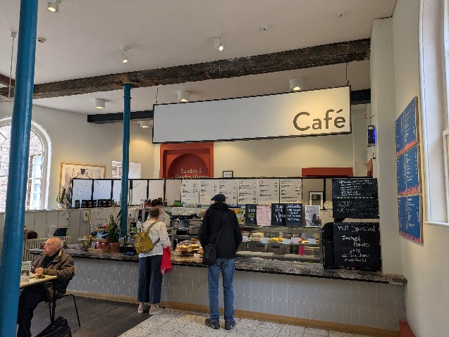
There is a café located in the main entrance space of The Bluecoat they take cash and card payments.

There are a few tables with benches in the front courtyard and in the garden where you can sit to eat your own food at the green tables with benches. Most tables with chairs in the garden are intended for café customers.

Toilets

Toilets are located on the ground floor and include an accessible toilet.

A link to more information about access at Bluecoat is here:
https://www.thebluecoat.org.uk/plan-your-visit/accessibility

About the Artists at Bluecoat

There are sounds played as part of some of the artworks that can be heard throughout the galleries.
Gallery 1
Entering the galleries the first space is on your immediate right.

Amber Akaunu

Amber is a Liverpool-born Nigerian-German filmmaker working in cinema and art to document and imagine stories from regional Black communities.

For Liverpool Biennial 2025, Akaunu has created a new film which tells a deeply personal tale of single motherhood in Toxteth, Liverpool – an area in which approximately 1 in 6 households are single-parent families. This autobiographical documentary-style film is inspired by the African proverb “it takes a village to raise a child”, and centres around single parents and their best friends who have built alternative ‘villages’ through which they collectively raise their children.

In the space there is also a cabinet showing symbolic items used in a Nigerian naming ceremony.

There is an audio described introduction to Amber Akaunu’s film and the accompanying exhibit here.

Gallery 2

The next space is further along the corridor and is split into two sections.

Amy Claire Mills

Amy is a Neurodivergent and Disabled artist whose work delves into themes of advocacy, identity, and resistance. Her art serves as a form of playful protest – using tactile materials and bright colours, the artist blends softness, tactility, empathy, and care with elements of dissent, disruption, and provocation.
‘Deep End’ is an immersive sensory installation that invites exploration through touch, sight, and sound. The project explores the concept of accessible and adaptive ‘third spaces’ - spaces beyond home and work, which are informal social environments. For many Disabled people, third spaces often default to medical environments like doctors' waiting rooms and outpatient clinics. Public pools have long served as adaptive third spaces existing somewhere between the social and the medical. Building on this concept, ‘Deep End’ invites you to wade into a future where care, access, and inclusion are part of the design from the very beginning.

There is an audio description of the installation made by Amy Claire Mills here.

Odur Ronald

Odur uses aluminium printing plates and scrap metal to explore ideas of free movement, migration, access, belonging and identity. "Mu Lyato Limu" (translated from Luganda as "All in One Boat") is Ronald’s most ambitious installation to date. The work is a commentary on the complexities of migration.

Using passports, it delves into the tension between free movement and the restrictions imposed by borders. For Ronald, these documents are more than just identification; they highlight how global mobility and personal autonomy are shaped by societal constraints, ultimately representing permission or denial of freedom to pursue one’s aspirations.

Gallery 3

At the end of the corridor is the final space on the ground floor.

Alice Rekab

The title ‘Bunchlann/Buncharriag’ translates from Irish Gaelic as ‘Origin Family/Bedrock’. It speaks directly to the subjects of community, resistance, diaspora and places of belonging that define the theme of Liverpool Biennial 2025. The artist uses their own personal experiences of Irish, Black and multi-heritage family life to explore hybrid identities, shared traditions and legacies of migration.
In their work, Rekab uses archival items and images such as family photographs, heirlooms and objects relating to their heritage from Sierra Leone, Syria, Ireland and the UK. They recreate and combine these historical references with memories, oral accounts, field notes, and readings, all derived from their encounters with and research into Irish, West African and Middle Eastern traditions, spirituality, and materiality.

Gallery 4

To access Gallery 4, you can use the lift just outside Gallery 3 or use the staircase at the end of the first corridor.

ChiChung Chang

ChihChung’s works combine multiple forms of media with skilled craftsmanship to explore the connections and differences between humans and nature. He references rapid-changing and evolving environments such as ships, islands, water and ports to question how civilisation and our surroundings constantly shape one another.
His ‘Port of Fata Morgana’ installation is the result of a two-year project inspired by a model ship created by the artist’s father. The work draws parallels between Liverpool and the port city of Kaohsiung, interweaving family memories, field studies, documentary research, and oral history.

Garden

You can enter the garden from the main hub and café.

Turn left outside the door into the garden and you will find the sculpture against the far wall in the left hand corner of the garden. You can get closer via 2 steps or navigate the step free route to the artwork.

Petros Moris

Petros Moris explores how fragments of history can help us think differently about the future, transforming remnants of the past into symbols of renewal. The work exhibited here in the Bluecoat Garden is part of the artist’s ‘ALONE’ series of mosaic sculptures and reliefs.
The ‘ALONE’ project is inspired by a personal encounter which the artist had in an abandoned urban playground in his home city of Lamia, Greece – a site that was left unbuilt due to archaeological discoveries. Here he found a marble tile mosaic crafted by his parents in 1985 which had been painted over by a local graffiti artist with the word ‘ALONE’.
Moris was fascinated by how this intervention transformed the original work into a multilayered artefact comprising the work of different people, raising questions about authorship and collaboration, and of the fates of urban spaces, craft traditions and personal heritage. This work is one of a series of reliefs which were made as cast copies of the original ‘ALONE’ mosaic. The moulding-casting process has allowed the artist to make multiple, detailed copies of the original structure, providing relief landscapes that act as abstract sculptural ‘canvases’.

There is an audio description of the artwork by Petros Moris here.

FACT Liverpool

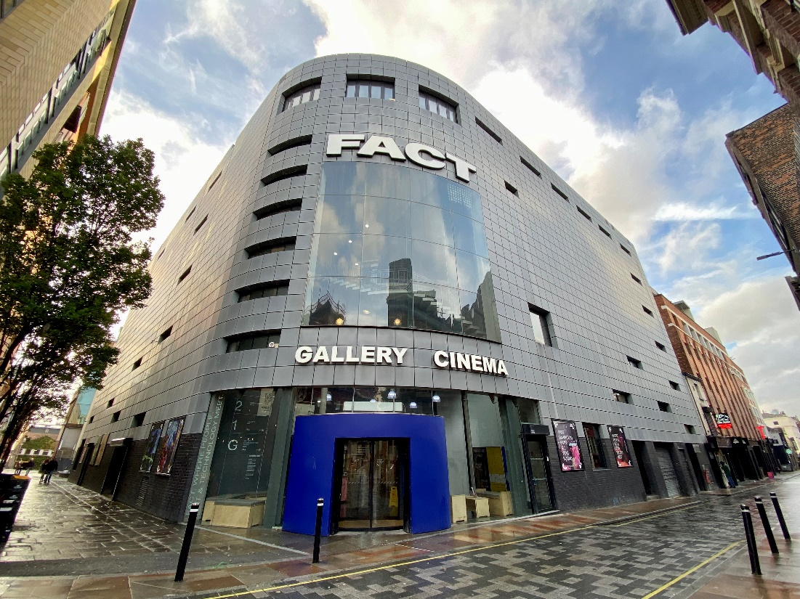

There are 3 artists showing work here.

The artists at FACT Liverpool explore both healing and extractive relationships with the environment, connecting their research to the urban and natural environments of the city.

FACT is in the Ropewalks area of the city.

The building is open on Wednesday to Sunday from 11am-6pm

What3words:
Wood Street Entrance - ///prove.pirate.deeper
Fleet Street Entrance - ///line.bulb.moves

FACT Liverpool Facilities

There is a café located on the ground floor selling hot and cold drinks, cakes, pastries and snacks.

There is a bar located on the first floor selling hot and cold drinks and snacks.
Toilets are located on the ground and first floors and include accessible toilets.

Parking

FACT does not have its own parking facilities, but there are several car parks nearby that you can use. You can find a list of local car parks and their cost here: https://en.parkopedia.co.uk/parking/liverpool/?arriving=202505231230&leaving=202505231430

You'll also find accessible parking spaces close by on Wood Street and Bold Street.

Entrances to FACT Liverpool

There are two entrances.
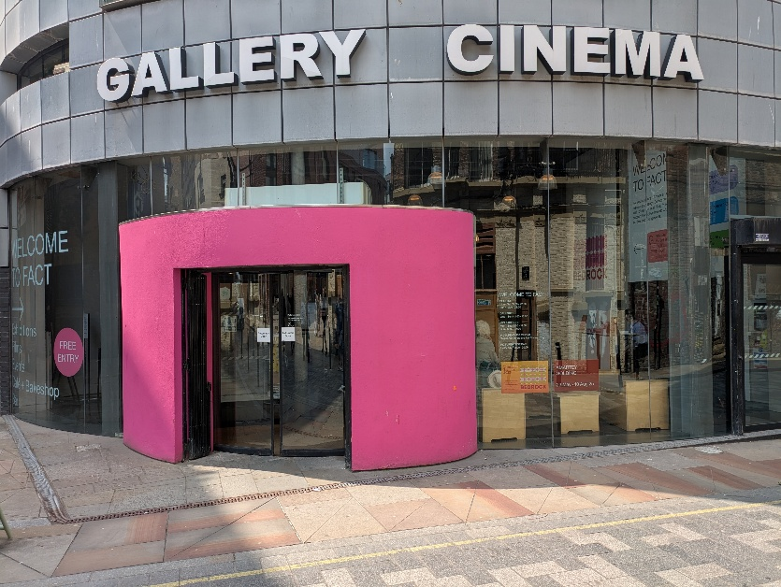
The front entrance is on Wood Street and has level access through automatic doors

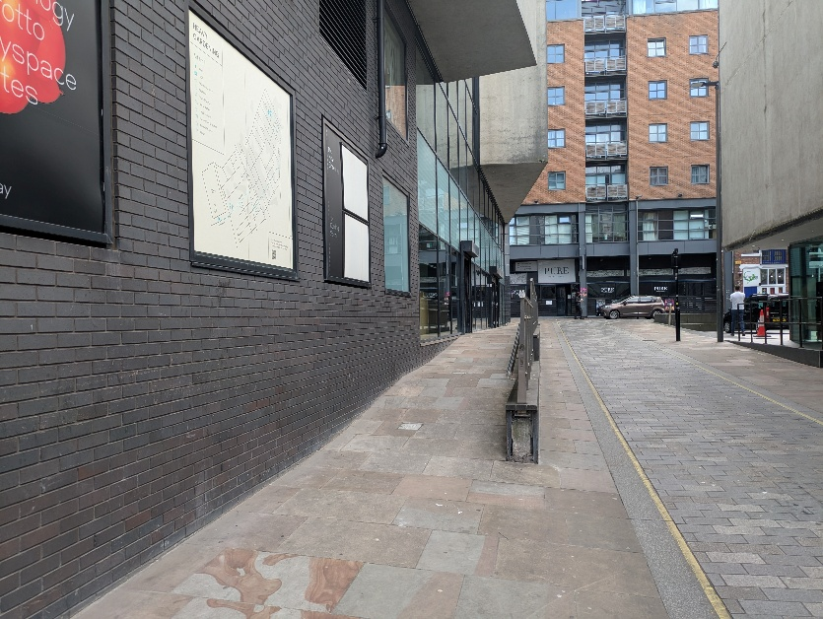
The rear entrance is on Fleet Street and has ramp access.

A link to more information about access at FACT is here:
https://www.fact.co.uk/visit/accessibility

About the Artists at FACT Liverpool

Foyer Gallery

Entering the building from Wood Street the foyer gallery is on your right. From Fleet Street you can go right through the ground floor space, past the box office and the gallery is on your left.

Kara Chin

Please be aware that this artwork contains flashing images and loud sounds.

For more information, please speak with a member of staff.

Kara Chin presents a new interactive multimedia installation for Liverpool Biennial 2025, inspired by Manga and apocalyptic video game graphics that explores rage, grief and nuisance. The artist draws on repeated motifs such as seagulls, parking meters, and the seemingly invasive Buddleia plant often found in cities, including Liverpool. Here, they serve as metaphors for global unease and anguish in the face of economic and ecological decline.
Chin's installation amplifies low-level and everyday annoyances such as pests, weeds and city-centre parking charges, transforming them into almost theatrical or comical over-the-top explosions of anger. Through doing so, she references how newspaper headlines often exacerbate stories into insidious narratives for clickbait.
However, these nuisance symbols also represent resilience and the ability to flourish in unlikely environments.
Kara Chin has also created intricate ceramic tiles that link to this installation and are embedded in the pavement on Berry Street.

Gallery 1

You can enter Gallery One from the foyer. It is located opposite the box office. The entrance is through the door on left from the recessed space. The entrance has step free access, via a ramp.

The gallery exit is via two steps. The step free exit is via the same route as the entrance.

There are loud sounds played as part of the artworks in this gallery.

DARCH

Content advice: This work explores the concepts of death and grief.

DARCH is the collaborative practice of artists Umulkhayr Mohamed and Radha Patel. Their work seeks creative ways to articulate care-centred practices for people of colour, with an approach grounded in solidarity and liberation. Central to their shared practice are rituals, shrine building and animism – the belief that objects, places, and creatures all possess a distinct spiritual essence.
For Liverpool Biennial 2025, DARCH have produced a new installation in collaboration with residents in Sefton, who have contributed stories about how their connection to spiritual traditions and their Merseyside community have shaped their relationship with death and grief. ‘Heaven in the Ground’ tells the story of the earth underneath our feet, and the bedrock as a great connector which holds all histories (prehistoric, colonial, personal) as well as possible futures.

The audio component of DARCH’s work is available to listen to here

Linda Lamignan

Linda Lamignan’s work questions the different ways in which humans treat and value the natural world, whether for profit or as something to be respected and protected. They work with materials connected to the industries, histories, living landscapes and cultural relations between West Africa and Europe.
This new multi-screen video work references the artist’s ancestry, the knowledge systems of animism – the belief that objects, places, and creatures all possess a distinct spiritual essence – and geology. It centres around the long history of palm oil and petroleum extraction in Nigeria’s Delta State and their trade with Liverpool from the late 18th century to the present day.

Open Eye Gallery

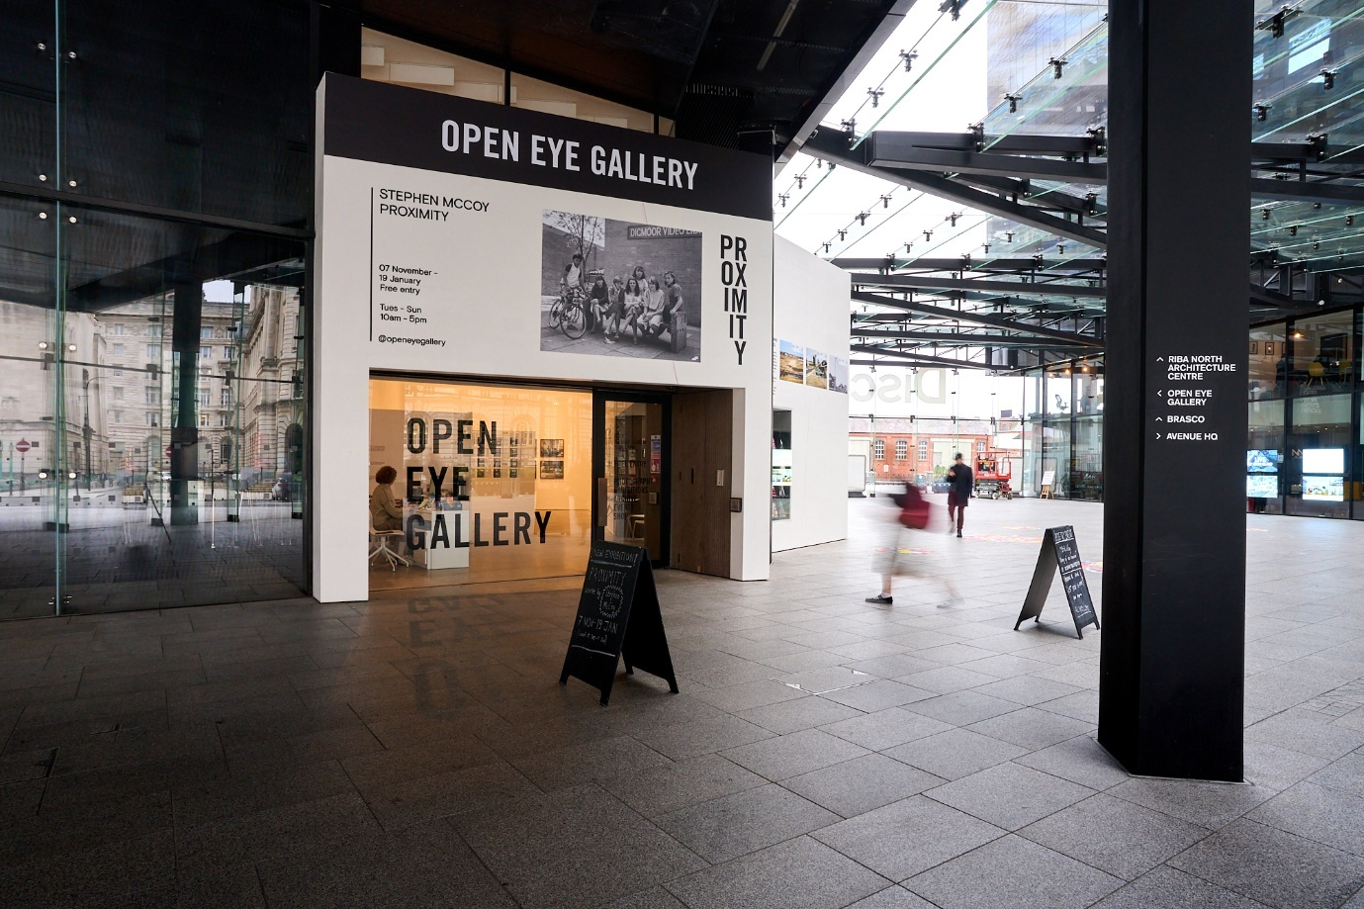

There are 3 artists showing work here.

The artists at Open Eye Gallery work with lens-based media and sculpture to conjure places that speak to their sense of identity. All three artists are reinterpreting stories, myths, lost traditions and memories to form new ones.

The gallery is part of the Mann Island development, a complex of three black buildings that sit between the Strand, the Canning dock and the new Museum of Liverpool.

What3words: ///blaze.tile.twigs

The building is open on Tuesday to Sunday from 10am-5pm.

Parking

The nearest multi-storey car park is Q-Park at Liverpool ONE, 35 Strand Street, Liverpool, L1 8LT.

On Mann Island, opposite the gallery, there are a small number of on street parking spaces, paid for by a meter – there are also 4 designated parking spaces for Blue Badge Holders.

Entrances to Open Eye Gallery
The entrance is on the ground floor of Mann Island, in a covered public courtyard which can be entered from the south side (facing the Museum of Liverpool) or the north side (facing Mann Island and the Liver Building). The entrances have flat access.

There is a lift to access the first floor.

Toilets
There are toilets located on the first floor including an accessible toilet.

A link to more information about access at Open Eye Gallery is here:
https://openeye.org.uk/plan-your-visit/access/

About the Artists at Open Eye Gallery

On the ground floor, the artists reinterpret archives, stories, myths, traditions and memories to reflect on contemporary narratives that are important to them personally and which also reflect on wider collective experiences.

Gallery 1
Nandan Ghiya

Nanda Ghiya’s ‘sculptural photographs’ span years of artistic practice and are centred around a new ambitious sculptural work which revisits a famous event in Hindu scriptures to highlight collective concerns around the climate crisis and the rapid redevelopment of cities.
You can hear a description of the sculpture made by the artist HERE.

Gallery 2
Widline Cadet

Widline Cadet presents photographs from an ongoing body of work which reference her family's journey of transformation as result of their (im)migration from Haiti to the United States. Although deeply personal, Cadet’s photographs encompass shared experiences of displacement around the world, depicting people and circumstances that may be simultaneously familiar and unfamiliar to the viewer.

Upstairs in Gallery 3
Katarzyna Perlak

There is sound played as part of the film in this artwork.

Katarzyna Perlack, working with local film organisation First Take’s REEL: Queer cohort, uses local history as a springboard from which to consider alternative futures. In her new, collaborative film work, Liverpool’s landmark Adelphi Hotel becomes a portal to other worlds and possibilities.
Tate Liverpool + RIBA North

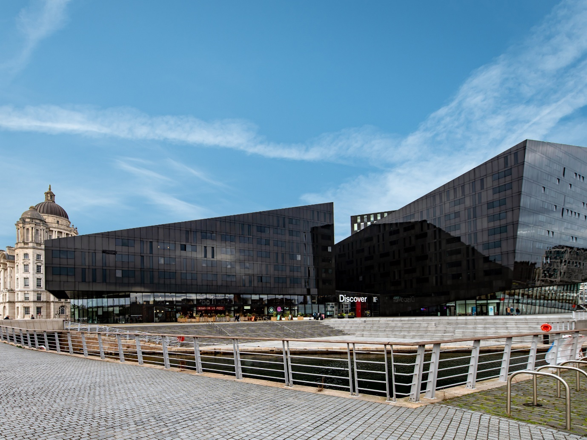

There are 8 artists showing work here.

The artists at Tate Liverpool + RIBA North map the grounding relationships and places that they carry with them, which include intimate familial and chosen family connections, and the idea of homeland as a place of both comfort and loss.

The gallery is part of the Mann Island development, a complex of three black buildings that sit between the Strand, the Canning dock and the new Museum of Liverpool.

What3words: ///eggs.vows.fully

The building is open on Monday-Sunday from 10am to 5:50pm

Parking

Q-Park Liverpool ONE, with 2,000 underground spaces: 35 Strand Street, Liverpool L1 8LT. Visitors to Tate Liverpool can park at Q Park and receive a 20% discount for up to 24 hours. Enter code TATELO20 on Q Park’s website to pre-book your discounted parking.
There are two dedicated Blue Badge parking spaces located on Brunswick Street, which is 5 minutes away from Tate Liverpool + RIBA North. See the Liverpool City Council website for details about Blue Badge parking.

Toilets

Toilets are located on the first floor and include an accessible toilet.

A link to more information about access at Tate Liverpool + RIBA North is here:
https://www.tate.org.uk/visit/tate-liverpool

About the Artists at Tate Liverpool + RIBA North

Antonio Guzman & Iva Jankovic

In the entrance to the building there is textile work created by Antonio Guzman and Iva Jankovic hanging from the ceiling. This can be viewed more closely from the balcony on the first floor that overlooks the entrance. The balcony rail is made from clear strengthened glass.

Antonio Guzman & Iva Jankovic’s collaborative practice uses textiles, soundscapes
and performance to tell stories of migration, memory, and transcultural exchange. The artists embrace the hybrid identities formed through the movement of people, culture, and knowledge across borders.

Part of their ongoing ‘Electric Dub Station’ series, this new work commissioned for
Liverpool Biennial 2025, uses a map to examine Liverpool’s colonial legacy and the
demonstrations of 2024. Incorporating indigo dyeing, patching and Instagram posts,
the design and technique symbolise both colonial exploitation and cultural resilience.

On the first floor and located on the pillar near the balcony looking over to Antonio and Iva’s work is Toxteth Dub Sonic Soundscape Vol. 07 mixed and composed for the city by the artists. This can be listened to through the headphones provided.

In the far corner of the first-floor level is the entrance to the gallery hosting more works by LB25 artists. The gallery is accessed through the door on the right. The door is heavy and you might need assistance to open it. Gallery staff will be happy to help.

Moving round the gallery following the walls on your left the artists are listed here in order:

Mounira Al Solh

The drawings on display here are part of an ongoing series, ‘I Strongly Believe in
Our Right to Be Frivolous’, which comprises over 500 drawings and embroideries to
date. The works record conversations the artist has had with displaced individuals,
groups and families since 2012.

Sheila Hicks

Since the 1970s, Sheila Hicks has established herself as one of the most distinctive
artists of her generation. Her highly tactile works explore the collective experience
of space - her ambition is to expand the possibilities of thread as a sculptural form,
referencing global textile traditions to transform everyday materials into
compelling works of art.

‘Boules’ are a key motif in Hicks’s work and a form to which she has repeatedly
returned. Each form consists of wrapped colourful threads around a central core,
created using garments that have previously belonged to the artist’s friends or
family. As such, they hold memories for Hicks who refers to them as her ‘memory
balls’. Their forms evoke organic rock forms or gemstones, whilst symbolising the formative impacts of human connectivity and kinship.

Fred Wilson

Wilson’s work challenges dominant narratives about history, culture, race, and the conventions of display. By reframing objects and cultural symbols, he alters traditional interpretations, encouraging viewers to reconsider social and historical narratives.
Here, the artist's ‘Flag’ series takes the designs of African and Caribbean countries' flags and drains them of colour, instead using black acrylic paint to illustrate specific details and motifs. The backgrounds remain unpainted, representing the loss of life and possibility caused by the devastating impacts of the Transatlantic Slave Trade, whilst also suggesting a site of permanent renewal and potential. Wilson seeks to highlight the dynamic and resilient nature of these nations and, by offering multiple readings of his work, offers opportunity for our own interpretation and further questioning.

Hadassa Ngamba

This work from the artist’s ‘Cerveau’ series (2018-2023), which translates to ‘brain’, is exhibited here for the first time in the UK. The piece is based on historical maps of the Democratic Republic of the Congo (DRC) and psychological mapping of the terrains that exist around and within us. The work provides a visual critique of colonial legacies and the impact of imposed borders and cartographies, while also suggesting a future where Congolese people can reclaim their agency.

Cevdet Erik

Cevdet Erek’s works investigate the units, structures, and forms that guide our perception of space and time. In 2007, Erek produced his first ruler, which begins with the year of his birth. Since then, he has continued to make rulers to mark and interpret successive events and relationships, from the temporal units of day, night, week, and year; to individual and social turning points; and to historical ruptures like coups and wars.

'Father’s Timeline / Babamın Zaman Çizelgesi (2007)’, one of Erek’s first works to deal with the concept of time, explores collective history through critical personal turning points. The artist first draws a line beginning from his father’s date of birth and asked his father to indicate important dates in his life on this ruler. For the first time since it was made, this work has been overlaid with a new work which offers an updated survey of his father’s life.

Christine Sun Kim

Christine Sun Kim’s infographic drawings consider how sound operates in society. They explore the artist’s own lived experience and her relationship to spoken and signed languages. Kim's works highlight the importance of socio-historical factors in privileging spoken over signed language yet also include highly personal reasons and references. They advocate for the value and authority of lived experiences, as well as signalling the absurdity of trying to capture highly complex determining forces and deep-rooted historical bias in the form of simple infographics.

Dawit L Petros

Dawit examines the intertwined narratives of colonialism and modernity.
He draws from his study of history to engage with the ongoing effects of displaced
or forgotten histories.

To the left, Petros’ series of screenprints explore popular representations of Eritrean
askari, indigenous troops recruited into Italy’s colonial army. These works are
created using images found in postcards and illustrated magazines collected and
reproduced here by the artist.

On the right, the steel sculpture commemorates the 1998-2000 border conflict
between Eritrea and Ethiopia. Discrepancies in colonial era maps were significant
catalysts for the war and are reflected here in the design which, although made of a
solid material, alludes to fluidity and movement through its lines and reflective
surface.
Liverpool Cathedral

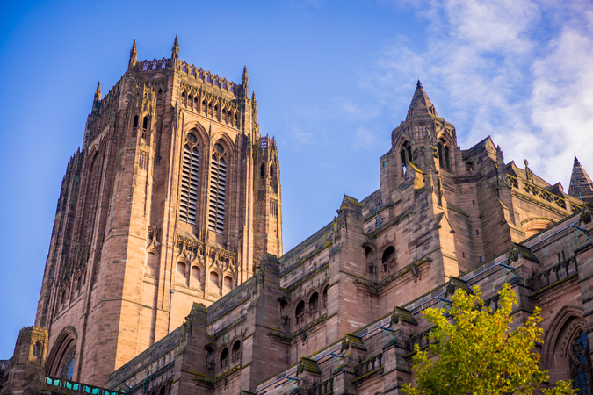

There are 2 artists showing work here.

Liverpool Cathedral – a monumental sandstone building set in a quarry which reveals the bedrock of the city – hosts two artists who highlight the venue as a place of sanctuary, and one in which women's contributions have played an important part.

What3words: ///saints.catch.flies

The main entrance and the car park are accessed via Upper Duke Street.

Parking

There is limited onsite parking available on a first-come, first-served basis. The first 30 minutes are free, after that, you pay for the time your car is in the car park. It is a pay-on-exit system car park.

The car park has eight designated bays for disabled parking.

Entering Liverpool Cathedral

Entrance to the Cathedral is via two sets of steps (six & eight steps) with handrails and double doors (186 cm wide).

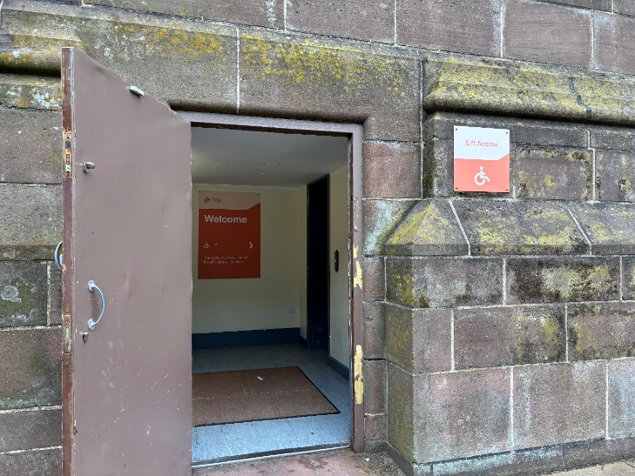
From the accessible parking bays there is a ramped entrance leading to a lift that will take you to the main floor of the cathedral.

A link to more information about access at Liverpool Cathedral is here:
https://liverpoolcathedral.org.uk/plan-your-visit/accessibility/

Liverpool Cathedral Café

There is a café located from the central space selling hot and cold drinks, meals and snacks.

Toilets

Toilets can be accessed from the central space and from the floor level of the Lady Chapel. There are accessible toilets on both levels.

About the Artists at Liverpool Cathedral

The Central Space

This artwork can be viewed from the central space and hangs from the Dulverton Bridge. It can also be viewed from The Nave (known here as The Well). This is a lowered area of the cathedral with steps to access it.

There is a platform lift accessed from the same area the accessible entrance leads onto.

Cathedral assistants will be able to assist to access this lift.

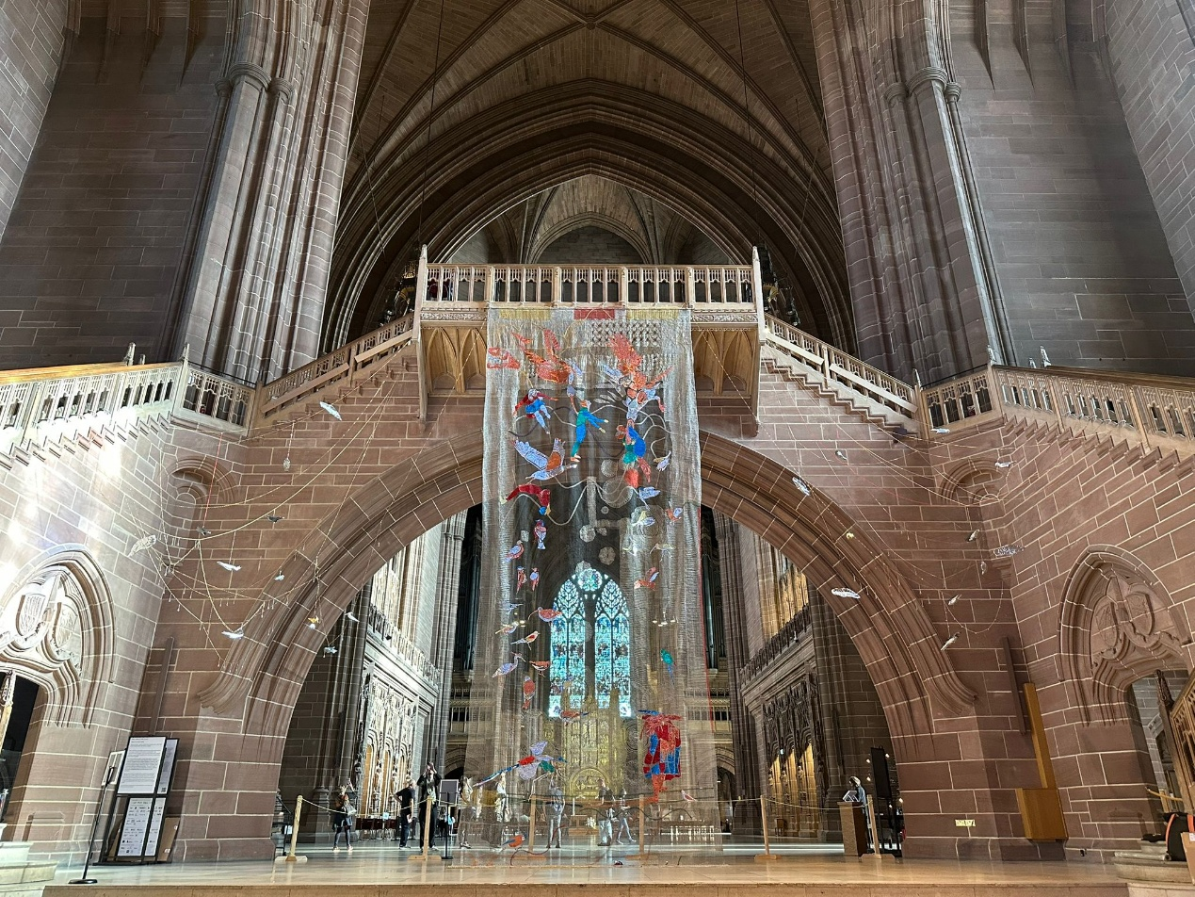

Maria Loizidou

Maria Loizidou’s art practice interweaves personal and political references in relation to the history of colonialism, war, oppression and minorities. Her artworks activate public spaces, creating a platform for interaction and discussion, emphasising the power of fragility.

For Liverpool Biennial 2025, Loizidou has created a beautiful and thoughtful installation which responds to the architecture of Liverpool Cathedral and the different species of birds that visit and nest in and around the building grounds. Hanging above us from the Dulverton Bridge, 'Where Am I Now?’ is created using a common traditional weaving technique – the work is hand-woven with thin steel wire and crafted with needles in patterns reminiscent of Mediterranean and international crochet traditions.

The Lady Chapel

These artworks are located in The Lady Chapel. The chapel can be accessed from the south east corner of the cathedral via a stone staircase. There is a lift to access the floor of the Lady Chapel located in the south east corner at the end of the corridor along from the staircase entrance.

Festival Guides and Cathedral staff will be able to direct you and assist if required.

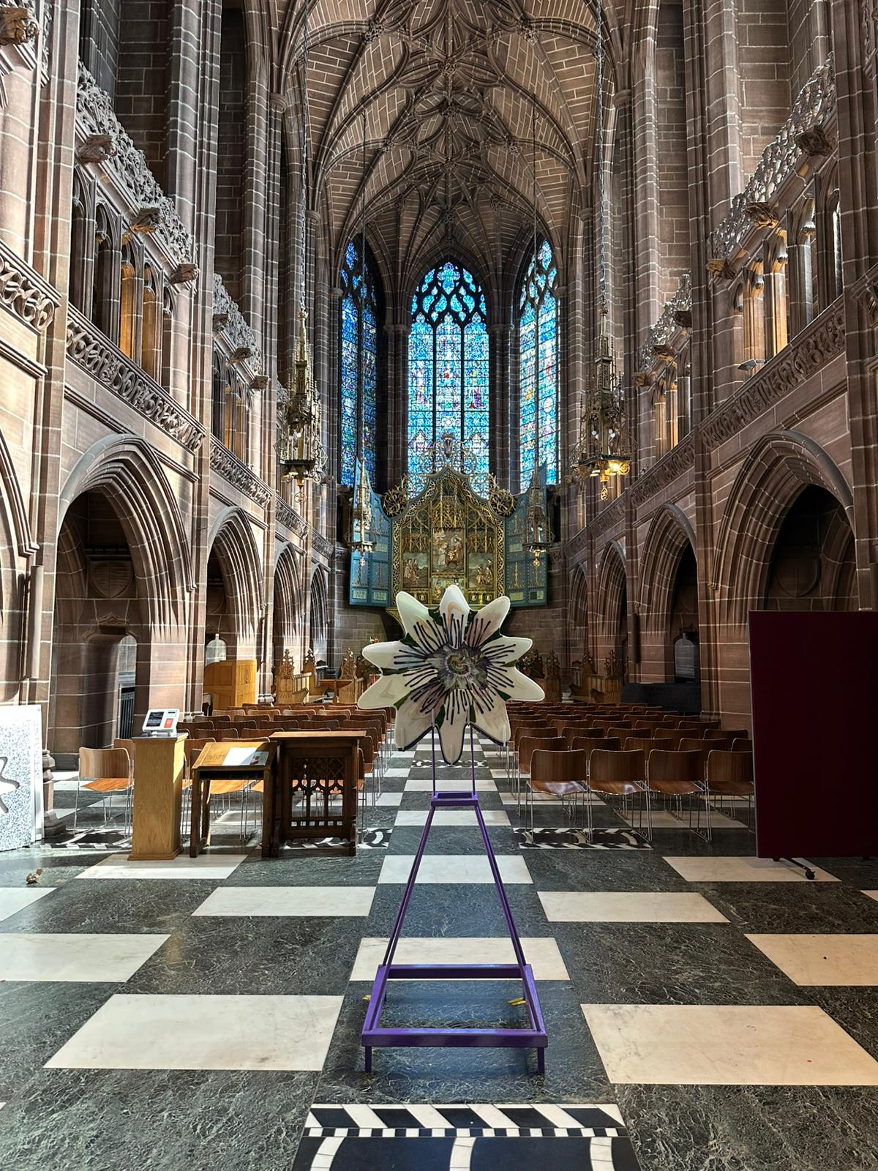

Ana Navas

Ana Navas’ art practice is rooted in research through which she explores the genealogy (the origin and development history) of objects and images. Her work vividly illustrates how our personal history, time, and surroundings invariably shape our worldview, and demonstrates how we often project familiar ideas onto unfamiliar images or objects in order to make sense of them.

Here in the Lady Chapel, the artist presents a series of glass collages which are akin to glass paintings. The works draw inspiration from the colours and forms found in the clothing and objects depicted in portraits of women from throughout art history. Among these pieces, Navas includes a newly commissioned glass and textile work which draws inspiration from the embroideries made by generations of women from Liverpool that are held in the Cathedral’s archives.
Liverpool Central Library

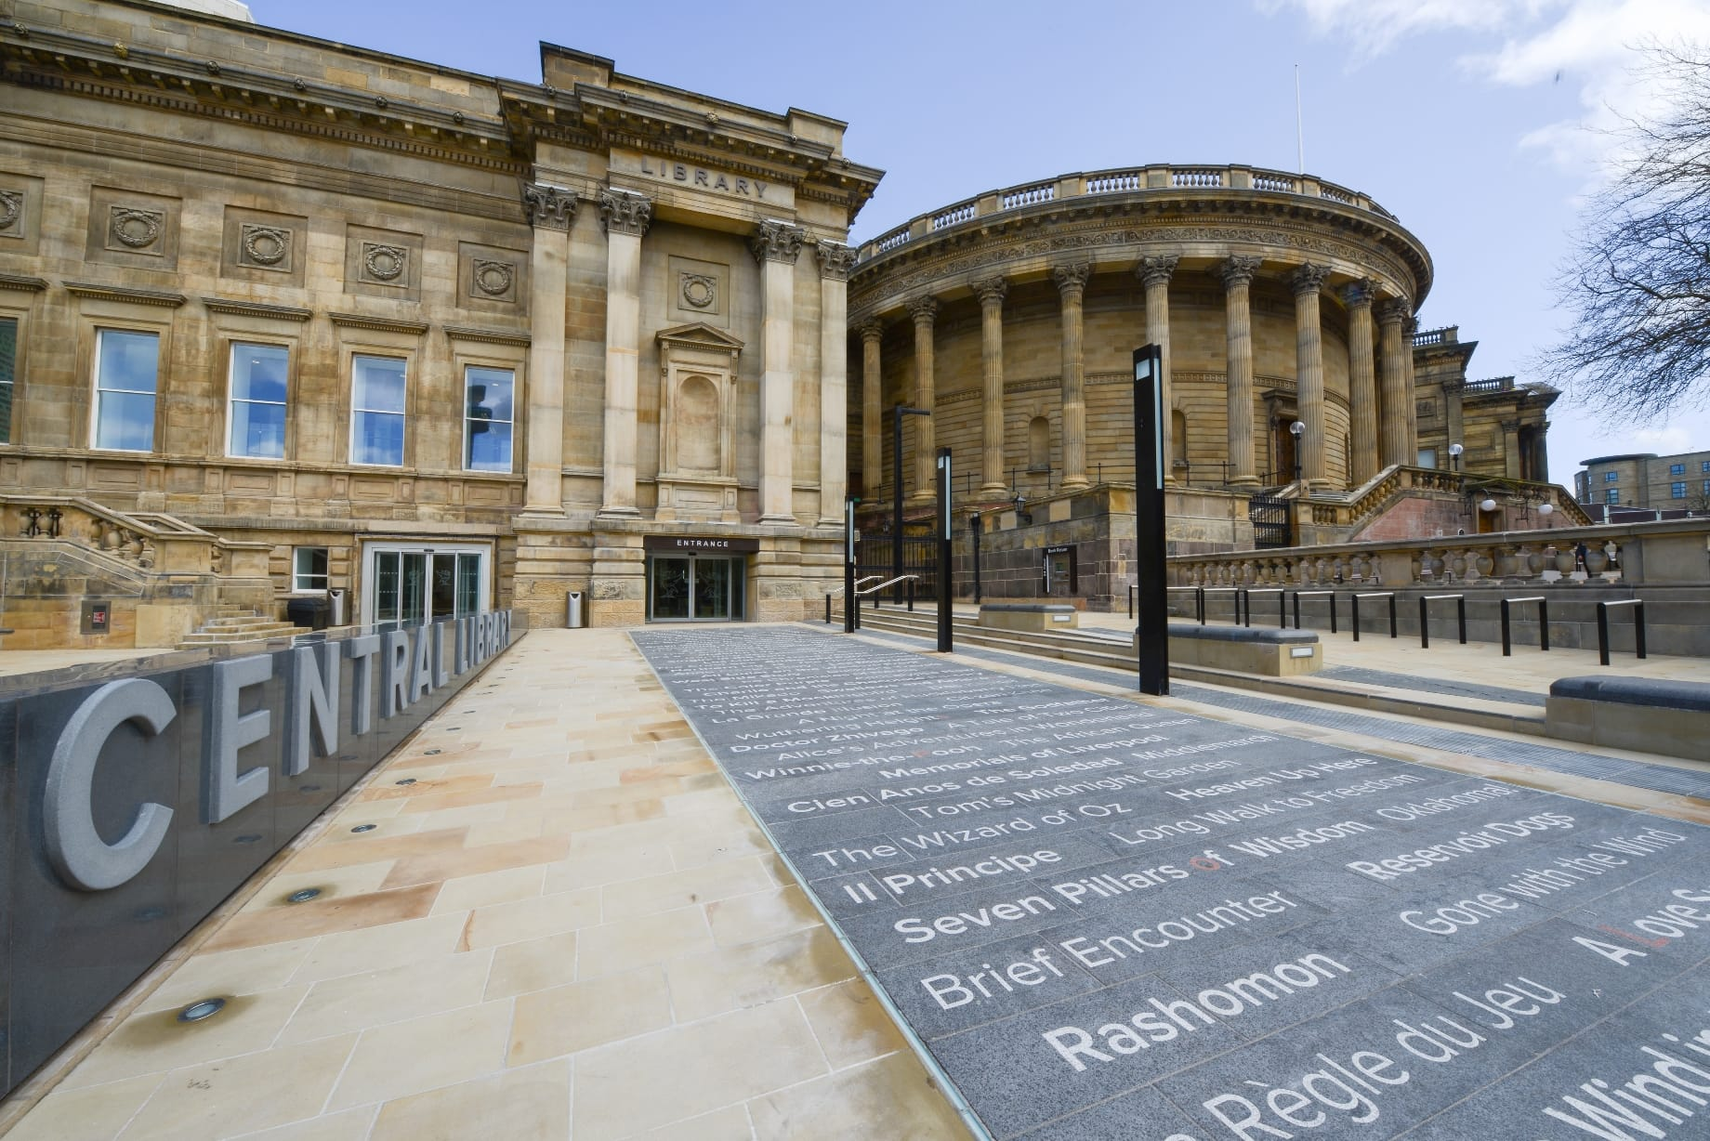

There is 1 artist showing work here.

Central Library is accessed from William brown Street. It's the home of a business centre, a dedicated family space and the Liverpool Record Office and Archives. It also houses the historic grade II listed Picton Reading Room and Hornby Library along with 15,000 rare books.

What3words: ///renew.finds.agrees

The library is open from 9am-8pm Monday-Friday and from 9am – 5pm on Saturdays.

Toilets
Toilets are located on all floors, including accessible toilets.

A link to more information about access at Liverpool Central Library is here:
https://liverpool.gov.uk/libraries/explore-central-library/central-library/

Parking
There is pay and display parking outside the museums and library on William Brown Street. The nearest other car park is at Queen Square.

There are a limited number of blue badge parking spaces on William Brown Street.
The road surface is cobbled.
Entering Liverpool Central Library

The entrance to the library is step-free and there are lifts to all floors.

Liverpool central Library Café

There is a café on the ground floor selling hot and cold drinks and snacks.

The Hornby Library is accessed vis the lift from the ground floor to the first floor. Turn left from the lift and then left where you will find the first floor information desk. The entrance to the Hornby Library corridor is behind the information desk on the right. Staff will be able to guide you on request.

About the Artists at Liverpool Central Library

Dawit L. Petros

In the Hornby Library, Dawit L. Petros presents a sprawling research project that aims to re-read a historic military expedition to the River Nile from 1884-1885 – a British-led expedition which included 379 Voyageurs from across Canada and Quebec including French Canadians, Western Canadians and First Nations.

Petros invites visitors to ‘textually travel’ through the records and artworks on display – some gathered and some newly-created in response to Liverpool’s archives of shipping and empire. Through doing so, the artist seeks to interrogate elements of the past which are simultaneously hidden and present in both material practices and the psyche, and in visible and invisible places.

He reflects on themes of control, power, movement and travel, making connections between events, diverse communities, languages and places frequently thought of as remote from each other.
Walker Art Gallery

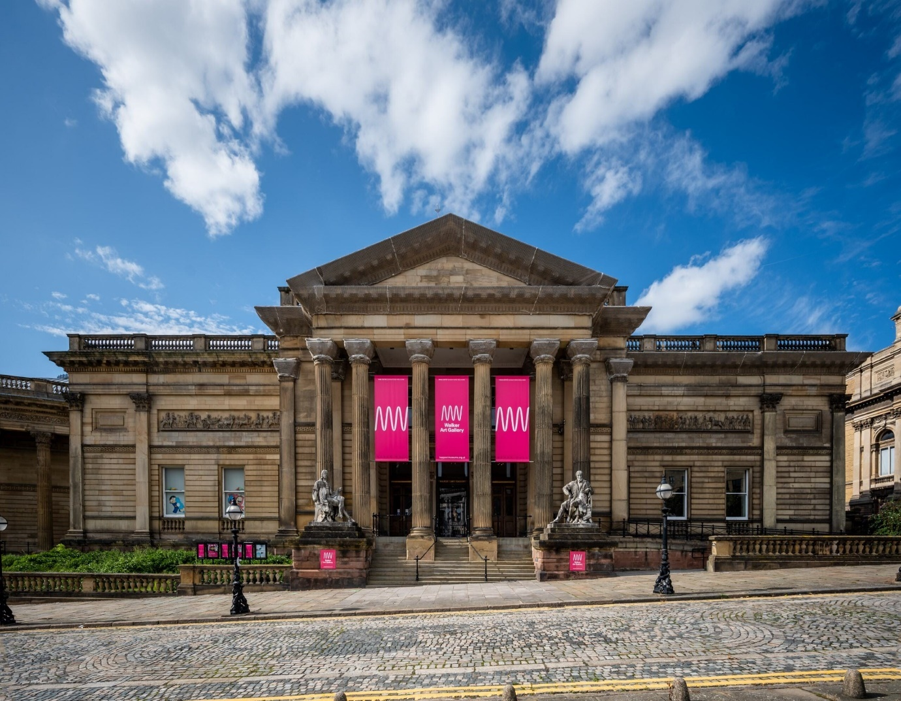

There are 9 artists showing work here.

The artists at Walker Art Gallery offer densely material works which interweave practices exploring personal and colonial legacies within an ornate building and national collection founded on the merchant wealth of the city.

The building is accessed via William Brown Street and is open on Tuesday to Sunday from 10am until 4pm.

What3words: ///catch.body.starts

Parking

There is pay and display parking outside the gallery on William Brown Street and behind World Museum on Hunter Street. The nearest other car park is at Queen Square.

Toilets

Toilets are located on the ground and foist floors and include accessible toilets.

A link to more information about access at Walker Art Gallery is here:
https://www.liverpoolmuseums.org.uk/walker-art-gallery/access-and-facilities

Entering Walker Art Gallery

The entrance to the building is via 12 steps or there is step free access via a ramp that runs from the right of the steps.
Entering the building you will see the reception in front of you where gallery staff will be glad to assist you and help you find your way.

Walker Art Gallery Café

There is a café on the ground floor selling hot and cold drinks and snacks.

About the Artists at Walker Art Gallery

Foyer

Antonio Jose Guzman & Iva Jankovic

Hanging from the ceiling to the right of the reception desk is a textile work by Antonio Guzman and Iva Jankovic

Antonio Jose Guzman & Iva Jankovic’s collaborative practice uses textiles, soundscapes and performance to tell stories of migration, memory, and transcultural exchange. Their work embraces the hybrid identities formed through the movement of people, culture, and knowledge across borders.

Indigo dyeing – a practice rich in historical significance – has become a recognisable feature of the duo’s works, used to symbolise colonial exploitation and cultural resilience.

To the right of the entrance is the Sculpture Gallery.

Petros Moris

Petros Moris explores how fragments of history can serve as foundations for alternative futures, transforming remnants of the past into symbols of renewal. The work exhibited here in the sculpture gallery is part of the artist’s ‘ALONE’ series of mosaic sculptures and reliefs.

The ‘ALONE’ project is inspired by a personal encounter which the artist had in an abandoned urban playground in his home city of Lamia, Greece – a site that was left unbuilt due to archaeological findings. Here he discovered a marble tile mosaic crafted by his parents in 1985 which had been painted over by a local graffiti artist with the word ‘ALONE’.
This work is one of a series of reliefs which were made as cast copies of the original ‘ALONE’ mosaic.

There is an audio description of the artwork by Petros Moris here.

There is a lift to the left of the main entrance that will take you to the first floor where the LB25 exhibition is located in the Special Exhibitions Galleries.

There are signs that will lead you to this gallery.

Special Exhibitions Gallery

Entering the gallery using the door on the left and moving around the gallery to your left the artists are shown in the following order:

Antonio Guzman and Iva Jankovic

There is sound played as part of this artwork.

Part of their ongoing ‘Electric Dub Station’ series, this new work evokes the ruins of a past or Afro-futuristic city, embodying a textile Stonehenge where fragments narrate stories of recent urban unrest and global conflicts. Designed as a ritual space, the installation features dub-inspired sonic sounds which resonate within the structure.
Presented alongside the textile work is Toxteth Dub Sonic Soundscape Vol. 07 mixed and composed for the city by the artists. This plays out loud in the space through speakers.

Leasho Johnson

Leasho Johnson, now based in Chicago, USA was born in Montego Bay, Jamaica, and raised in Sheffield, a small town on the outskirts of Negril. He uses his experience growing up Black, queer, and male to explore concepts around forming an identity after empire.

His densely pigmented, large-scale paintings often include characters that live on the edge of perception through figurative abstraction. The characters and motifs in his work reference both ancestral and contemporary stories. Johnson reinterprets real narratives and accounts – often of homophobic or gender-based violence – merging them with contemporary matters and his own lived experience.

Cevdet Erek

Erek’s wall-based sculptures are inspired by football stadia layouts, with the smaller ‘away’ stands marked in gold leaf. Erek presents birds-eye views of grounds in both Istanbul, the artist’s home city, and Liverpool to question how football supporters’ culture and the spatial design of stadia can simultaneously connect us and divide us.

Karen Tam

Through her multi-disciplinary work, Tam examines how stereotypes and opinions of cultures and communities are imagined and influenced. In particular, she often recreates spaces and adopts traditions from Chinese culture to question how we understand history, whose histories get to be collected and how they are told, and to interrogate the narratives that have been constructed around the Chinese diaspora.
Tam uses cast resin to resemble marble, recreating her own versions of Chinese ‘Dreamstones’ -- natural stone paintings cut from stone found on Shuang Yang Mountain in Dali. The veins and natural patterns in the marble often resemble landscapes, mountain ranges, mist or clouds. They are cut into thin slabs and polished to enhance their unique designs and are highly prized by collectors and scholars for their resemblance to traditional Chinese ink-brush paintings.

You can hear a description of the works made by the artist HERE.

Katarzyna Perlak

Through her work, Katarzyna Perlak employs a notion of ‘tender crafts’, exploring how crafts, heritage and traditions can be revisited and re-imagined from contemporary feminist, queer and diasporic (migrant) perspectives. She references myths, folklore, dreams, desires and collective memories to question and resist how history is often written and how traditions are represented.

This new, large-scale textile and embroidery work is made from bags which the artist’s mother sends her care packages in from Poland to her home in London, UK – it is the artist’s most ambitious textile work to date. Newspaper clippings used to wrap jars and other fragile items are transferred onto the fabric, alongside ‘kitchen wisdoms’ captured through regular conversations with her mum. For Perlak, the work reflects on maternal care, issues of migration and homesickness, and shared political and economic challenges across borders.

Jennifer Tee

Weaving together the artist’s Dutch and Chinese-Indonesian heritage, these key works from Jennifer Tee’s ongoing ‘Tampan Tulips’ series draw inspiration from the colourful, geometric aesthetics of tampan textiles - traditional woven cloths from the Lampung region of southern Sumatra, Indonesia. They are created seasonally, two per year, using tulip petals which are meticulously picked, dried, pressed and placed.

Isabel Nolan

Isabel Nolan has an expansive practice that incorporates sculptures, paintings, textile works, photographs, writing and works on paper. She draws inspiration from a diverse range of different sources, including cosmological phenomena, religious relics, Greco-Roman sculptures, literary and historical figures, as well as human and animal behaviour. These artistic investigations are driven by intensive research, but the result is always deeply personal and open to different interpretations.
Here, ‘Eurydice (dead again...) and Orpheus’ (2022) depicts a married couple from Greek mythology, the re-telling of a story about resurrection through enchanting music. The textile work ‘Miracle wave, 2698 C.E’ (2021) shows a wave which Nolan imagines has travelled for over two thousand years since it first engulfed St Cuthbert on the holy island of Lindisfarne, whilst ‘The wolf who made a city tremble c.1216 (After Sassetta)’ (2023) refers to a painting by the Sienese early-Renaissance painter Sasseta.

Nour Bishouty

Through sculpture, photo-collage, drawing, writing, and textiles, Nour Bishouty foregrounds questions around permission and articulation, referencing cultural narratives and histories which are often overwritten through the dispossession of land and property and the displacement of communities. Her works appropriate and unsettle the impulses of tourism and sightseeing, investigating the resulting gaps in archival memory and the Western production of knowledge and fantasy.
This multimedia installation, entitled ‘Nothing is lost except nothing at all except what is not had’ builds upon an oil painting by the artist’s father, Ghassan Bishouty (1941-2004). Bishouty uses the artwork ‘Al-Wadi’, which depicts a Bedouin tribe in the desert of Jordan, as a jumping off point to create new pieces which extract from and preserve the original – drawing on its form, content, and cultural and personal significance.
Crosby Library

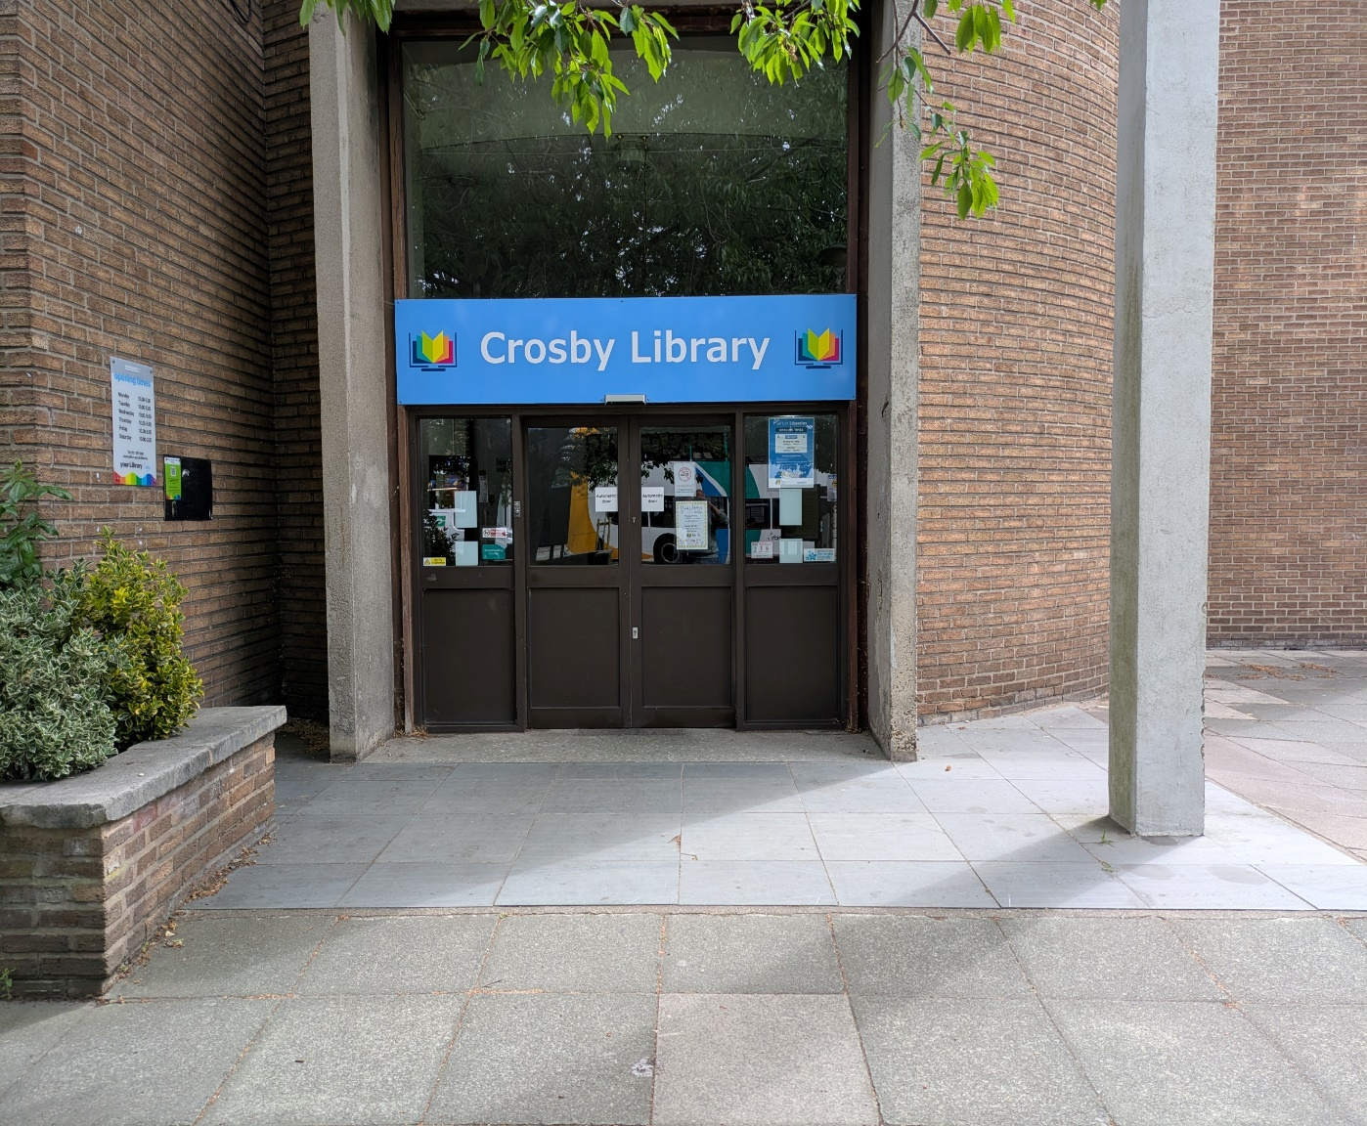

There is 1 artist collective showing work here.

You can access the library on foot from Crosby Road North.

The library is open Monday-Friday from 10am-5pm and on Saturday from 10am-2pm.

What3Words: ///trail.splash.twins

There is a free car park for library users with accessible parking spaces accessed from Park Road, behind the library:

What3Words: ///vibrates.heave.hangs

Toilets

Toilets are located on the ground floor accessed to the right of the information desk.
There is an accessible toilet.

A link to more information about Crosby Library is here:
https://www.sefton.gov.uk/childrens-services/schools-and-learning/libraries/your-local-library/crosby-library/

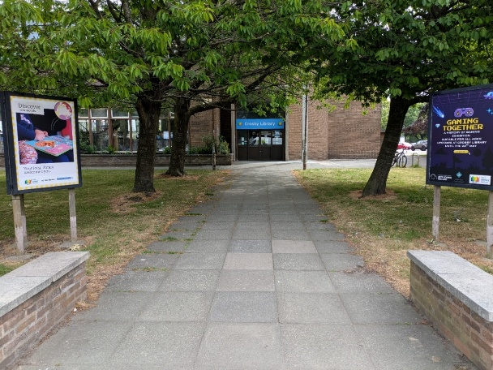
From Crosby Road North there is step free access to the building via a straight path leading to the main entrance. There are automatic doors.

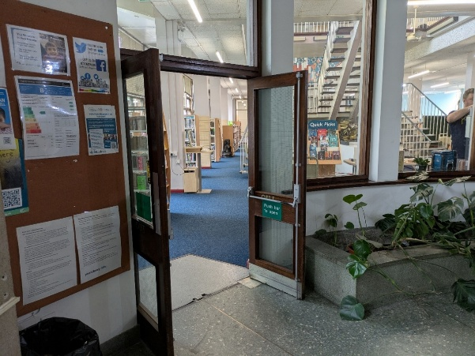
From the foyer, turn right and you will enter the main library space.

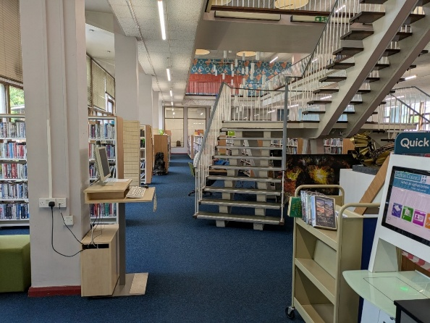
You will find the artwork by moving straight ahead between the bookshelves, past the staircase to the end of the main room.

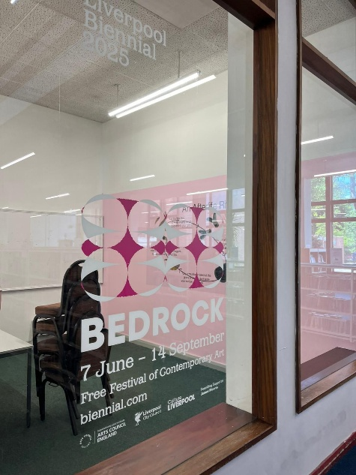
The artwork is in the Community Room that has glass windows and a door in the centre.

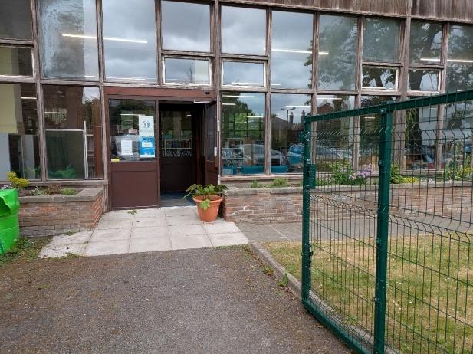
From the rear car park you can access the library through automatic doors.

In the community room you will find an installation by DARCH.

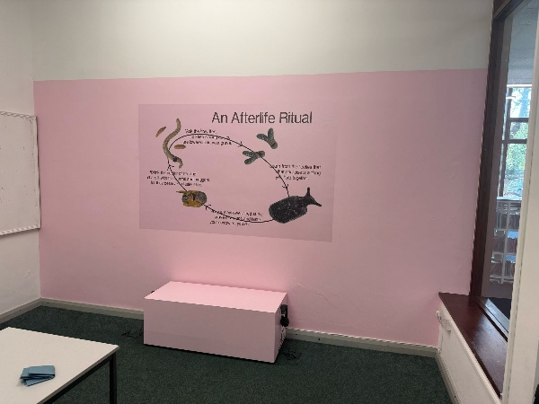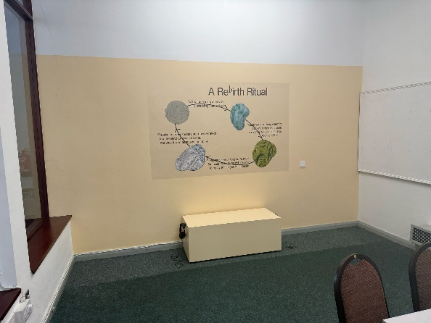

DARCH

DARCH is the collaborative practice of artists Umulkhayr Mohamed and Radha Patel. Their work seeks creative ways to articulate care-centred practices for people of colour, with an approach grounded in solidarity and liberation. Central to their shared practice are rituals, shrine building and animism – the belief that objects, places, and creatures all possess a distinct spiritual essence.

For Liverpool Biennial 2025, DARCH have produced a new installation in collaboration with residents in Sefton, who have contributed stories about how their connection to spiritual traditions and their Merseyside community have shaped their relationship with death and grief. ‘Heaven in the Ground’ tells the story of the earth underneath our feet, and the bedrock as a great connector which holds all histories (prehistoric, colonial, personal) as well as possible futures.

If you are looking for any specific advice or guidance on accessing Liverpool Biennial 2025, you can email:

access@biennial.com



