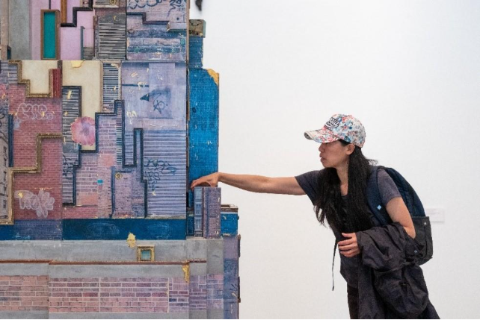
Looking back at Liverpool Biennial 2025

CONTENTS
p. 3 Introduction
p. 6 - 21 Summary of Findings

INTRODUCTION
Since its beginnings in 1998 Liverpool Biennial has presented work by over 590 leading artists from around the world, hosted over 50 million visits and delivered 39 collaborative projects, many with long-lasting social impact. We aim to connect the best of international art and artists to Liverpool for the benefit of everybody who lives, studies, works within and visits our brilliant city.

The 13th edition of Liverpool Biennial, titled ‘BEDROCK’, took place from 7 June – 14 September 2025. Curated by Liverpool-based curator Marie-Anne McQuay, the festival comprised a series of outdoor artworks across the city and free exhibitions in leading arts and cultural venues including Bluecoat, FACT Liverpool, Liverpool Cathedral, Liverpool Central Library, Open Eye Gallery, Tate Liverpool + RIBA North, The Black-E and Walker Art Gallery, alongside exhibitions in unexpected locations including Eurochemist, the grounds of Liverpool John Moores University, Pine Court and SEVENSTORE.

BEDROCK included the work of 30 artists and collectives from around the world, including 22 new commissions, drawing on Liverpool’s distinctive geography and the beliefs and strong civic values which underpin the city.
Across the summer we delivered a dynamic programme of free performances, talks, conferences, tours and events. For families, schools and the wider community, the 2025 Learning Programme included a Children’s Guide, wellbeing routes to navigate the Biennial and free family workshops inspired by the work of Biennial artists at Liverpool Central Library.

I would like to offer our gratitude to Marie-Anne, who combined her intimate knowledge of Liverpool, its places and people with connections made with artists across the world. I would also like to extend my gratitude to the artists who worked with us to create a Biennial that was truly rooted in the city.

Many thanks to our key supporters Arts Council England, Liverpool City Council and Culture Liverpool, UK Trusts and Foundations, International Agencies, and corporate supporters, as well as individuals from our Collector, Director and Commissioning Circles for their ongoing support.

And finally, a huge thank you to our wonderful team and our delivery and venue partners across the city for bringing ‘BEDROCK’ to life. We could not achieve what we do without everyone’s hard work and unwavering support. We look forward to further strengthening our relationships with partners across Liverpool City Region as we prepare for our next edition.

I look forward to welcoming you all to Liverpool Biennial 2027.

Dr Samantha Lackey
Director
Liverpool Biennial

SUMMARY OF FINDINGS
Evidence for this report is based on the responses of Liverpool Biennial visitors, delivery partners and other key stakeholders. These responses were collected in the following ways:
- Comprehensive visitor surveys (conducted at venues or filled in online)
- Follow-up interviews with visitors at several venues during the festival
- In-depth consultation sessions with partner venues and interviews with other stakeholders (the latter group included cultural organisations, educational institutions, funders, and peers from other biennial organisations.)
Building on findings in 2021 and 2023, the evaluation of ‘BEDROCK’ responds to the three core aims of Liverpool Biennial 2025. The main findings have been summarised under each aim:
Opportunity – impact on audiences, artists, peers, Liverpool residents – providing opportunities and breaking down barriers through free engagement with contemporary art.
Growth – impact on the city, artist career development, training and career opportunities for staff, impact on partner venues, support and development of local production.
Connection – presenting groundbreaking works by emerging and established national and international contemporary artists – facilitating knowledge exchange, debate/discourse and networking.
The evaluation of ‘BEDROCK’ was led by The Audience Agency (TAA), an independent research and development non-profit, whose purpose is to enable a thriving, people-centred cultural sector.
This report provides statistics and background information, measuring our performance against each of these outcomes, as well as comments from visitors and partners.

OPPORTUNITY
Impact on audiences, artists, peers, Liverpool residents – providing opportunities and breaking down barriers through free engagement with contemporary art.
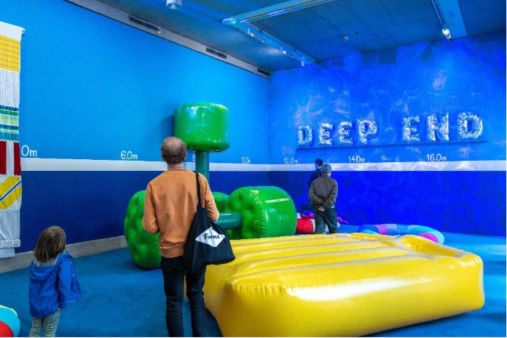
LB2025 engaged an estimated 154,569 individual visitors (across an estimated 1,391,730 individual visits)
This represents a 52% increase on individual visitors at LB2023. Audiences visited an average of 9 individual events at LB2025, demonstrating a high level of engagement from individuals, which has increased from the LB2023 average of 7.5 visits and LB2021 average of 4.2. 60% attended with friends and/or family, 32% alone. 55% visited with other adults only.
LB2025 both attracted new audiences and demonstrated strong audience retention over many years.
As at LB2023, LB2025 achieved a good balance between attracting new audiences (43%) and retaining previous audiences. Those who had attended before were most likely to have also visited in 2023 (45% of total audiences) and 2021 (33%) and 2018 (30%). However, there is good audience retention over multiple years, with a quarter of previous audience members having visited in 2016 and almost a fifth in both 2014 and 2012.

Audiences had a wide range of motivations for visiting the Biennial.
Main motivations for visiting LB2025 were ‘to be intellectually stimulated’, ‘for enjoyment’, ‘to be inspired’, ‘to learn something’, ‘contemporary art is an important part of who I am’ and ‘I was curious’.
Looking at motivations by age of respondent, audiences aged 16-24 were more likely than older groups to be motivated for peace and quiet, curiosity and for academic reasons.

The most important communication channel was Liverpool Biennial’s website (61% seen/engaged).
This was followed by Liverpool Biennial’s printed guide (34%), Liverpool Biennial’s Instagram (32%) and word of mouth (32%), then by Liverpool Biennial’s e-newsletter (23%), a banner, flag or sign around the city (23%) and a window display at a venue (18%).
Younger audiences aged 16-24 were less likely than older groups to use the Biennial’s website and receive the Biennial’s newsletter; and more likely to see a window display, and the Biennial’s TikTok and LinkedIn.

Personal impacts of a visit to LB2025 were strong.
Audiences were especially likely to agree that their visit to Liverpool Biennial ‘…was enjoyable’ and ‘…made me feel interested in new things.’
Responses were also positive across other impact areas: Liverpool Biennial ‘…was different to things I’ve been to before’, ‘…left a strong impression on me’, ‘…allowed me to spend quality time with friends, family or other attenders,’ and ‘…had a strong impact on my sense of wellbeing.’
In the visitor interviews, some participants described very strong emotional reactions to several works, in particular those exploring themes of family, faith, gender and community, and immersive and sensory experiences:

“I remember one piece of artwork, it had a projector streaming a video about the history of a village, maybe in Japan or China in the early 20th century. I came out of the exhibition immediately wanting to know more, googling everything to understand the story and inspiration behind the work, the context of it just seemed really interesting” (Visitor)

LB2025 attracted diverse audiences.
Audiences were fairly equally split between a specialist interest in contemporary art (e.g. academic or professional), enthusiast (interested as a hobby/passion) and general interest – with just under a third falling into each of these categories.
In addition to this, LB2025 attracted audiences with a diverse demographic profile:
• Audiences at LB2025 were well spread across age groups, with a particular leaning towards 25-39.
• 41% identified as White: British (compared to 50% attending LB2023). Those identifying as White: Irish totalled 18% (higher than 12% at LB2023). Those identifying as any other White background was also high at 14%. Other significant groups attending LB2025 were Gypsy, Roma or Irish Traveller (4%) and Asian/Asian British: Chinese (2%), Mixed background: Asian and White (2%) and any other Asian background (2%).
• 61% of audiences responding to the survey identify as a Woman, 29% as a Man, 4% as Non-binary and 1% prefer to self-describe.
• 10% of audiences identify as a D/deaf and/or disabled person, or have a long-term health condition (closely in line with 9% at LB2023). 19% identify as neurodivergent (slightly higher than 17% at LB2023).
Over three-quarters of audiences (77%) found Liverpool Biennial accessible.
Respondents were most likely to say that they didn’t require any access provisions
(65%). Those who did use provisions were most likely to say they found useful the Wayfinding Guide (11%), Large Print Guide (7%) and Easy Read Guide (7%). 7% were not aware of access provisions that they would have found useful.

GROWTH
Impact on the city, artist career development, training and career opportunities for staff, impact on partner venues, support and development of local production.
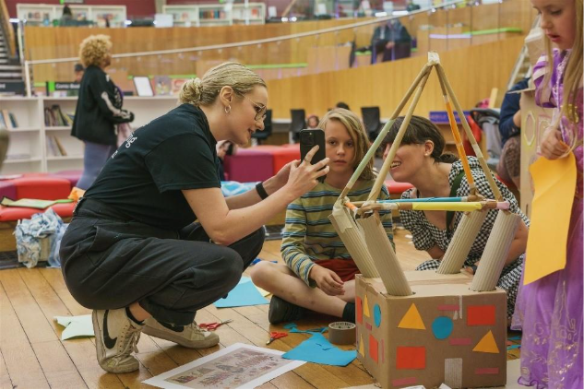
LB2025 attracted significant numbers into Liverpool from outside the city, as well as from the local area.
Almost half travelled from outside the region – with 23% international visitors and 26% from the UK outside the North West. 38% were from Liverpool City Region and 13% from other areas of the North West. Visitors came from 26 countries.

Audience travel at LB2025 supports increased positive environmental impacts.
Audiences were most likely to travel to LB2025 by train (42%), followed by car (16%), walking (15%) and bus (13%). The proportion attending by car has dropped since 2023 (23% LB2023 vs 16% LB2025) and the proportion attending by each of train, walking and bus has increased slightly. Almost all (96%) travelled around Liverpool city centre on foot to visit the Biennial (91% for LB2023).

The economic impact of the Biennial on Liverpool has increased in 2025.
The estimated economic impact of LB2025 on Liverpool was higher than previous years at £17,406,072.
A noteworthy 44% of total audiences visited from outside the area specifically for LB2025, with 36% of LB2025 audiences staying overnight, the majority of these in hotels – bringing significant spend into the city. This was combined with high engagement with LB2025, as demonstrated through the average of 9 Biennial events visited, which we can assume positively influenced time spent in Liverpool and resulting spend.

Liverpool Biennial plays a crucial role in Liverpool’s cultural landscape.
Stakeholders and partners regard Liverpool Biennial as a crucial pillar in Liverpool’s cultural landscape, recognising its ability to bring together artists, organisations and concepts with local relevance, whilst also attracting national and international talent and interest too. They also feel that it helps to solidify Liverpool’s standing on the cultural map, bringing in audiences from near and far.
Amongst stakeholders, Liverpool Biennial has an established reputation as a platform consistently showcasing high quality and exciting artwork that helps artists to increase their visibility and reach. It also provides a platform for showcasing work from underrepresented artists, providing opportunities and support for those who may not have come through traditional career routes.

“It’s an incubator or a start point for an artist…The Biennial is generous in how it nurtures and creates this fabulous platform... for artists to grow and fly and be themselves.” (Stakeholder)

Both stakeholders and partners expressed that Liverpool Biennial has a lasting effect on the local arts ecosystem, nurturing careers and inspiring generations.

“How many people in the city are working in the arts because of Liverpool Biennial in 1999? Myself included…It was their introduction to contemporary art...[Liverpool Biennial] was the thing that got us passionate, and we still are…It has probably more power when it’s at its best to inspire a new generation of artists than anything else in the North of England.” (Stakeholder)

LB2025 supported partners to achieve their own aims in a variety of ways.
The Biennial supported partners to achieve their aims in many ways including through its programming, networking and profile-raising opportunities.

“Artistically it felt really aligned with what we're trying to achieve here. So I'd say that was a definite in terms of our artistic ambitions.” (Partner)

There were significant impacts on many partners in terms of increasing audience size and the Biennial successfully brought in audiences from outside the city to partner venues. Some partners noted that their audiences were diversified through specific projects, activities, artists on show and diversity of content at their venue, and the children’s guide was well received.

“…it's been very, very high…it's outdone the target we had for the show, which is great. And with that, people have come again. (Partner)

“There were younger people, people from outside Liverpool, a lot. There's quite a mix.” (Partner)

CONNECTION
Presenting groundbreaking works by emerging and established national and international contemporary artists – facilitate knowledge exchange, debate/discourse and networking.
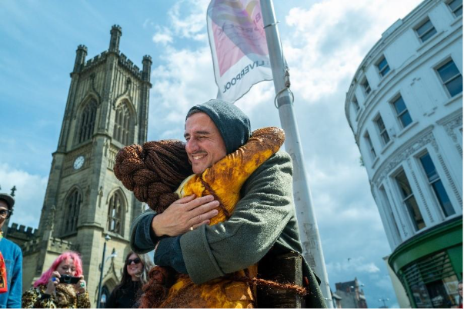
Overall audience experience ratings were positive.
93% rated the whole experience as ‘very good’ or ‘good’; 93% rated the quality of the exhibition/event as ‘very good’ or ‘good’. 83% agreed that ‘Liverpool Biennial presents exceptional work’, 96% that ‘I would come to something like this again’ and 94% that ‘I found Liverpool Biennial welcoming.’

Audiences described the Biennial as:
‘interesting’, ‘inspiring’, ‘fun’, ‘stimulating’, ‘thought-provoking’, ‘welcoming’ and ‘diverse’.
Staff were highly praised.
Audiences interviewed described staff across venues as friendly, approachable, knowledgeable and recalled helpful conversations with them surrounding the content of the artwork and exhibitions.
“I found the staff were all very engaged in in the art and wanted to talk about it… they all seem to be very well informed.” (Visitor)
Audiences recognise Liverpool Biennial’s important placemaking role.
A recognition of Liverpool Biennial’s placemaking role was reflected by the majority of audiences in their survey responses. 97%, agreed that ‘it’s important for Liverpool to stage events like this’ and 95% agreed that ‘Liverpool Biennial has a positive impact on the city’s cultural offer’.
Additionally, 70% agreed that ‘I’m more likely to visit Liverpool again as a result of my experience’ (it is notable that 10% responded ‘not applicable’ to this question, presumably those living in Liverpool).

The LB2025 programme was well-received by stakeholders and partners
Stakeholders’ overall thoughts on the LB2025 programme were positive, with a feeling that this year’s Biennial integrated particularly well into Liverpool’s social and historical setting and was well-grounded within the city’s current context.
Several stakeholders noted LB2025 as being on a smaller footprint than previous years, with the absence of Tate Liverpool for example, but did not feel this was necessarily a negative. They felt that was a sensible approach which had been well-executed and largely presumed it was due to the wider financial context.
A number of partners felt that spectacle was less visible in the 2025 Biennial, however in common with the sentiment from stakeholders, this was felt to be appropriate for the time and the biennial felt more welcoming and relatable to people.
“I found it overall very interesting...It was very much grounded in the social history and social fabric of the city.” (Stakeholder)

“It was quite a restrained Biennial and I think there's maybe like a few different ways to look at that…Somebody said to me it feels like it feels like a Biennial that's appropriate for the time.” (Partner)
“I think that the high quality, it is definitely there. It's there in the curatorial concept.” (Stakeholder)
Liverpool Biennial plays leading roles in both local and wider landscapes
Across the stakeholder interviews, Liverpool Biennial was consistently recognised for its strong, strategic leadership and the institutional respect and overall positive reputation this has earned them. The Biennial’s accessibility, through free entry, public locations, community outreach and excellent public communication was considered by stakeholders to be a defining feature which set it apart from others. Amongst some partners, there was a strong sense of the influential role that the Biennial plays within Liverpool’s cultural and political landscape.

“… the Biennial opening or any big events that the Biennial host…everyone will turn out for it and that includes people from the cultural sector, which you would expect, but also politicians. You know you're going to get the more heavy hitters and people from the visitor economy.” (Partner)

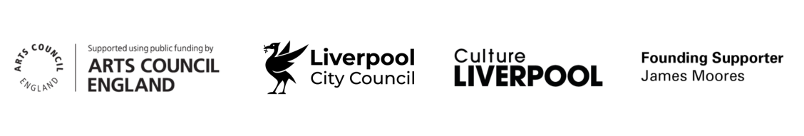
Image Credits: (1) Liverpool Biennial 2025: ‘BEDROCK’ at Open Eye Gallery. Photography by Mark McNulty. (2) Liverpool Biennial 2025: ‘BEDROCK’ at Bluecoat. Photography by Mark McNulty. (3) Liverpool Biennial 2025 Family Workshop at Liverpool Central Library. Photography by Adam Edwards. (4) Hadassa Ngamba, ‘Pathway Ngamba’, 2025. Liverpool Biennial 2025: ‘BEDROCK’. Photography by Mark McNulty.

Economic impact refers to 'new' money that has been 'injected' into the economy of Liverpool (from outside this area) that would not have been present had Liverpool Biennial 2025 not taken place. For example, all money spent by project participants/attendees who live within Liverpool is excluded from the economic impact estimate - money spent by this group of people is viewed as money which would have been spent in the area’s economy with or without Liverpool Biennial 2025. Furthermore, only money spent by participants/attendees who were motivated to visit the area because of Liverpool Biennial 2025 is included.

